Software Requirements Specification

Version #3.0

Made to Measure

Client: Cyber Solutions

Team #2

|  |  |
| --- | --- |
| Member Name | Primary Responsibility |
| Hamza Saleem | project management, Appendix: G, Appendix: H, Appendix: I, Implementation of Warehouse Functionalities |
| Luqmanud din Muhammad | Appendix:E (Test Cases) |
| Sultan Ahmad | Implementation of Customer & Stitching Unit Functionalities |
| SherjeelAmer | Appendix: F (IV & V Report) |
| Hammad Zia | Implementation of Shop Functionalities |
| Khizar Iqbal | Implementation of Admin Functionalities |

Table of Contents

1. Introduction 1

1.1 Product 1

1.2 Scope 1

1.3 Business Goals 1

1.4 Document Conventions 1

1.5 References 1

2. Overall Description 2

2.1 Product Features 2

2.2 User Classes and Characteristics 2

2.3 Operating Environment 2

2.4 Design and Implementation Constraints 3

2.5 Assumptions and Dependencies 3

3. Functional Requirements 4

3.1 Track Order Status 4

3.2 View Order History 5

3.3 View Profile 6

3.4 Add a new Customer 7

3.5 Add a Stitching Job 8

3.6 Generate Invoice 9

3.7 View History Details 10

3.8 Adjust invoice on pickup 11

3.9 View the stock position of warehouse 12

3.10 View the stock position of Item in warehouse 13

3.11 Order stock from the associated warehouse 14

3.12 Generate job card 15

3.13 Add fabric stock to the inventory 16

3.14 Add accessary stock to the inventory 17

3.15 Process Order with fabric issued from shop 18

3.16 Process order with fabric not issued from shop 19

3.17 Process Shop Order 21

3.18 Add to Vendor List 22

3.19 Assign Roles to Stitching Employees 23

3.20 Process job role 24

3.21 Add new Shop 25

3.22 Add new Warehouse 26

3.23 Add new Stitching Unit 27

3.24 Associate Shop with Warehouse 28

3.25 Associate shop with Stitching Unit 29

3.26 Associate Stitching unit with Warehouse 30

3.27 Generate Report 31

3.28 Add Employee 31

4. Nonfunctional Requirements 32

4.1 Performance Requirements 32

4.2 Security Requirements 32

4.3 Usability Requirements 32

5. Other Requirements 33

Appendix A: Glossary 33

Appendix B: Analysis Models 34

Use case Diagram 34

Entity Relationship Diagram 35

Class Diagram 36

Data Flow Diagram 38

Appendix C: Design Models 48

Component Diagram 48

Appendix D: Screenshots 49

Appendix E: Test Cases 70

5.1 Login 70

5.2 Login 70

5.3 Track Order Status 71

5.4 Track Order Status 71

5.5 View Order History 72

5.6 View Profile 72

5.7 View Profile 73

5.8 Add a New Customer 73

5.9 Add a New Customer 74

5.10 Add a Stitching Job 75

Add a Stitching Job 76

5.11 Generate Invoice 76

5.12 View History Details of particular order of Customer 77

5.13 Generate Receipt 77

5.14 Generate Receipt 78

5.15 View the stock position of warehouse 78

5.16 View the stock position of warehouse 79

5.17 View the stock position of Item in warehouse 79

5.18 View the stock position of Item in warehouse 80

5.19 Order stock from the associated warehouse 80

5.20 Order stock from the associated warehouse 81

5.21 Generate Job Card 82

5.22 Generate Job Card 82

5.23 Add fabric stock to the inventory 83

5.24 Add fabric stock to the inventory 84

5.25 Add fabric stock to the inventory 85

5.26 Add accessory stock to the inventory 85

5.27 Add accessory stock to the inventory 86

5.28 Add accessory stock to the inventory 87

5.29 Process Order with fabric issued from shop 89

5.30 Process Order with fabric issued from shop 89

5.31 Process Order with fabric issued from shop 90

5.32 Process order with fabric not issued from shop 91

5.33 Process order with fabric not issued from shop 91

5.34 Process order with fabric not issued from shop 92

5.35 Process Shop Order 93

5.36 Process Shop Order 93

5.37 Process Shop Order 94

5.38 Add to Vendor List 94

5.39 Add to Vendor List 95

5.40 Assign Roles to Stitching Unit Employees 96

5.41 Un-Assign Roles to Stitching Unit Employees 97

5.42 Assign Roles to Stitching Unit Employees 97

5.43 Process job role 98

5.44 Add new Shop 98

5.45 Add new Shop 99

5.46 Add new Warehouse 99

5.47 Add new Warehouse 100

5.48 Add new Stitching Unit 100

5.49 Add new Stitching Unit 101

5.50 Associate Shop with Warehouse 102

5.51 Associate Shop with Warehouse 102

5.52 Associate Shop with Warehouse 103

5.53 Cancel association between a Shop and Warehouse 103

5.54 Associate shop with Stitching Unit 104

5.55 Associate shop with Stitching Unit 104

5.56 Associate shop with Stitching Unit 105

5.57 Cancel Association between shop with Stitching Unit 105

5.58 Associate Stitching unit with Warehouse 106

5.59 Associate Stitching unit with Warehouse 106

5.60 Associate Stitching unit with Warehouse 107

5.61 Cancel Association between Stitching unit with Warehouse 107

5.62 Generate Report 108

5.63 Add Employee 109

5.64 Add Employee 109

5.65 Performance Requirement 110

5.66 Security Requirements 111

5.67 Security Requirements 112

5.68 Security Requirements 113

5.69 Security Performance 114

Appendix F: IV & V Report 115

Appendix G: Risk Report 116

Appendix H: Activity Timesheet 117

Appendix I: Updated Project Plan 118

Revision History

|  |  |  |  |
| --- | --- | --- | --- |
| **Name(s)** | **Date** | **Reason(s) For Change(s)** | **Version** |
| Hamza Saleem, Luqmanud din, SherjeelAmer, Sultan Ahmad, Hammad Zia | 20-Sep. 2016 | Use cases are added | 0.1 |
| Hamza Saleem | 21-Sep. 2016 | Non functional & other requirements are added | 0.2 |
| Khizar Iqbal | 22 Sep. 2016 | Use cases & requirements corrected | 0.3 |
| Khizar Iqbal | 22 Sep. 2016 | IV&V report added | 0.4 |
| Hamza Saleem | 22 Sep. 2016 | Risk report, Glossary, Project Plan added | 1.0 |
| Hamza Saleem | 5 Oct. 2016 | Slight Modifications in Section# 1.5, 2.1, 2.2, 2.3, 3, 4.2, 4.3, 5, Appendix: G, H, I | 1.1 |
| Hamza Saleem | 10 Oct. 2016 | Use case diagram added | 1.2 |
| Sultan Ahmad | 14 Oct. 2016 | Class diagram added | 1.3 |
| Hammad Zia | 20 Oct. 2016 | ER diagram added | 1.4 |
| Sharjeel Ahmad | 24 Oct. 2016 | Component Diagram added | 1.5 |
| Luqmanud din | 27 Oct. 2016 | IV&V report added | 1.6 |
| Hamza Saleem | 27 Oct.  2016 | DFD added, GUIs added | 2.0 |
| Luqmanud din | 1 Dec. 2016 | Appendix: E Test cases Added | 2.1 |
| Sharjeel Amir | 1 Dec. 2016 | Appendix: F IV & V Report Added | 2.2 |
| Hamza Saleem | 2 Dec. 2016 | Risk report, Activity Timesheet, Project Plan added | 3.0 |
|  |  |  |  |

# Introduction

## Product

“Made to Measure” is web based management suite for tailoring industry which will cover sales, order processing, inventory at warehouse and real time order status for customers.

## Scope

This software system will be a web based management suite for the tailoring industry. We intend to design it in order to ease the day to day business workflow and organize processes. This will in turn help the tailoring industry to maximize their work efficiency while remaining easy to understand and use.

More specifically, the system is designed to handle the operations regarding sales at the shop, stock at the warehouse, and feedback of stitching processes at the stitching units. Going one step further, we plan to engage the customer by sending stitching feedback once each process is completed via the web portal and SMS.

The software will also facilitate communication between the head office, warehouses and shops by providing a real time view of the whole ongoing operations respectively ranging from stock position to orders received.

## Business Goals

Scalability and Time Saving: The system will replace the uses of pencil and paperwork; the shopkeeper will not go through all the notebooks to check measurements of one customer. The shopkeeper and warehouse manager can easily check the status of stock sitting on their chairs.

Business Monitoring: Admin can monitor and control his/her business from remote locations.

Keep track of stock: Keeping the history of stocks in digital machine will aid in calculating statistics of the stocks for future times.

Customer Satisfaction: Facility for customers to track their order status will increase customer satisfaction.

## Document Conventions

## References

# Overall Description

## Product Features

1. The shopkeepers shall be able to book a stitching order.

2.Shopkeepers shall be able to lookup the current stock position at the warehouse.

3. System shall also provide the functionality to generate invoice/receipt.

4. The system shall keep a record of incoming/outgoing stock and generate barcodes for stock arrivals at the warehouse.

5. Production process at the stitching unit shall also be accounted for by notifying the customer once each task is completed (cutting has been done for e.g.).

6. Administrative functionalities shall also be provided by the system to create logins for new employees, add new shops/warehouses/stitching units and generate reports.

7. The customer portal shall show customer profile and list the order history.

## User Classes and Characteristics

The users are distinguished on privilege level. The different types of users are explained below.

**Admin**

Admin is a male with age 37. He is a computer literate. He has an experience of about 8 years. He will access the system from the Head Office.

**Customer**

A customer can be both male or female with age greater than 12 years. He can be a computer literate or illiterate.

**Shopkeeper**

A shopkeeper is a male with age greater than or equal to 20. He is a computer literate.

**Warehouse Manager**

A warehouse manager is a male with age greater than or equal to 30. He is a computer literate. He has a minimum experience of 3 years in the Fabric Industry.

**Stitching Unit Manager**

A Stitching Unit Manager is a male with age greater than or equal to 30. He is a computer literate.

**Stitching Unit Staff**

A Stitching unit staff person is a male with age greater than or equal to 25. He is a computer literate.

## Operating Environment

The website will be accessed throughgoogle chromebrowser (Version 50 and above).Desktop computers with Intel core i3 (2 GB RAM) or higher specs will be used at the shops, warehouses and stitching units. Barcode Scanners and Printers need to be attached with these systems. The system will be accessed through Microsoft Windows operating system (Windows 7 or above) at these places. However, the customer can access the system through desktop computer, laptop or smart phone with varying software and hardware specifications.

## Design and Implementation Constraints

The website should be implemented using ASP.NET. MVC architecture should be used along with SQL databases. Responsive design should be implemented. Every input field should be validated against false inputs (number validation, alphabets validation, email, phone number, password length). Basic security concerns like SQL Injection and XSS should be removed.

## Assumptions and Dependencies

Since our system is web app, it is assumed that internet will be available at the shops, warehouses and stitching unit to access the system. Moreover, the system requires the use of barcode scanners and printers along with desktop computers present at all three places and their availability is assumed.

We also plan to use a software component to send SMS to customers, and we have assumed that it works fine and is available open source for use.

# Functional Requirements

## Track Order Status

|  |  |  |  |
| --- | --- | --- | --- |
| **Identifier** | | Track Order Status | |
| **Purpose** | | Customer sees the status of particular order whether it is finished processing and ready at shop or is still in particular stage of processing. | |
| **Priority** | | Medium | |
| **Actors** | | Customer | |
| **Pre-condition(s)** | | system is online | |
| **Post-condition(s)** | | No change in system | |
| **Typical Course of Action** | | | |
| **S#** | **Actor Action** | | **System Response** |
| **1** | Enter phone number and password | |  |
| **2** |  | | Display customer’s home page |
| **3** | Select pending orders option | |  |
| **4** |  | | Display all pending orders list |
| **5** | Select particular order from the list | |  |
|  |  | | Show details of selected order |
| **Alternate Course of Action(Incorrect Login Info)** | | | |
| **S#** | **Actor Action** | | **System Response** |
| **1** | Enter incorrect phone number and/or password | |  |
| **2** |  | | Display error “The login information you entered is incorrect” |
| **Alternate Course of Action(No Pending Order)** | | | |
| **S#** | **Actor Action** | | **System Response** |
| **4** |  | | Show message “No pending order” |

## View Order History

|  |  |  |  |
| --- | --- | --- | --- |
| **Identifier** | | View Order History | |
| **Purpose** | | Customer sees history of all the orders placed till today | |
| **Priority** | | Medium | |
| **Actors** | | Customer | |
| **Pre-condition(s)** | | System is online; Customer account is created | |
| **Post-condition(s)** | | No change in system | |
| **Typical Course of Action** | | | |
| **S#** | **Actor Action** | | **System Response** |
| **1** | Enter phone number and password | |  |
| **2** |  | | Display customer’s home page |
| **3** | Select orders history option | |  |
| **4** |  | | Display list of all of customer’s orders sorted by descending order date |
| **5** | Select particular order from the list | |  |
|  |  | | Show order date, status, type and shopaddress of orders. |
| **Alternate Course of Action(Incorrect Login Information)** | | | |
| **S#** | **Actor Action** | | **System Response** |
| **1** | Enter incorrect phone number and/or password | |  |
| **2** |  | | Display error “The login information you entered is incorrect” |

## View Profile

|  |  |  |  |
| --- | --- | --- | --- |
| **Identifier** | | View Profile | |
| **Purpose** | | Customer views his/her profile, profile contains customer name, contact number, current measurements etc. | |
| **Priority** | | Medium | |
| **Actors** | | Customer | |
| **Pre-condition(s)** | | System is online; Customer account is created | |
| **Post-condition(s)** | | No change in system | |
| **Typical Course of Action** | | | |
| **S#** | **Actor Action** | | **System Response** |
| **1** | Enter phone number and password | |  |
| **2** |  | | Display customer’s home page |
| **Alternate Course of Action(Incorrect Login info)** | | | |
| **S#** | **Actor Action** | | **System Response** |
| **1** | Enter incorrect phone number and/or password | |  |
| **2** |  | | Display error “The login information you entered is incorrect” |

## Add a new Customer

|  |  |  |  |
| --- | --- | --- | --- |
| **Identifier** | | Add a new Customer | |
| **Purpose** | | To add a new Customer to the system | |
| **Priority** | | Medium | |
| **Actors** | | Shopkeeper | |
| **Pre-conditions** | | Shopkeeper is logged in | |
| **Post-conditions** | | A new customer is added to the system. | |
| **Typical Course of Action** | | | |
| **S#** | **Actor Action** | | **System Response** |
| **1** | Selects the option to add a new customer. | |  |
| **2** |  | | Prompts for user details. |
| **3** | Provides phone number, password, & name of the customer and selects the add button. | |  |
| **4** |  | | Shows confirmation message. |
| **Alternate Course of Action(Already existing user added)** | | | |
| **S#** | **Actor Action** | | **System Response** |
| **4** |  | | Displays Error message “Customer already exists”. |

## Add a Stitching Job

|  |  |  |  |
| --- | --- | --- | --- |
| **Identifier** | | Add a Stitching Job | |
| **Purpose** | | To add a Stitching Job by the shopkeeper | |
| **Priority** | | Medium | |
| **Actors** | | Shopkeeper | |
| **Pre-conditions** | | Shopkeeper is logged in | |
| **Post-conditions** | | A new job is added to the system. | |
| **Typical Course of Action** | | | |
| **S#** | **Actor Action** | | **System Response** |
| **1** | Selects the option to add a new stitching job. | |  |
| **2** |  | | Prompts for stitching job details and advance amount to be paid. |
| **3** | Provides expected date, job type, item codes, shop code, customer contact no andselects the add joboption. | |  |
|  |  | | Shows confirmation message and prints an invoice of the job. |
| **Alternate Course of Action(Customer does not exist)** | | | |
| **S#** | **Actor Action** | | **System Response** |
| **3** | Enter Customer that does not exist | |  |
| **4** |  | | Displays Error message “Customer does not exist”. |

## Generate Invoice

|  |  |  |  |
| --- | --- | --- | --- |
| **Identifier** | | Generate Invoice | |
| **Purpose** | | As soon as all stitching jobs of a particular customer have been added, an invoice is generated and handed over to the customer indicating an advance payment. | |
| **Priority** | | High | |
| **Actors** | | Shopkeeper | |
| **Pre-condition(s)** | | All stitching job(s) have been added. | |
| **Post-condition(s)** | | An invoice against orders is issued. | |
| **Typical Course of Action** | | | |
| **S#** | **Actor Action** | | **System Response** |
| **1** | Add stitching job or alteration job UC(UC-5)& UC(UC-6). | |  |
| **2** | Select generate invoice. | |  |
| **3** |  | | System prompts for advance payment. |
| **4** | Enter advance payment received. | |  |
| **5** |  | | System logs in that amount and calculates outstanding balance. |
| **6** | Select print invoice. | |  |
|  |  | | System prints the invoice with unique invoice number. |
| **Alternate Course of Action(Shopkeeper changes advance payment)** | | | |
| **S#** | **Actor Action** | | **System Response** |
| **4** | Shopkeeper enters a new payment | |  |
| **5** |  | | System recalculates the outstanding balance. |
| **Go to 6** | | | |

## View History Details

|  |  |  |  |
| --- | --- | --- | --- |
| **Identifier** | | View History Details | |
| **Purpose** | | To view the measurements in case the customer asks for a stitching job on the basis of recent measurements. | |
| **Priority** | | High | |
| **Actors** | | Shopkeeper | |
| **Pre-condition(s)** | | Customer has registered a stitching job before. | |
| **Post-condition(s)** | | These measurements are used to create a stitching job. | |
| **Typical Course of Action** | | | |
| **S#** | **Actor Action** | | **System Response** |
| **1** | Enter customer’s Phone number | |  |
| **2** |  | | System displays the order history list of that customer. |
| **3** | Select a particular order. | |  |
| **4** |  | | System displays the order date, job type & measurements of the order |

## Adjust invoice on pickup

|  |  |  |  |
| --- | --- | --- | --- |
| **Identifier** | | Adjust invoice on pickup | |
| **Purpose** | | Once the customer arrives for collecting the order, the outstanding balance is reconciled and a receipt indicating the transaction is issued. | |
| **Priority** | | High | |
| **Actors** | | Shopkeeper | |
| **Pre-condition(s)** | | Package has arrived at the shop. | |
| **Post-condition(s)** | | A receipt against the invoice is issued. | |
| **Typical Course of Action** | | | |
| **S#** | **Actor Action** | | **System Response** |
| **1** | Enter invoice number | |  |
| **2** |  | | System displays the invoice. |
| **3** | Select generate receipt. | |  |
| **4** |  | | System prints the receipt. |

## View the stock position of warehouse

|  |  |  |  |
| --- | --- | --- | --- |
| **Identifier** | | View the stock position of warehouse | |
| **Purpose** | | How a shopkeeper can view stock position of the warehouse associated | |
| **Priority** | | High | |
| **Actors** | | Shopkeeper | |
| **Pre-condition(s)** | | Shopkeeper is logged in | |
| **Post-condition(s)** | | None | |
| **Typical Course of Action** | | | |
| **S#** | **Actor Action** | | **System Response** |
| **1** | Select view stock position | |  |
| **2** |  | | Display list of items with their stock |

## View the stock position of Item in warehouse

|  |  |  |  |
| --- | --- | --- | --- |
| **Identifier** | | View the stock position of Item in warehouse | |
| **Purpose** | | How a shopkeeper can view stock position of an item in the warehouse associated. | |
| **Priority** | | High | |
| **Actors** | | Shopkeeper | |
| **Pre-condition(s)** | | Shopkeeper is logged in | |
| **Post-condition(s)** | | None | |
| **Typical Course of Action** | | | |
| **S#** | **Actor Action** | | **System Response** |
| **1** | Select view stock position of an item | |  |
| **2** |  | | Prompts for the item name |
| **3** | Enter item name | |  |
| **4** |  | | Display stock position of the item |
| **Alternate Course(s) of Action(Item not found)** | | | |
| **S#** | **Actor Action** | | **System Response** |
| **4** |  | | Display “Item Name Not Found” |
| **Go to step 3** | | | |

## Order stock from the associated warehouse

|  |  |  |  |
| --- | --- | --- | --- |
| **Identifier** | | Order stock from the associated warehouse | |
| **Purpose** | | How a shopkeeper can order stock from the warehouse associated. | |
| **Priority** | | High | |
| **Actors** | | Shopkeeper | |
| **Pre-condition(s)** | | Shopkeeper is logged in | |
| **Post-condition(s)** | | Add entry to the the vendor list of warehouse | |
| **Typical Course of Action** | | | |
| **S#** | **Actor Action** | | **System Response** |
| **1** | Select order stock Option | |  |
| **2** |  | | Prompts for the item code |
| **3** | Enter item code | |  |
| **4** |  | | Prompts for item quantity |
| **5** | Enter item quantity | |  |
| **6** |  | | Display “Order placed” |
| **Alternate Course(s) of Action(Item Not found)** | | | |
| **S#** | **Actor Action** | | **System Response** |
| **4** |  | | Display “Item Name Not Found” |
| **Go to step 3** | | | |

## Generate job card

|  |  |  |  |
| --- | --- | --- | --- |
| **Identifier** | | Generate job card | |
| **Purpose** | | How a shopkeeper can generate job card for a specific job | |
| **Priority** | | High | |
| **Actors** | | Shopkeeper | |
| **Pre-condition(s)** | | Shopkeeper is logged in and a particular job exists | |
| **Post-condition(s)** | | Job card id is registered in the System | |
| **Typical Course of Action** | | | |
| **S#** | **Actor Action** | | **System Response** |
| **1** | Select issue job card | |  |
| **4** |  | | Display the details of job |
| **7** |  | | Prompts for confirmation |
| **8** | User confirms | |  |
| **9** |  | | Generate Job Card |
| **Go to step 3** | | | |
| **Alternate Course(s) of Action(Cancel Process)** | | | |
| **S#** | **Actor Action** | | **System Response** |
| **8** | User Declines | |  |
| **9** |  | | Display “You have Declined Job Card Issuance” |

## Add fabric stock to the inventory

|  |  |  |  |
| --- | --- | --- | --- |
| **Identifier** | | Add fabric stock to the inventory | |
| **Purpose** | | Warehouse manager adds new fabric stock issued from vendors to the warehouse. | |
| **Priority** | | Medium | |
| **Actors** | | Warehouse Manager | |
| **Pre-condition(s)** | | System is online; Manager is logged in | |
| **Post-condition(s)** | | New fabric stock added to the system | |
| **Typical Course of Action** | | | |
| **S#** | **Actor Action** | | **System Response** |
| **1** | Select option for adding new fabric | |  |
| **2** |  | | Generate the barcode |
| **3** |  | | Print the barcode |
| **4** |  | | Prompt the user to enter the required details for item |
| **5** | Enter the category name, sub category name, brand name, vendor name, cost price, color, unit of measure, quantity | |  |
|  |  | | Add new fabric stock entry in the database |
| **Alternate Course(s) of Action(Incomplete Information)** | | | |
| **S#** | **Actor Action** | | **System Response** |
| **3** |  | | Display ” Enter Complete information” |
| **Go To 4** | | | |

## Add accessary stock to the inventory

|  |  |  |  |
| --- | --- | --- | --- |
| **Identifier** | | Add accessary stock to the inventory | |
| **Purpose** | | Warehouse manager adds new accessory stock issued from vendors to the warehouse. | |
| **Priority** | | Medium | |
| **Actors** | | Warehouse Manager | |
| **Pre-condition(s)** | | System is online; Manager is logged in | |
| **Post-condition(s)** | | New accessory stock added to the system | |
| **Typical Course of Action** | | | |
| **S#** | **Actor Action** | | **System Response** |
| **1** | Select option for adding new accessory | |  |
| **2** |  | | Generate the barcode |
| **3** |  | | Print the barcode |
| **4** |  | | Prompt the user to enter the required details for the item |
| **5** | Enter the category name, sub category name, brand name, vendor name, cost price, color, unit of measure, quantity | |  |
|  |  | | Add new accessory stock entry in the database |
| **Alternate Course(s) of Action** | | | |
| **S#** | **Actor Action** | | **System Response** |
| **3** | All required details not entered | |  |
| **4** |  | | Focus cursor to the “Not entered” required detail and show message “This detail is mandatory” |

## Process Order with fabric issued from shop

|  |  |  |  |
| --- | --- | --- | --- |
| **Identifier** | | Process Order with fabric issued from shop | |
| **Purpose** | | Warehouse manager processes required accessories to send to the stitching unit for further order processing | |
| **Priority** | | Medium | |
| **Actors** | | Warehouse Manager | |
| **Pre-condition(s)** | | System is online; Manager is logged in | |
| **Post-condition(s)** | | Accessory stock decreased from warehouse | |
| **Typical Course of Action** | | | |
| **S#** | **Actor Action** | | **System Response** |
| **1** | Select option for processing new order with fabric issued from shop. | |  |
| **2** |  | | Display list of orders |
| **3** | Select order from the list | |  |
| **4** |  | | Waiting for reading the barcode for accessory |
| **5** | Scan required accessories | |  |
| **6** |  | | Prompt the user to enter number of scanned accessory required etc. |
| **7** | Enter the ordered info for scanned accessory; If there are further accessories to be scanned, got to 3 | |  |
| **8** |  | | Save the order info to the system history; generate job order for further processing to the selected stitching unit |
| **Alternate Course(s) of Action(Barcode Not Properly scanned)** | | | |
|  | **Actor Action** | | **System Response** |
| **6** |  | | Barcode not being read properly; display message “Please enter item no manually” |
| **7** | Enter accessory number manually | |  |
| **8** |  | | Go to step 6 in sunny day scenario |

## Process order with fabric not issued from shop

|  |  |  |  |
| --- | --- | --- | --- |
| **Identifier** | | Process order with fabric not issued from shop | |
| **Purpose** | | Warehouse manager processes required accessories to send to the stitching unit for further order processing in case fabric is not issued from shop | |
| **Priority** | | Medium | |
| **Actors** | | Warehouse Manager | |
| **Pre-conditions** | | Warehouse Manager is logged in | |
| **Post-conditions** | | A confirmation message is displayed and the system waits for further instructions. | |
| **Typical Course of Action** | | | |
| **S#** | **Actor Action** | | **System Response** |
| **1** | Selects the option to View Orders. | |  |
| **2** |  | | Displays all the available orders and their details. |
| **3** | Selects an order from the list with those orders whose fabric is not issued from the shop. | |  |
| **4** |  | | Shows order details. |
| **5** | Selects the option to process order. | |  |
| **6** |  | | Asks to scan the fabric and accessories bar code. |
| **7** | Scans the fabric and accessories bar code. | |  |
|  |  | | Prompt the user to enter number of scanned accessory required etc. |
| **8** | Enter the ordered info for scanned accessory; If there are further accessories to be scanned, got to 7 | |  |
| **9** |  | | Save the order info to the system history; generate job order for further processing to the selected stitching unit |
| **10** |  | | Shows a confirmation message and prints the job card. |
| **Alternate Course of Action(Wrong item scanned)** | | | |
| **S#** | **Actor Action** | | **System Response** |
| **7** | Scans the fabric and accessories bar code. | |  |
| **8** |  | | The system displays error message that the barcode scanned does not belong to the fabric or accessories required by the order. |
| **Go To 6** | | | |
| **Alternate Course of Action(Item Quantity not available)** | | | |
| **S#** | **Actor Action** | | **System Response** |
| **7** | Scans the fabric and accessories bar code. | |  |
| **8** |  | | The system displays error message that the fabric or accessary whose barcode is scanned does not contain enough amount to process the order. |
| **Go To 6** | | | |

## Process Shop Order

|  |  |  |  |
| --- | --- | --- | --- |
| **Identifier** | | Process Shop Order | |
| **Purpose** | | Warehouse manager will process the order that came from that particular shop and send the required stock | |
| **Priority** | | Medium | |
| **Actors** | | Warehouse Manager | |
| **Pre-condition(s)** | | System is online; Ware House Manager is logged in | |
| **Post-condition(s)** | | System database will be updated according to the stock ordered | |
| **Typical Course of Action** | | | |
| **S#** | **Actor Action** | | **System Response** |
| **1** | Select option for processing shop orders | |  |
| **2** |  | | Displays list of orders from various shops |
| **3** | Selects a shop order | |  |
| **4** |  | | Checks the presence of all required stock in the database mentioned in the order |
| **5** |  | | Updates the system database |
| **6** |  | | Displays the message “Order Successfully processed” |
| **Alternate Course(s) of Action(No order present)** | | | |
| **S#** | **Actor Action** | | **System Response** |
| **4** |  | | Displays error message “No orders present” |
| **Alternate Course(s) of Action(Stock Not available)** | | | |
| **S#** | **Actor Action** | | **System Response** |
| **5** |  | | Displays error message “Required stock Not Available” |

## Add to Vendor List

|  |  |  |  |
| --- | --- | --- | --- |
| **Identifier** | | Add to Vendor List | |
| **Purpose** | | Warehouse manager adds the running out stock in the vendor list | |
| **Priority** | | Medium | |
| **Actors** | | Warehouse Manager | |
| **Pre-condition(s)** | | System is online; Manager is logged in | |
| **Post-condition(s)** | | Vendor list will be updated | |
| **Typical Course of Action** | | | |
| **S#** | **Actor Action** | | **System Response** |
| **1** | Select option for adding stock to vendors list. | |  |
|  |  | | Displays a list of vendors |
| **3** | Selects a vendor from the list | |  |
| **4** |  | | Prompts to enter the items to be ordered along with their quantities |
| **5** | Enter the category name, sub category name, brand name, vendor name, color, unit of measure, quantity | |  |
| **6** |  | | Adds items to the list and displays the message “Items Successfully added to Vendors List” |

## Assign Roles to Stitching Employees

|  |  |  |  |
| --- | --- | --- | --- |
| **Identifier** | | Assign Roles to Stitching Employees | |
| **Purpose** | | Stitching Unit Manager assigns job roles to different employees working in various sections of stitching Unit as Department Heads | |
| **Priority** | | Medium | |
| **Actors** | | Stitching Unit Manager | |
| **Pre-condition(s)** | | System is online; Stitching Unit Manager is logged in | |
| **Post-condition(s)** | | A particular job role will be assigned against the user id entered | |
| **Typical Course of Action** | | | |
| **S#** | **Actor Action** | | **System Response** |
| **1** | Select option for assigning job roles | |  |
| **2** |  | | Prompts to enter user id (phone Number) of an employee. |
| **3** | Enters user id | |  |
| **4** |  | | Displays a list of job roles |
| **5** | Selects a job role | |  |
| **6** |  | | Assigns the selected job role to the entered user id |
| **Alternate Course(s) of Action(Invalid User Id)** | | | |
| **S#** | **Actor Action** | | **System Response** |
| **4** |  | | Displays error message “Invalid User Id” |
| **GO TO 3** | | | |

## Process job role

|  |  |  |  |
| --- | --- | --- | --- |
| **Identifier** | | Process job role | |
| **Purpose** | | Stitching Unit Department Head will scan the job card and will update the order status according to the job role processed | |
| **Priority** | | Medium | |
| **Actors** | | Stitching Unit Department Head | |
| **Pre-condition(s)** | | System is online; Stitching Unit Manager is logged in | |
| **Post-condition(s)** | | Order status will be updated according to the job role processed | |
| **Typical Course of Action** | | | |
| **S#** | **Actor Action** | | **System Response** |
| **1** | Scans the job card | |  |
| **2** |  | | Prompts for confirmation of particular job role against the job card scanned |
| **3** | Confirms the processing of job role | |  |
| **4** |  | | Updates the order status accordingly |
|  |  | | Send customer order update SMS. |
| **Alternate Course(s) of Action(Invalid User Id)** | | | |
| **S#** | **Actor Action** | | **System Response** |
| **3** | User cancels the processing | |  |
| **4** |  | | Displays message “Job Processing canceled” |
| **Go To 3** | | | |

## Add new Shop

|  |  |  |  |
| --- | --- | --- | --- |
| **Identifier** | | Add new Shop | |
| **Purpose** | | Admin adds a new record if a new shop is about to start its operations. | |
| **Priority** | | Medium | |
| **Actors** | | Admin | |
| **Pre-condition(s)** | | System is online. | |
| **Post-condition(s)** | | New Shop record added. | |
| **Typical Course of Action** | | | |
| **S#** | **Actor Action** | | **System Response** |
| **1** | Enter username and password. | |  |
| **2** |  | | Display admin’s home page |
| **3** | Select add a new shop. | |  |
| **4** |  | | Prompts for the information required |
| **5** | Provide shop code and address. | |  |
| **6** |  | | System adds the shop |
| **Alternate Course of Action(Incorrect Information)** | | | |
| **S#** | **Actor Action** | | **System Response** |
| **2** |  | | Display error “The login information you entered is incorrect” |
| **Alternate Course of Action(Incomplete Information)** | | | |
| **S#** | **Actor Action** | | **System Response** |
| **6** |  | | Display error “Fill out the complete information”. |
| **7** | **Go To 3** | | |

## Add new Warehouse

|  |  |  |  |
| --- | --- | --- | --- |
| **Identifier** | | Add new Warehouse | |
| **Purpose** | | Admin adds a new record if a new warehouse is about to start its operations. | |
| **Priority** | | Medium | |
| **Actors** | | Admin | |
| **Pre-condition(s)** | | System is online. | |
| **Post-condition(s)** | | New Warehouse record added. | |
| **Typical Course of Action** | | | |
| **S#** | **Actor Action** | | **System Response** |
| **1** | Enter username and password. | |  |
| **2** |  | | Display admin’s home page |
| **3** | Select add a new warehouse. | |  |
| **4** |  | | Prompts the information required (warehouse address for e.g.) |
| **5** | Provide warehouse code and address. | |  |
| **6** |  | | System adds the warehouse. |
| **Alternate Course of Action(Incorrect Login Info)** | | | |
| **S#** | **Actor Action** | | **System Response** |
| **2** |  | | Display error “The login information you entered is incorrect” |
| **Alternate Course of Action(Incomplete information)** | | | |
| **S#** | **Actor Action** | | **System Response** |
| **6** |  | | Systems throws an exception to fill all required fields. |
| **Go To 5** | | | |

## Add new Stitching Unit

|  |  |  |  |
| --- | --- | --- | --- |
| **Identifier** | | Add new Stitching Unit | |
| **Purpose** | | Admin adds a new record if a new stitching unit is about to start its operations. | |
| **Priority** | | Medium | |
| **Actors** | | Admin | |
| **Pre-condition(s)** | | System is online. | |
| **Post-condition(s)** | | New Stitching unit record added. | |
| **Typical Course of Action** | | | |
| **S#** | **Actor Action** | | **System Response** |
| **1** | Enter username & password. | |  |
| **2** |  | | Display admin’s home page |
| **3** | Select add a new stitching unit. | |  |
| **4** |  | | Display the information required (stitching unit address for e.g.) |
| **5** | Provide stitching unit code and address. | |  |
| **6** |  | | System adds the stitching unit. |
| **Alternate Course of Action(Incorrect Login Info)** | | | |
| **S#** | **Actor Action** | | **System Response** |
| **2** |  | | Display error “The login information you entered is incorrect” |
| **Alternate Course of Action(Incomplete information)** | | | |
| **S#** | **Actor Action** | | **System Response** |
| **6** |  | | Systems throws an exception to fill all required fields. |
| **Go To 5** | | | |

## Associate Shop with Warehouse

|  |  |  |  |
| --- | --- | --- | --- |
| **Identifier** | | Associate Shop with Warehouse | |
| **Purpose** | | How an admin can link shop(s) with a warehouse | |
| **Priority** | | Medium | |
| **Actors** | | Admin | |
| **Pre-condition(s)** | | Admin is logged in | |
| **Post-condition(s)** | | Shop(s) linked with selected warehouse | |
| **Typical Course of Action** | | | |
| **S#** | **Actor Action** | | **System Response** |
| **1** | Select Associate shop(s) and warehouse Option | |  |
| **2** |  | | Prompts List of warehouse(s) |
| **3** | Select warehouse by location | |  |
| **4** |  | | Prompts list of shop(s) |
| **5** | Select shop(s) by location to be associated | |  |
| **6** |  | | Add shop(s) in the selected list |
| **7** | User press save button | |  |
| **8** |  | | Display shop(s) linked with that specific warehouse |

## Associate shop with Stitching Unit

|  |  |  |  |
| --- | --- | --- | --- |
| **Identifier** | | Associate shop with Stitching Unit | |
| **Purpose** | | How an admin can link a shop with unit | |
| **Priority** | | Medium | |
| **Actors** | | Admin | |
| **Pre-condition(s)** | | Admin is logged in | |
| **Post-condition(s)** | | A shop is linked with selected stitching unit | |
| **Typical Course of Action** | | | |
| **S#** | **Actor Action** | | **System Response** |
| **1** | Select Associate shop and stitching unit Option | |  |
| **2** |  | | Prompts List of shops |
| **3** | Select shop by location | |  |
| **4** |  | | Prompts list of stitching units |
| **5** | Select stitching unit by location to be associated | |  |
| **6** |  | | Add stitching unit in the selected list |
| **7** | User press save button | |  |
| **8** |  | | Prompts stitching unit is linked with that specific shop |

## Associate Stitching unit with Warehouse

|  |  |  |  |
| --- | --- | --- | --- |
| **Identifier** | | Associate Stitching unit with Warehouse | |
| **Purpose** | | How an admin can link a stitching unit with multiple warehouses | |
| **Priority** | | Medium | |
| **Actors** | | Admin | |
| **Pre-condition(s)** | | Admin is logged in | |
| **Post-condition(s)** | | A stitching unit is linked with selected warehouse | |
| **Typical Course of Action** | | | |
| **S#** | **Actor Action** | | **System Response** |
| **1** | Select Associate stitching unit and warehouse from menu | |  |
| **2** |  | | Prompts List of stitching units |
| **3** | Select stitching unit by location | |  |
| **4** |  | | Prompts list of warehouse |
| **5** | Select warehouse by location to be associated | |  |
| **6** |  | | Add warehouse in the selected list |
| **7** | User press save button | |  |
| **8** |  | | Display warehouse linked with that specific stitching unit |

## Generate Report

|  |  |  |  |
| --- | --- | --- | --- |
| **Identifier** | | Generate Report | |
| **Purpose** | | How an admin can generate orders fulfillment report | |
| **Priority** | | Medium | |
| **Actors** | | Admin | |
| **Pre-condition(s)** | | Admin is logged in | |
| **Post-condition(s)** | | Processed orders report is generated | |
| **Typical Course of Action** | | | |
| **S#** | **Actor Action** | | **System Response** |
| **1** | Select Generate Report | |  |
| **2** |  | | Prompts List of shops |
| **3** | Select shop by location | |  |
| **4** |  | | Generates report |

## Add Employee

|  |  |  |  |
| --- | --- | --- | --- |
| **Identifier** | | Add Employee | |
| **Purpose** | | Add employee | |
| **Priority** | | Medium | |
| **Actors** | | Admin | |
| **Pre-condition(s)** | | Admin is logged in | |
| **Post-condition(s)** | | Processed orders report is generated | |
| **Typical Course of Action** | | | |
| **S#** | **Actor Action** | | **System Response** |
| **1** | Select Generate Report | |  |
| **2** |  | | Prompts List of shops |
| **3** | Select shop by location | |  |
| **4** |  | | Generates report |

# Nonfunctional Requirements

## Performance Requirements

1. The system shall not take more than 2 minutes of time for sending the customer, the updated status of his order via SMS.

## Security Requirements

1. The system shall not allow false inputs (number validation, alphabets validation, email, phone number, password length constraint greater than 6 letters) and should prevent SQL Injection and XSS.

2. The identity information required by the staff to log in shall be provided by the admin.

## Usability Requirements

1. The staff shall be able to use the system functions after three hours of training. After this training, the average number of errors made by experienced users shall not exceed 4 per hour of system use.

2. The system shall provide captions for the jobs/tasks in Urdu font as well to facilitate the easy understanding and use of the system by the personnel at the stitching units.

# Other Requirements

# 

# Appendix A: Glossary

ASP.NET: Stands for “Active Server Pages .NET”, developed by Microsoft and used to create dynamic, rich web sites and web applications and is an integral part of Microsoft's .NET framework vision.

Barcode: An optical, machine-readable, representation of data.

MVC: Stands for “Model, View, Controller”. A software architectural pattern widely adopted for World Wide Web applications in major programming languages.

Printer: A peripheral which makes a persistent human-readable representation of graphics or text on paper or similar physical media.

Shop: Refers to one of the many tailoring shops/outlets.

SQL: A special-purpose programming language designed for managing data held in a RDBMS, or for stream processing in a relational data stream management system RDSMS.

Stitching unit: Refers to one of the many stitching units used to stitch/alter the clothes sent to them by warehouses or shops.

Warehouse: Refers to one of the many warehouses used to store and manage the inventory of fabric and different accessories used in stitching clothes.

# Appendix B: Analysis Models

## Use case Diagram

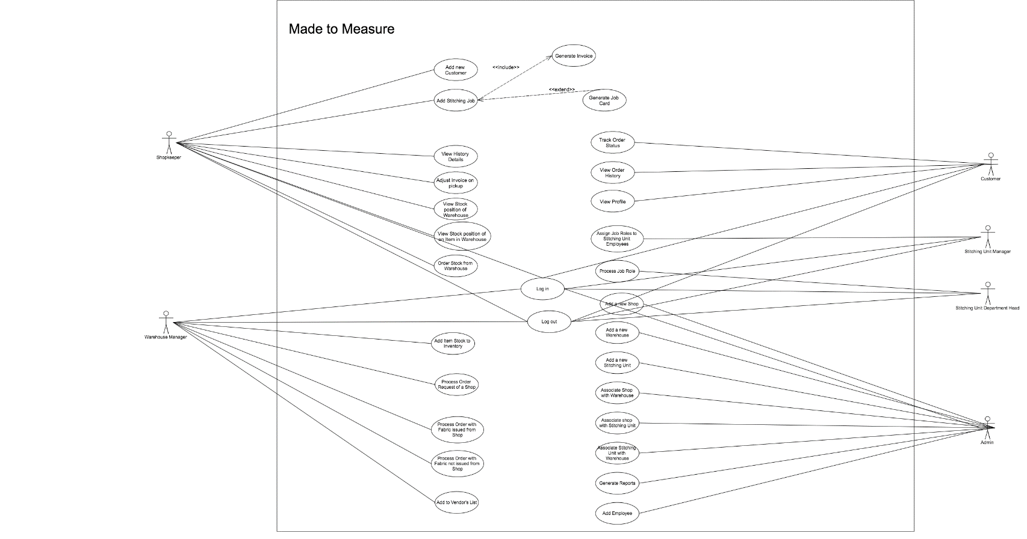

Figure 1: Use case Diagram

## Entity Relationship Diagram

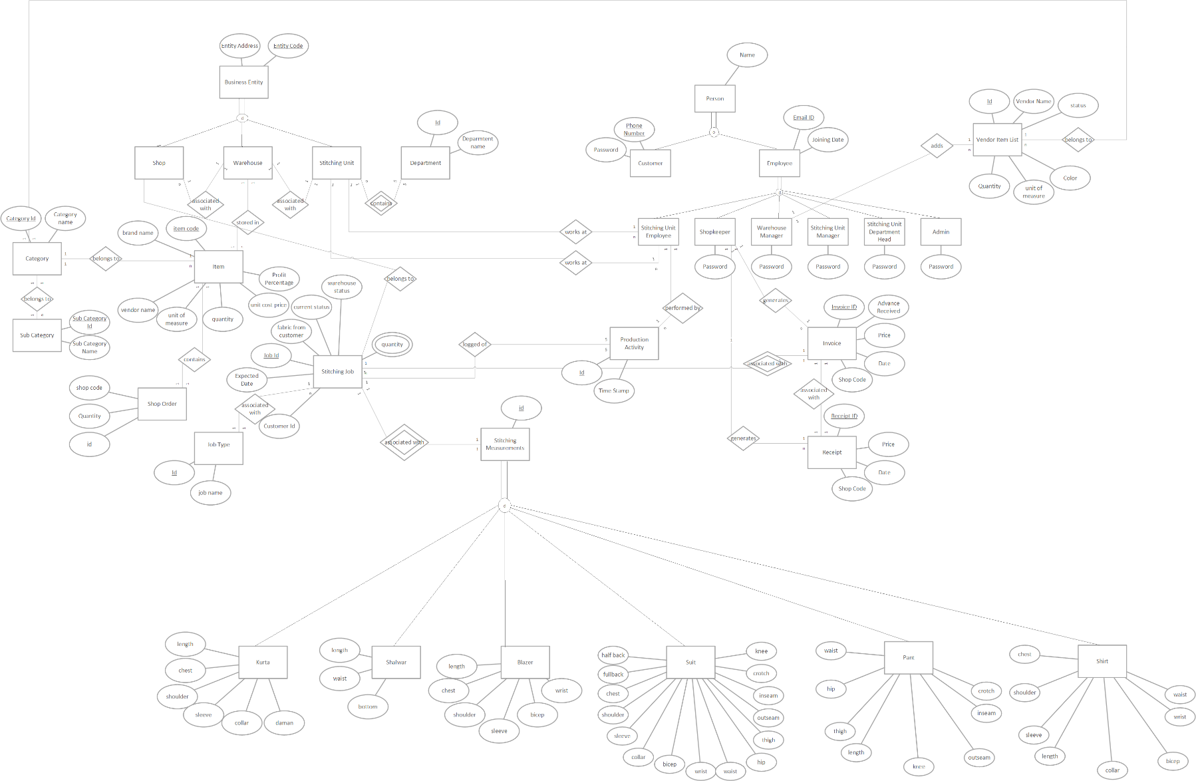

Figure 2: EER Diagram

## Class Diagram

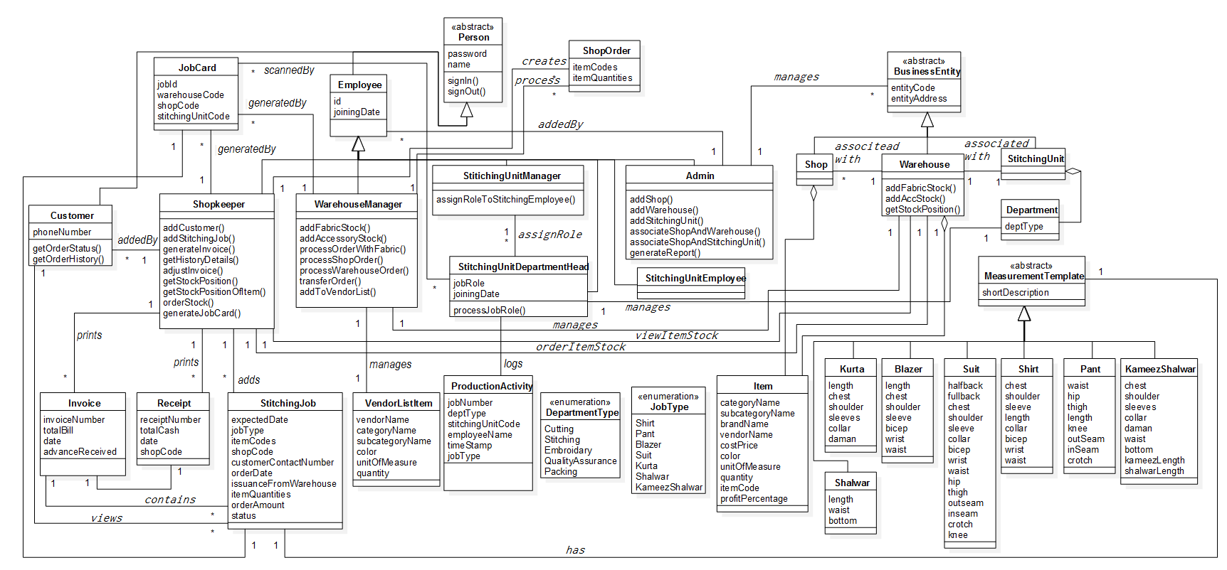

Figure 3: Class Diagram

## Data Flow Diagram

Figure 4: DFD level 0

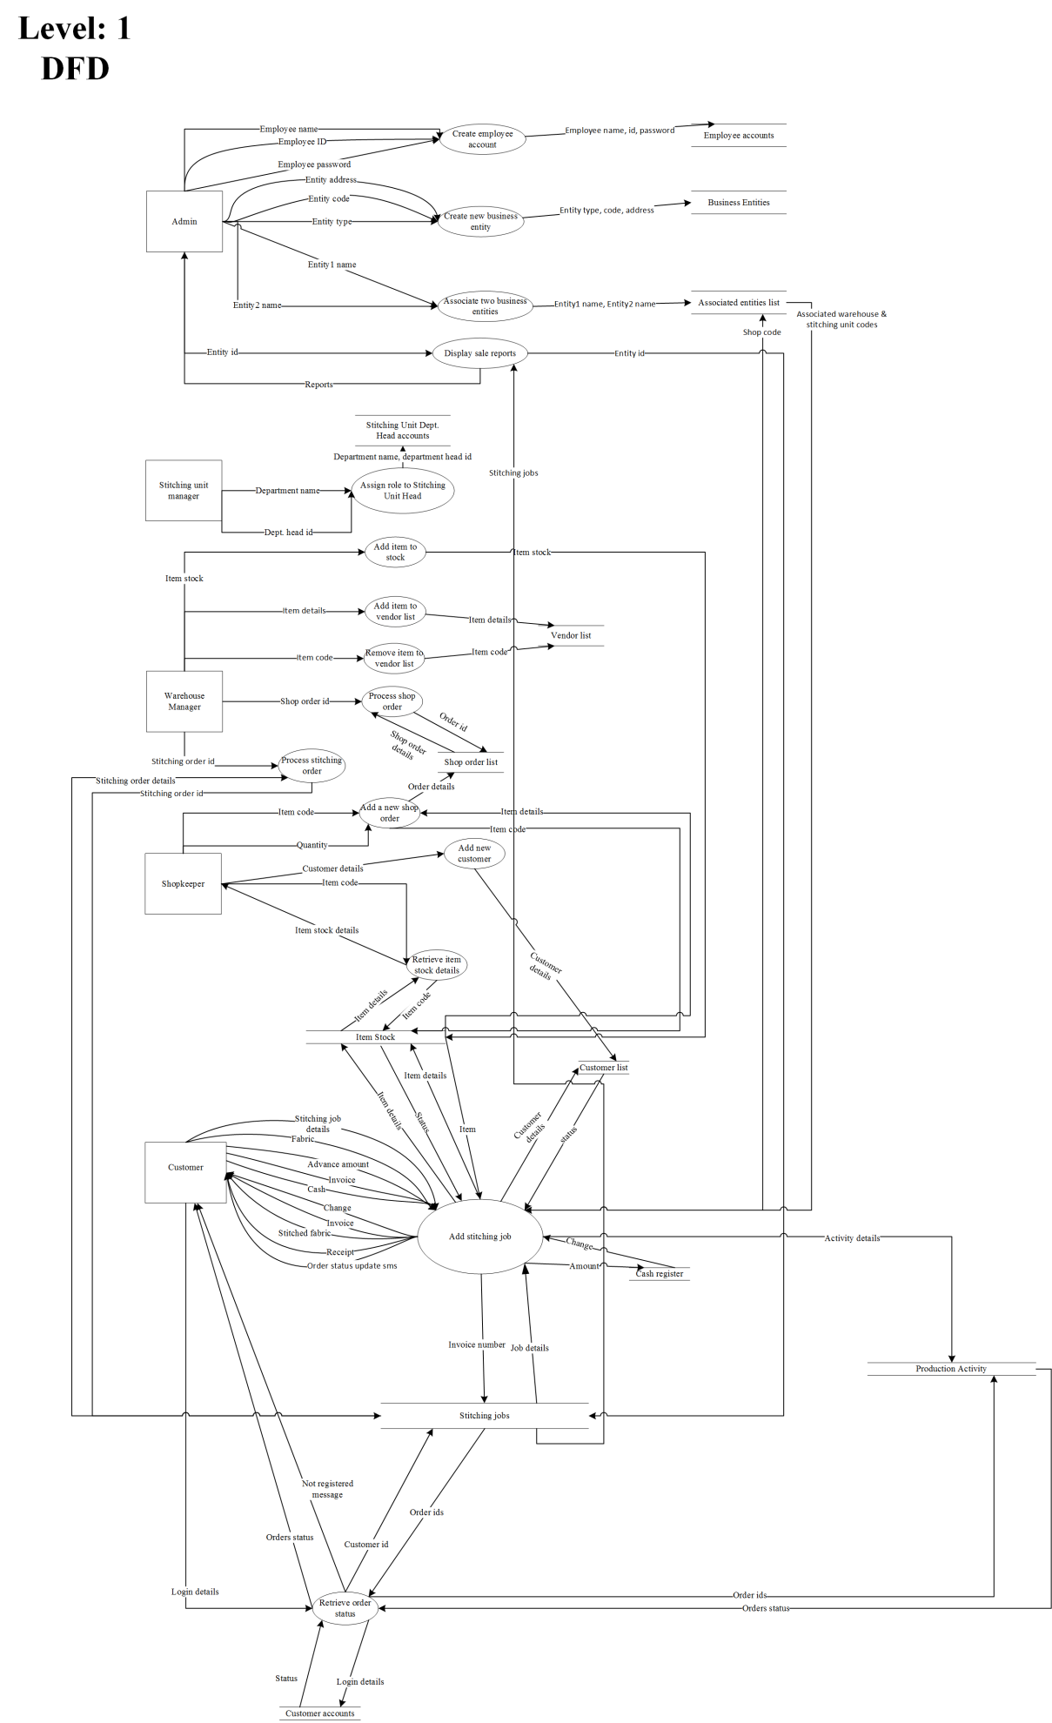

Figure 5: DFD Level 1

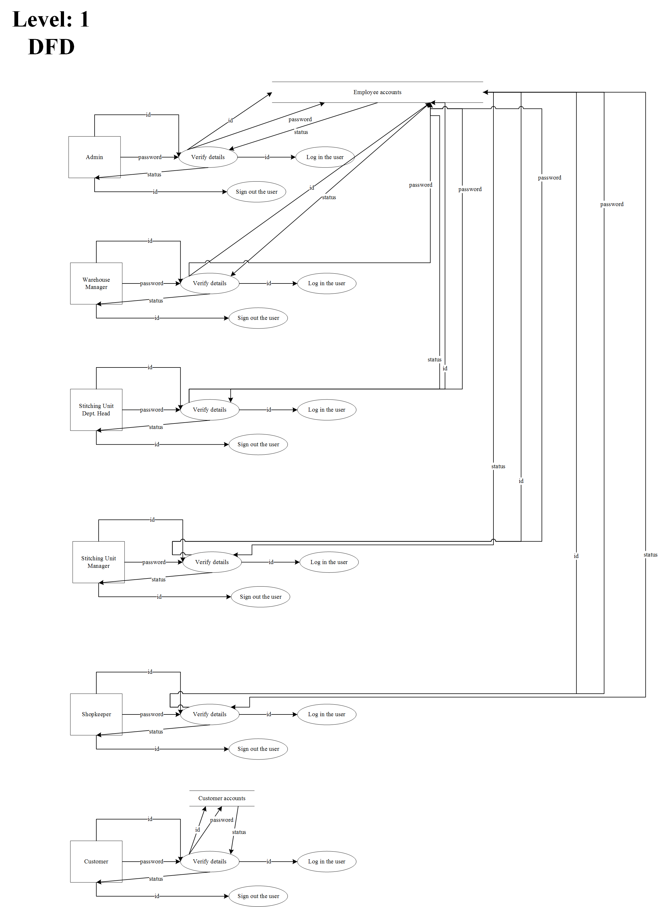

Figure 6: DFD Level1

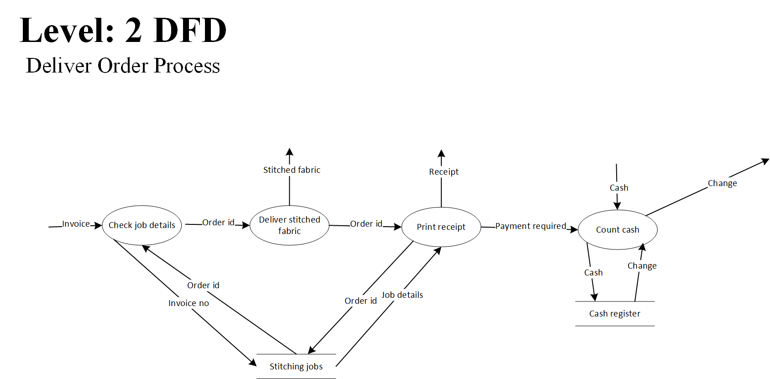

Figure 7: DFD Level2

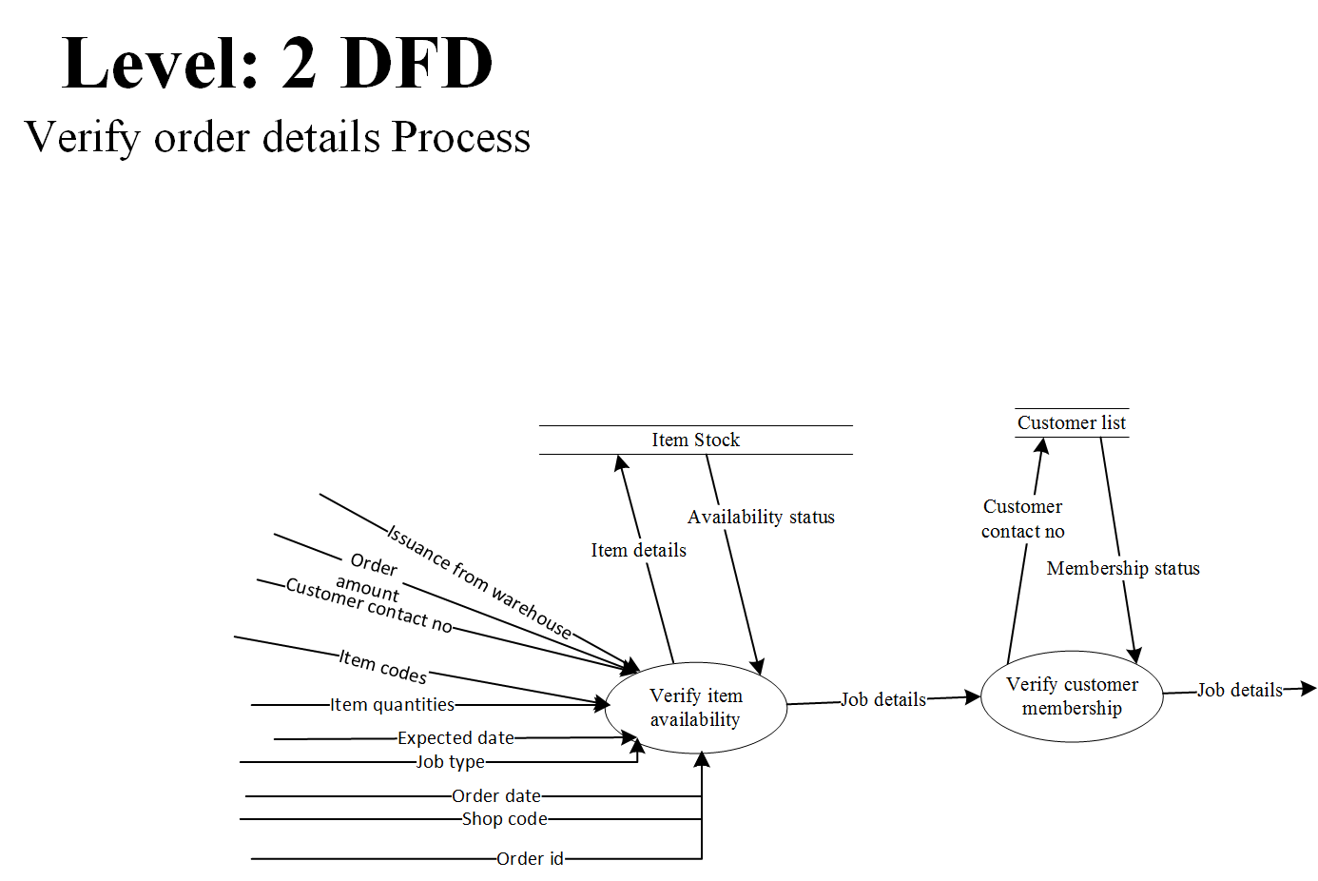

Figure 8: DFD Level2

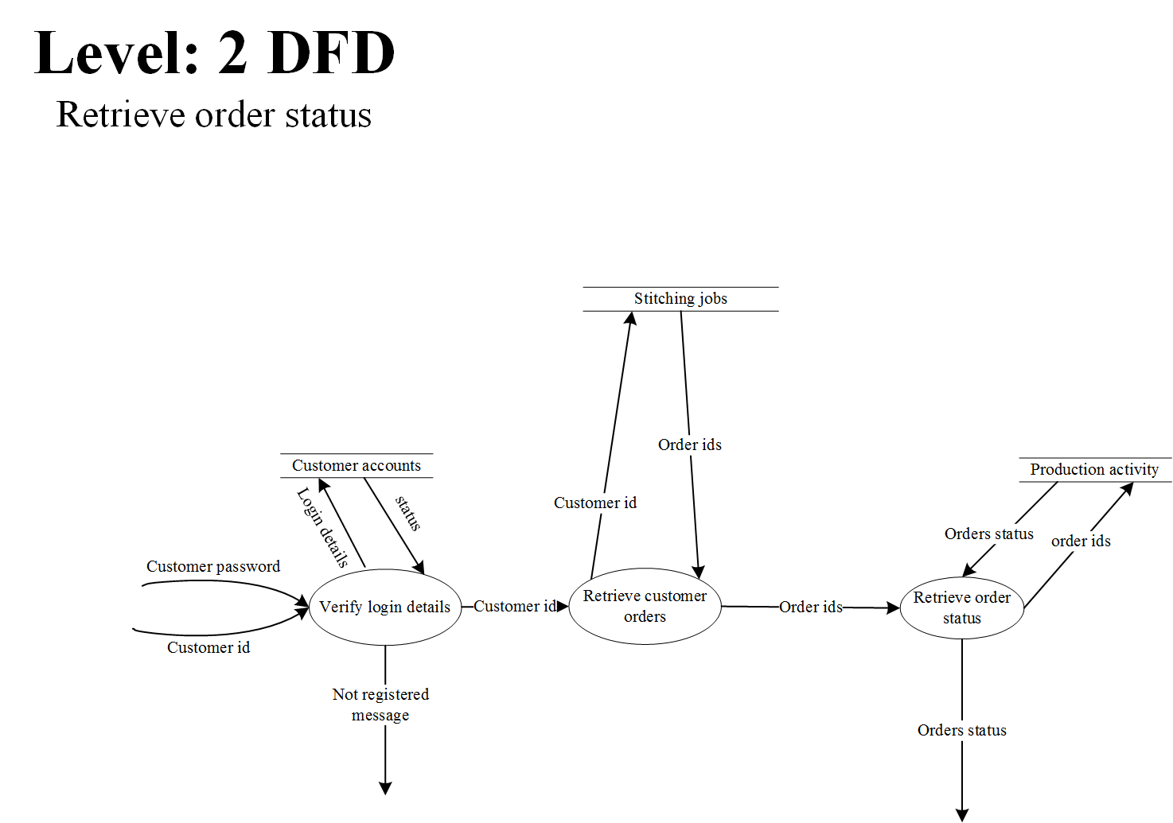

Figure 9: DFD Level2

Figure 10: DFD Level2

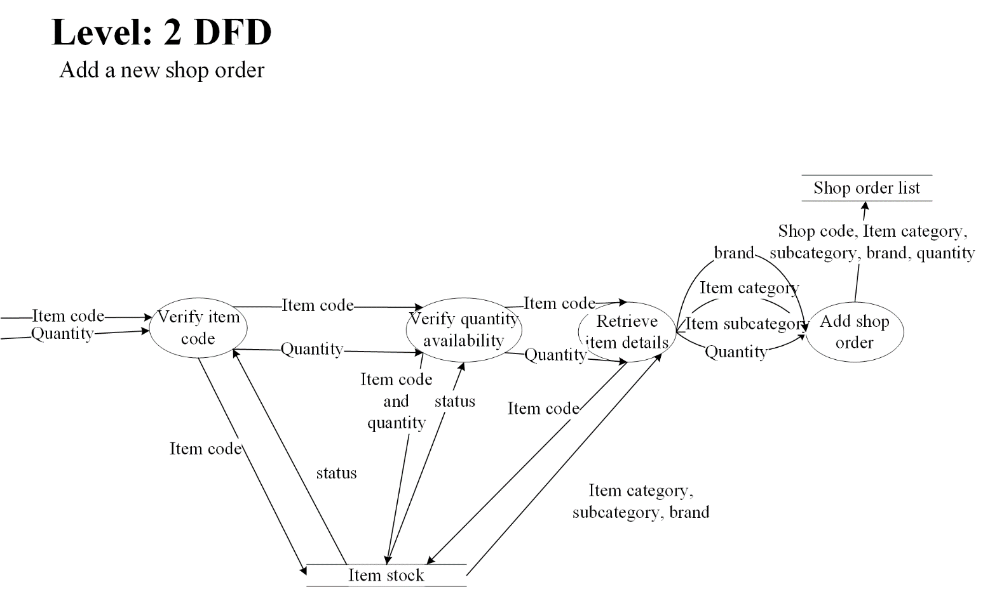

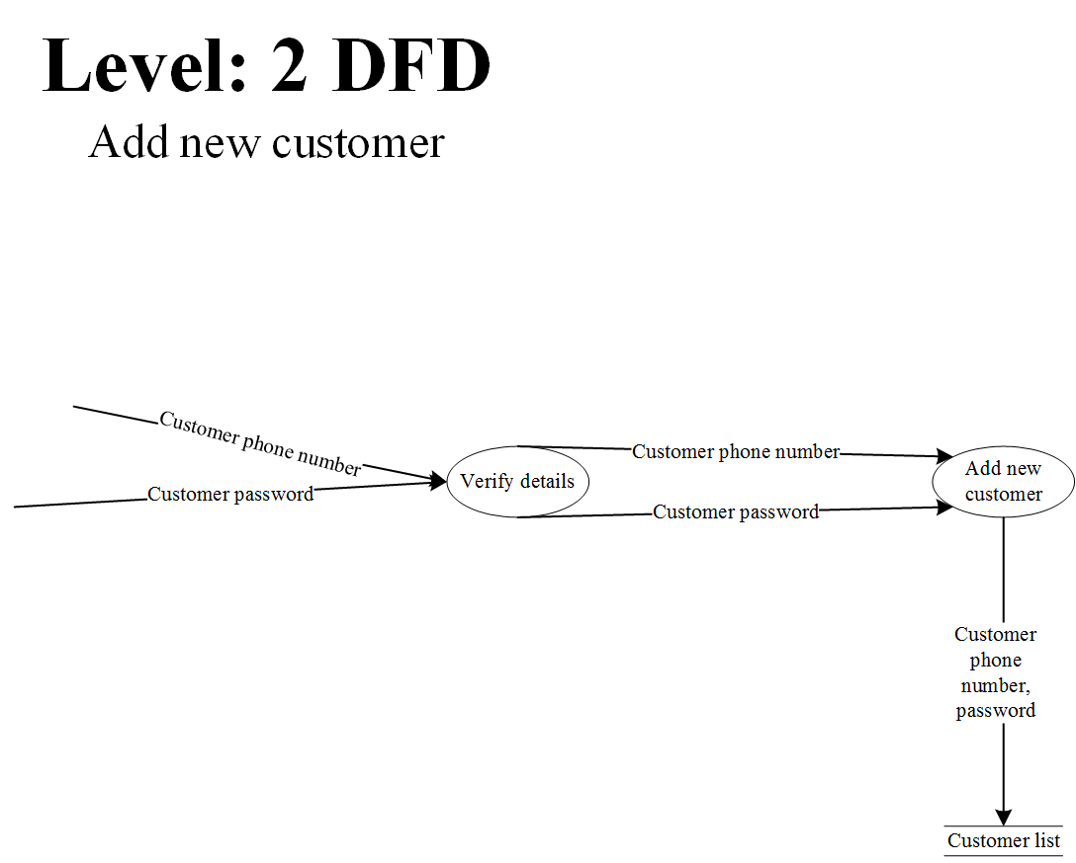

Figure 11: DFD Level2

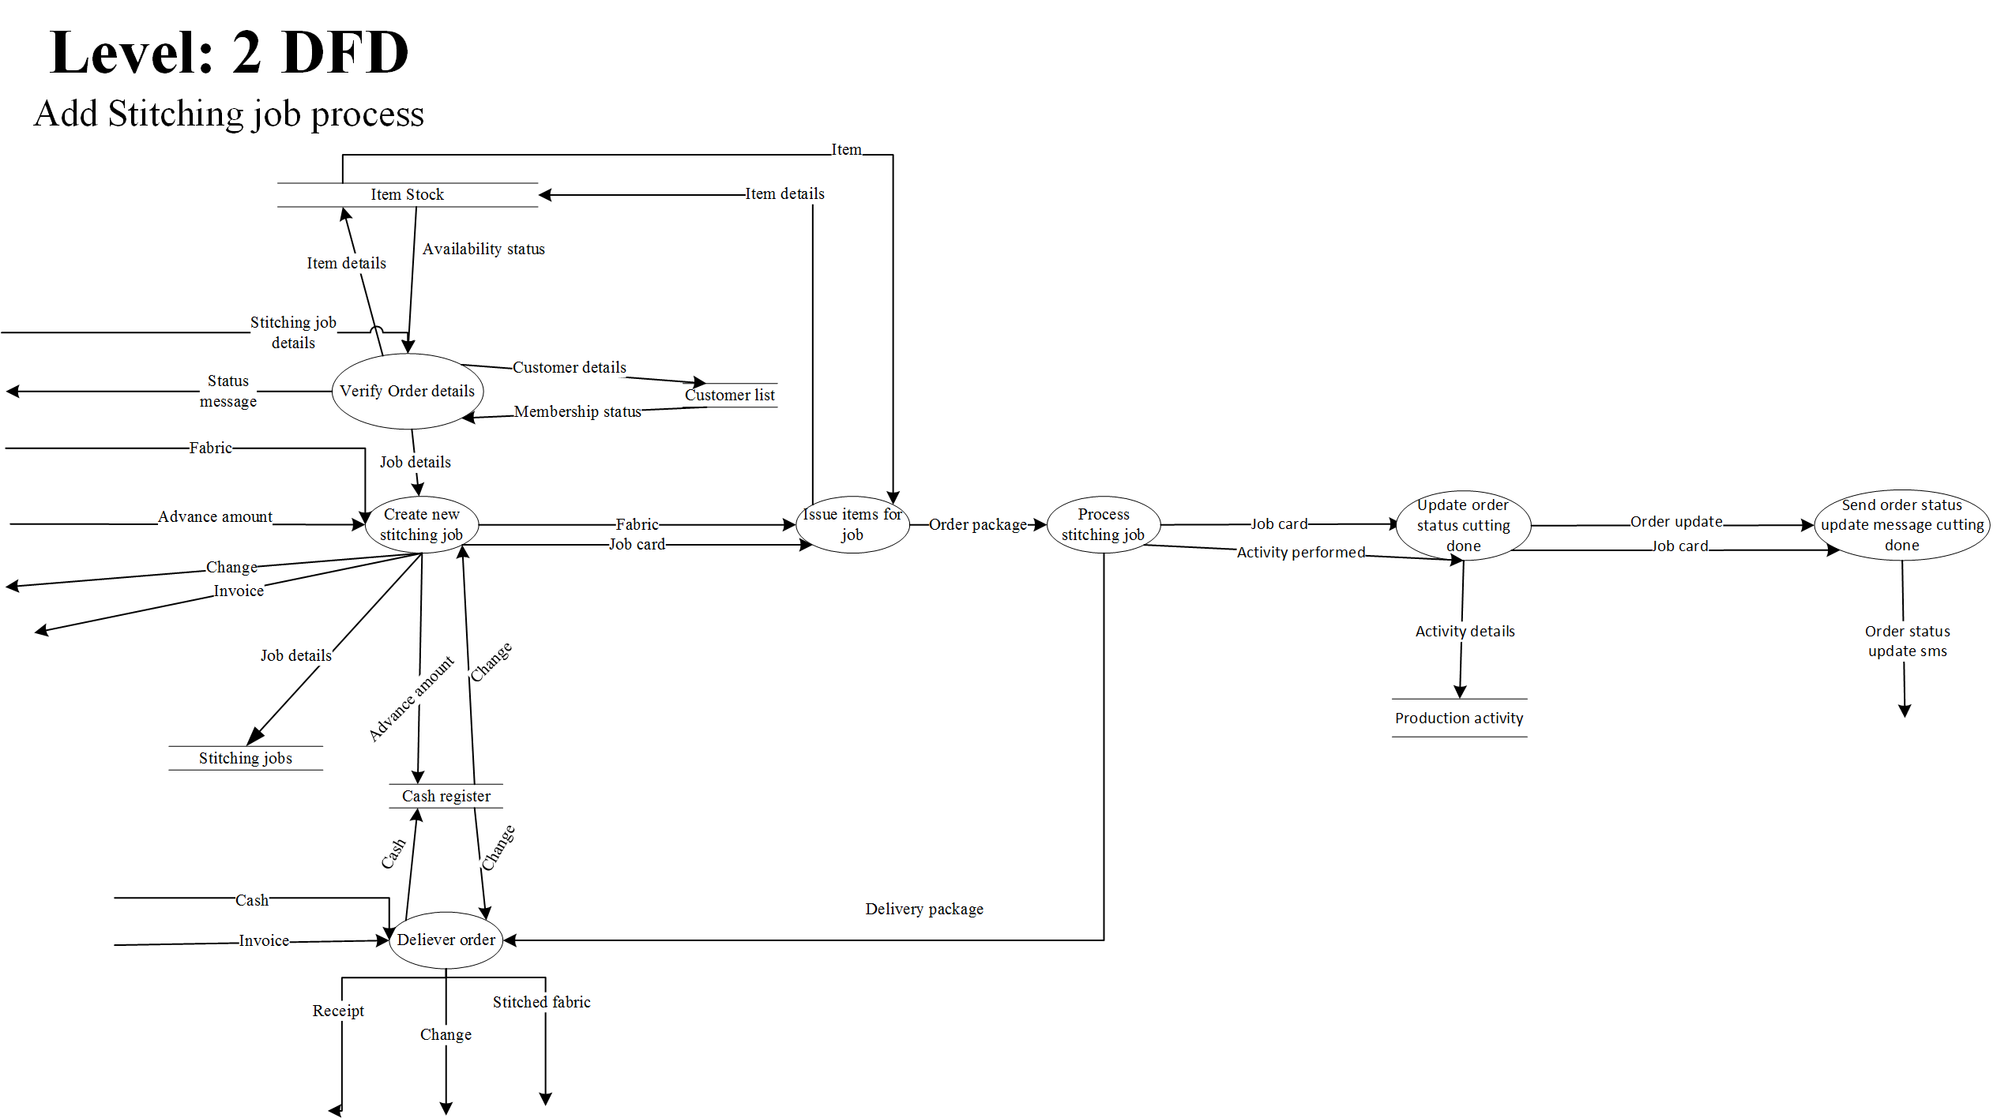

Figure 12: DFD Level2

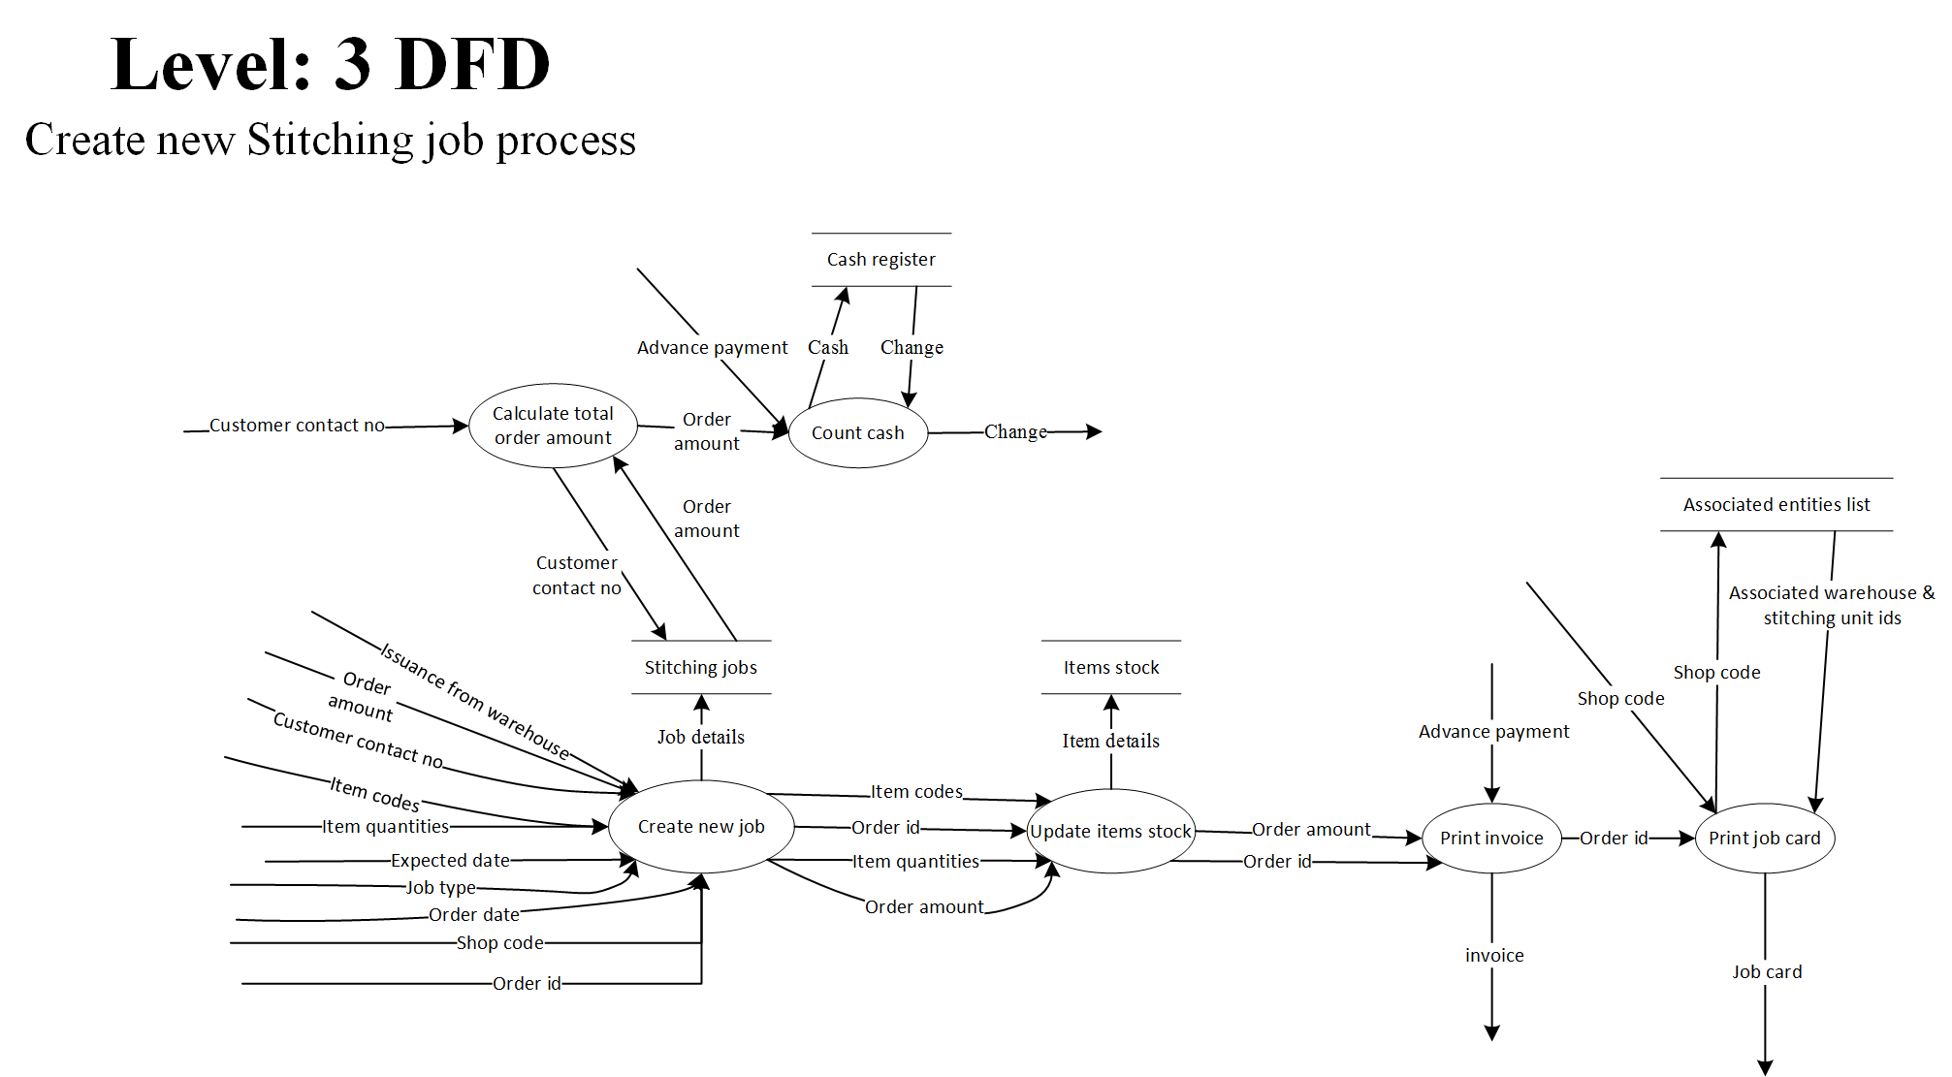

Figure 13: DFD Level3

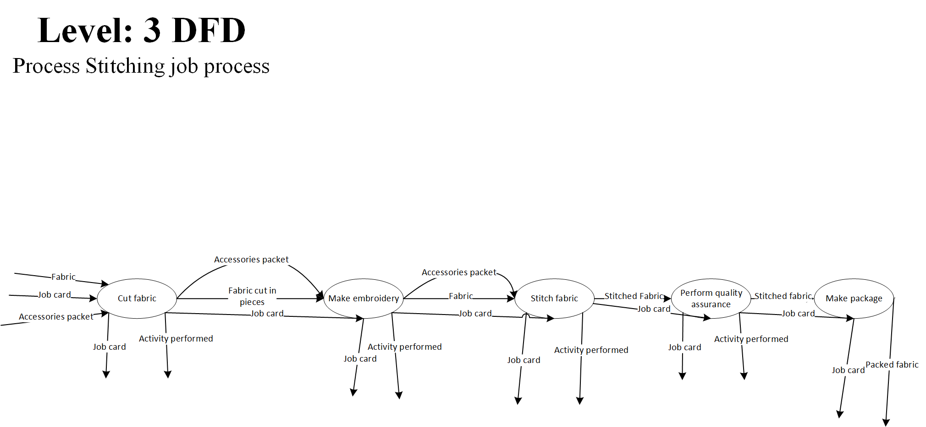

Figure 14: DFD Level3

# Appendix C: Design Models

## Component Diagram

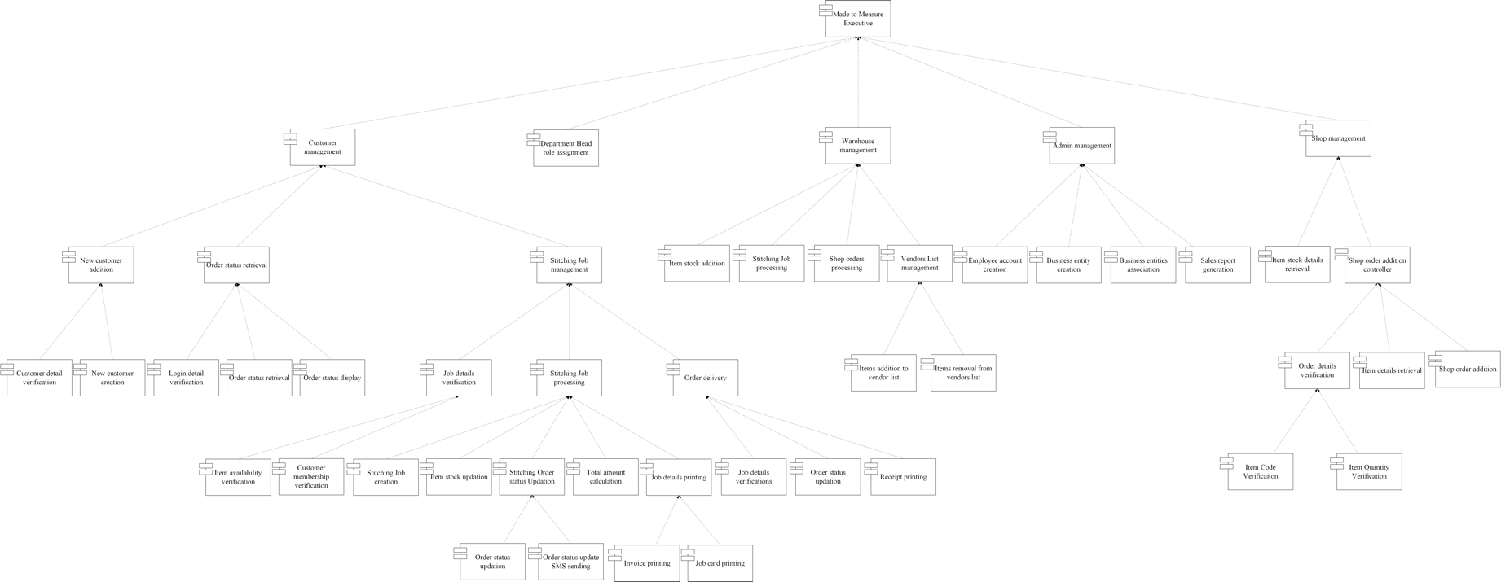

Figure 15: Component Diagram

# Appendix D: Screenshots

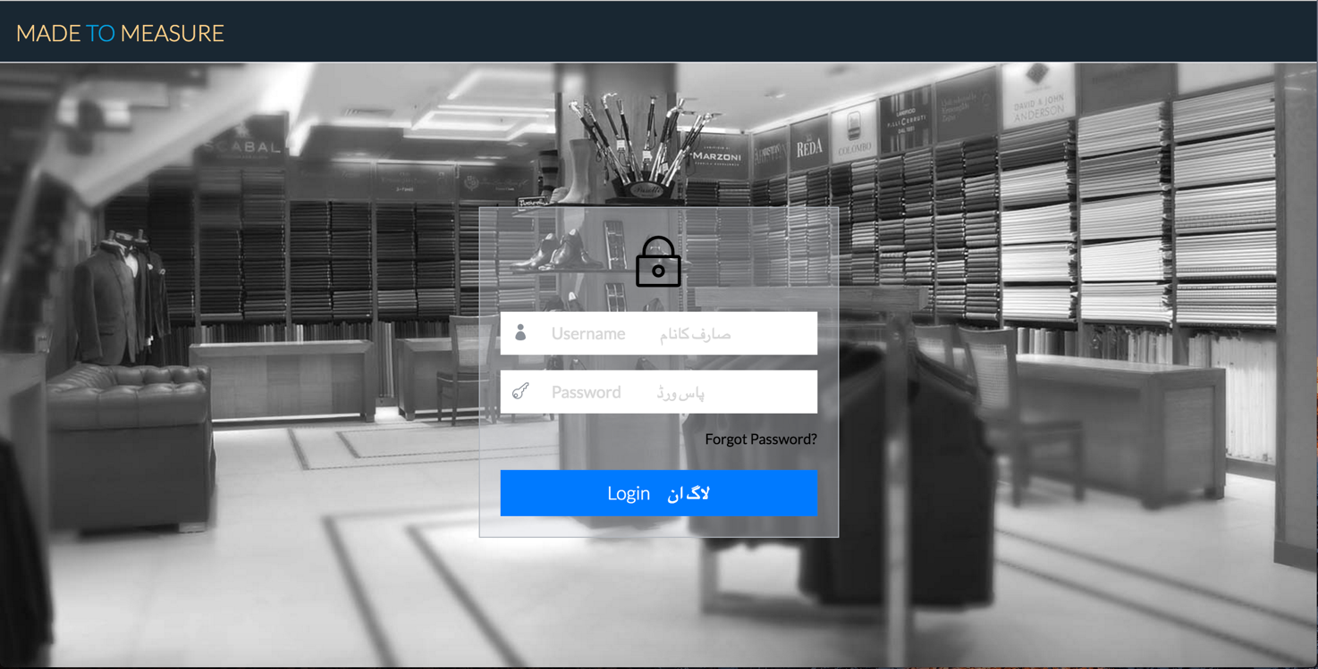Login

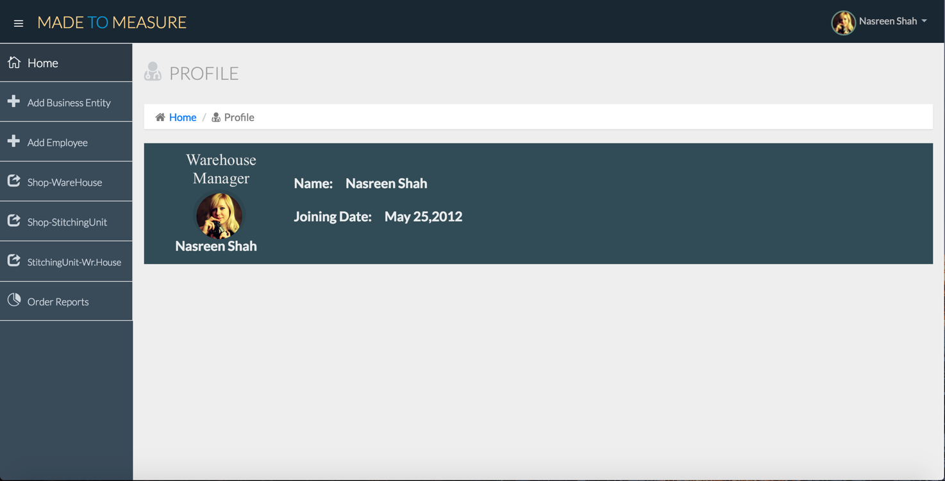Warehouse Manager Profile

Add item stock

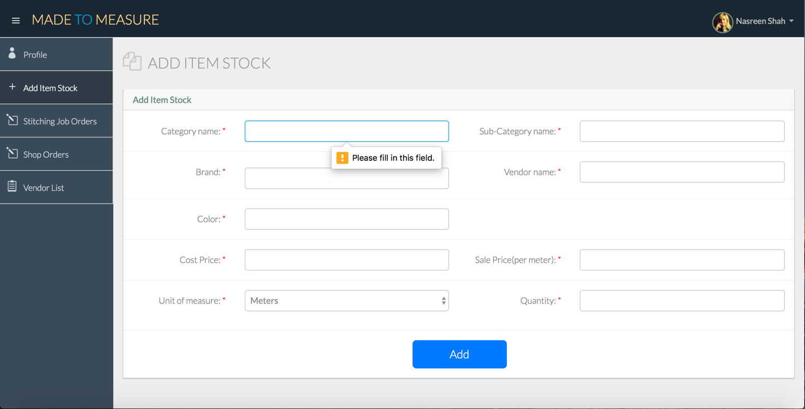

Process Shop Orders

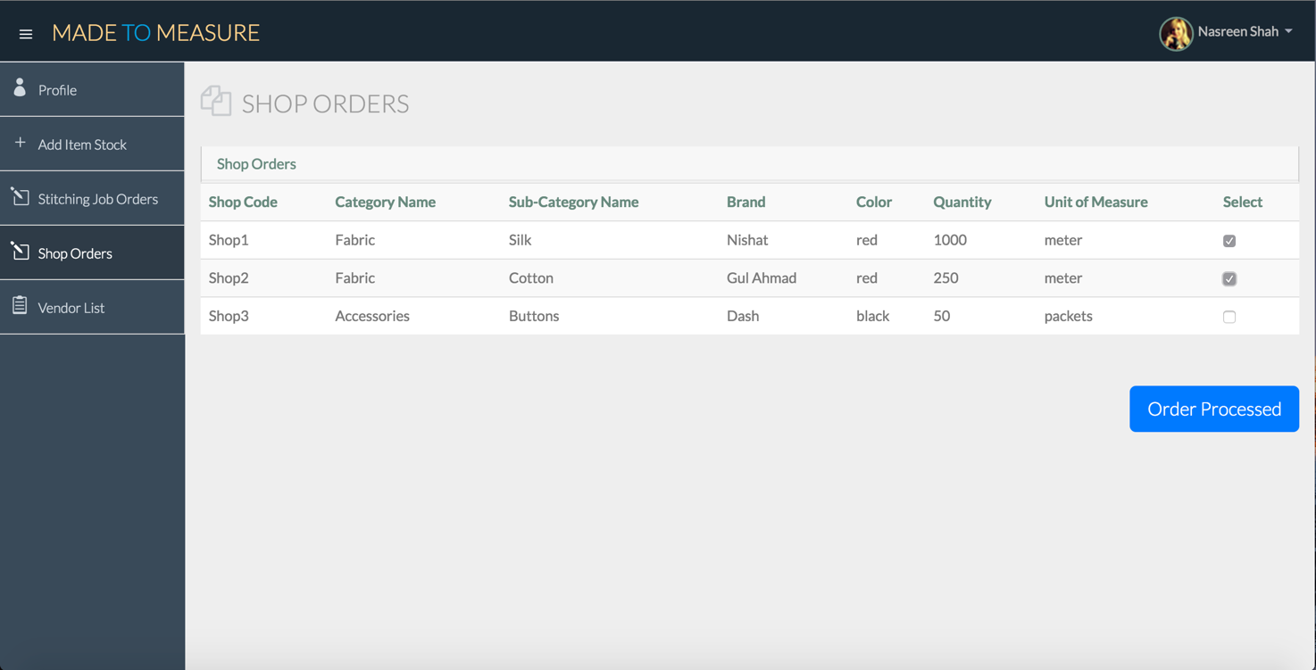

Stitching Orders

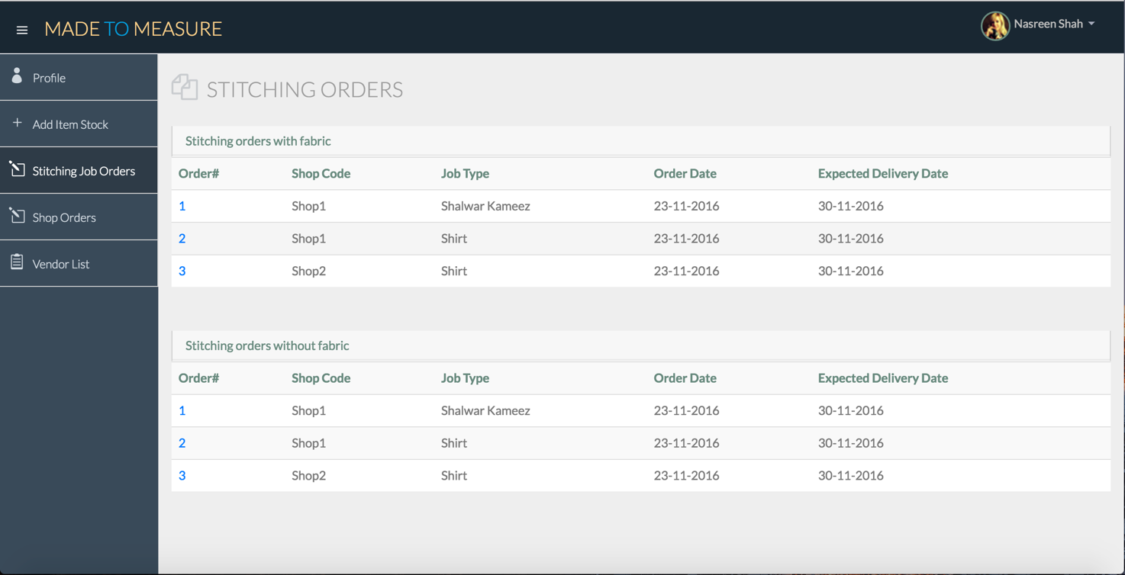

Process Stitching Order with Fabric

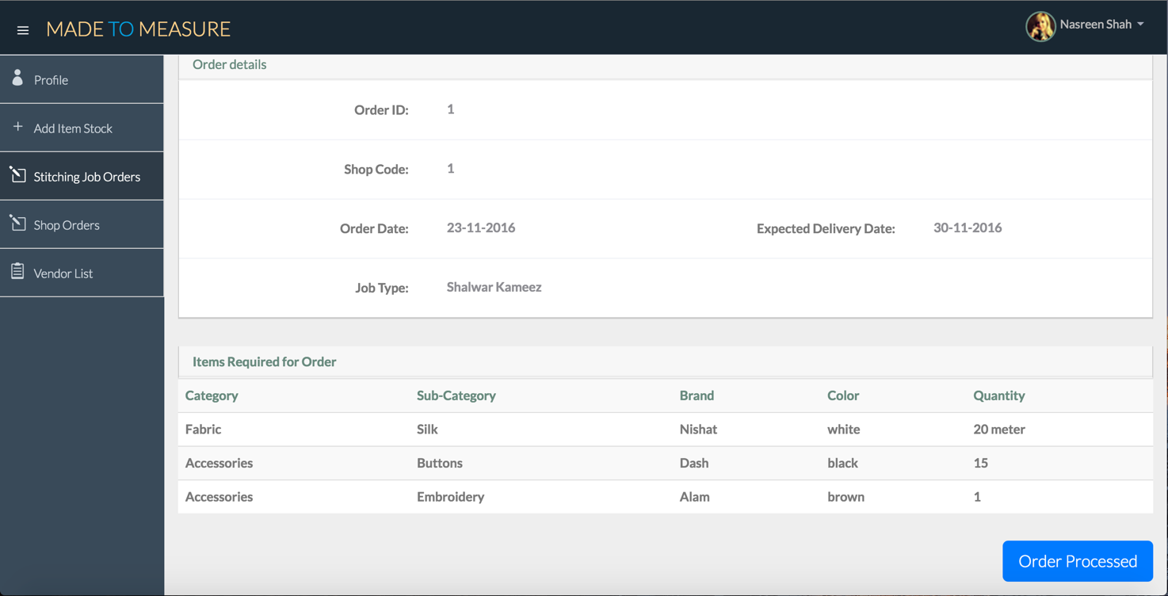

Process Stitching Order without Fabric

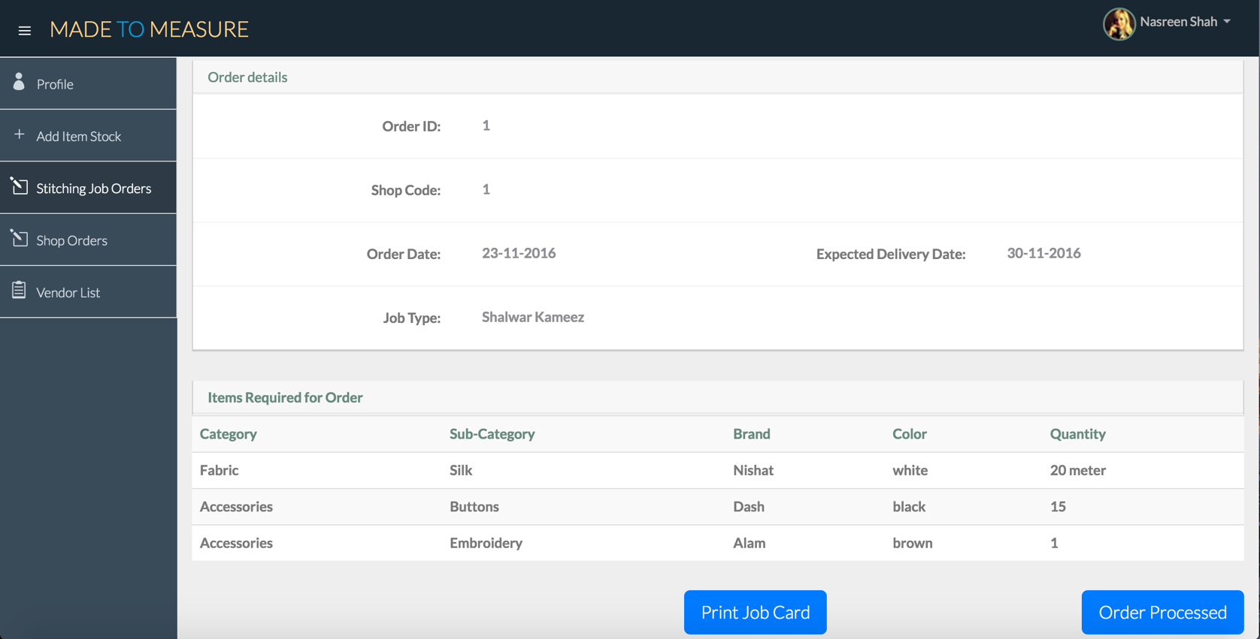

Add to Vendor List

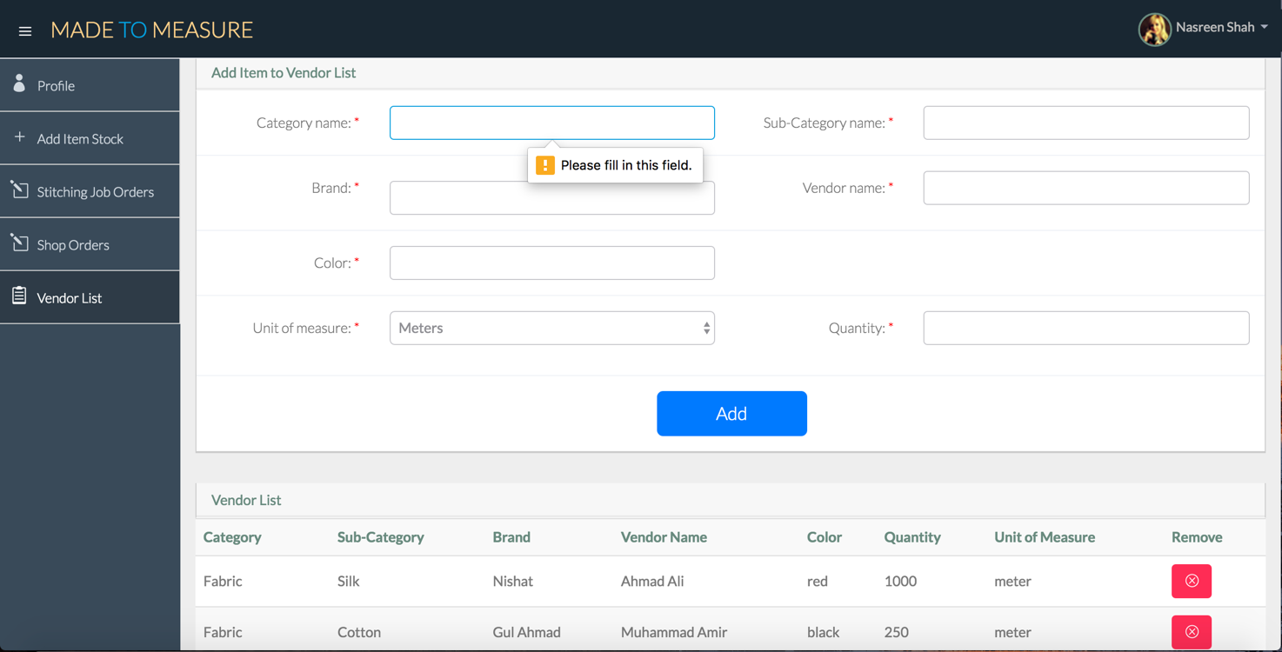

Shopkeeper Profile

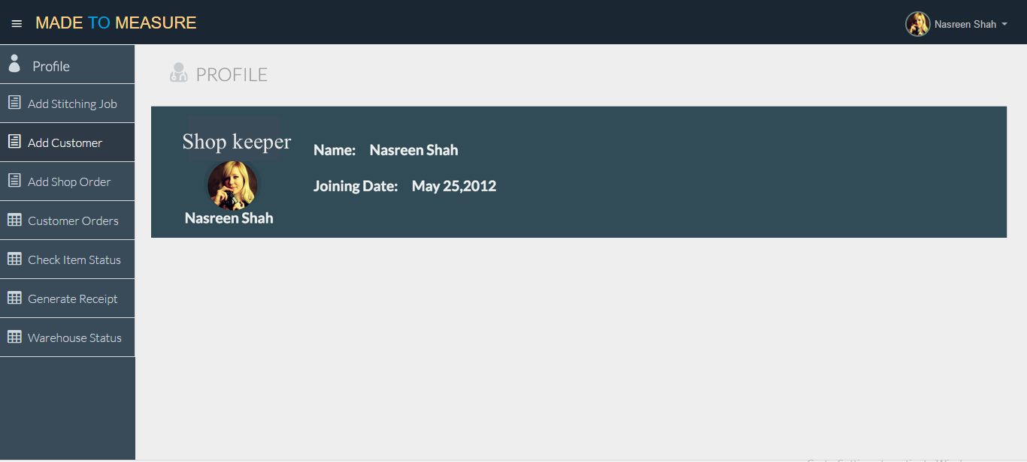

Add customer

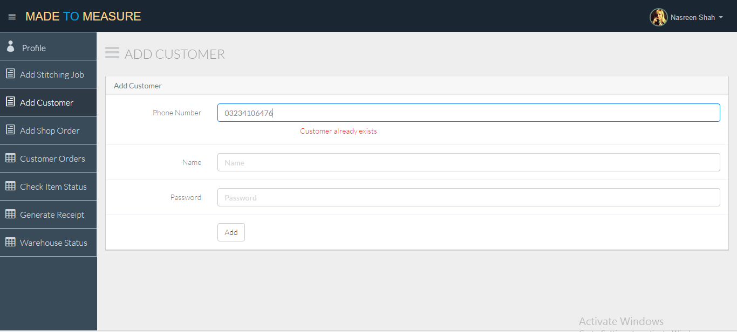

Add shop Order

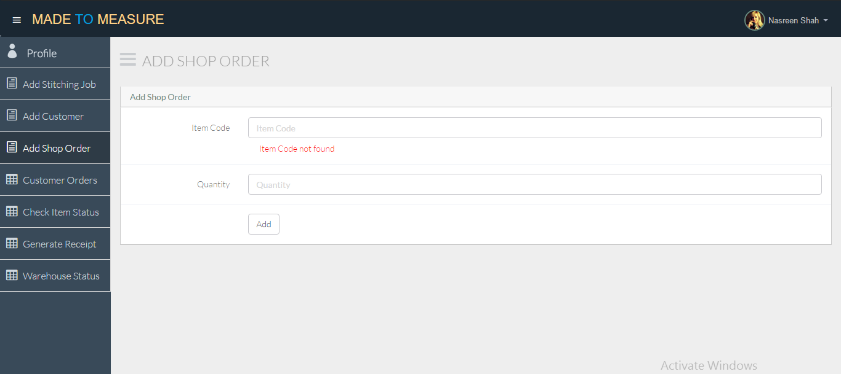

Add stitching job

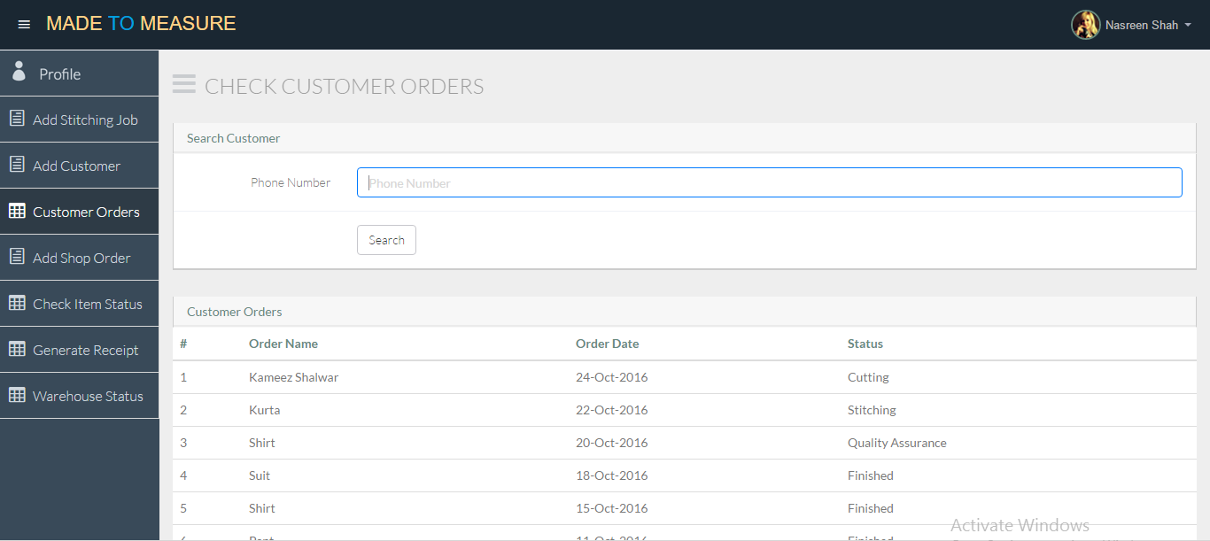

Check Customer Orders



Check Item Status

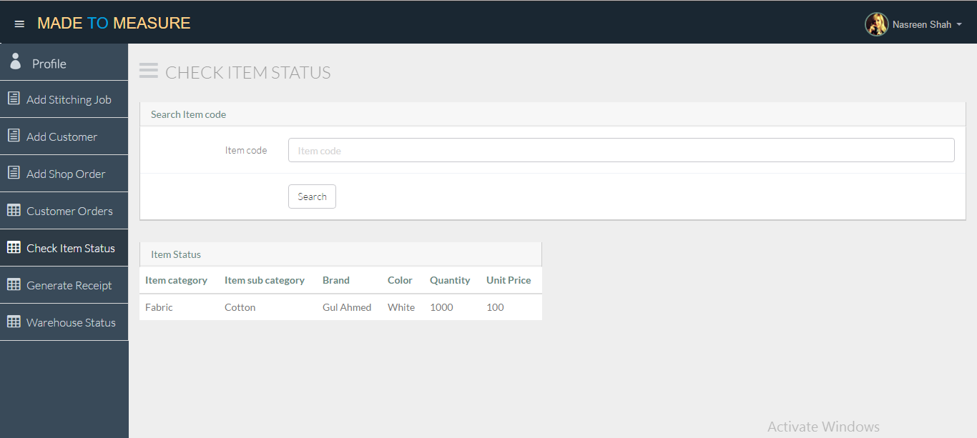

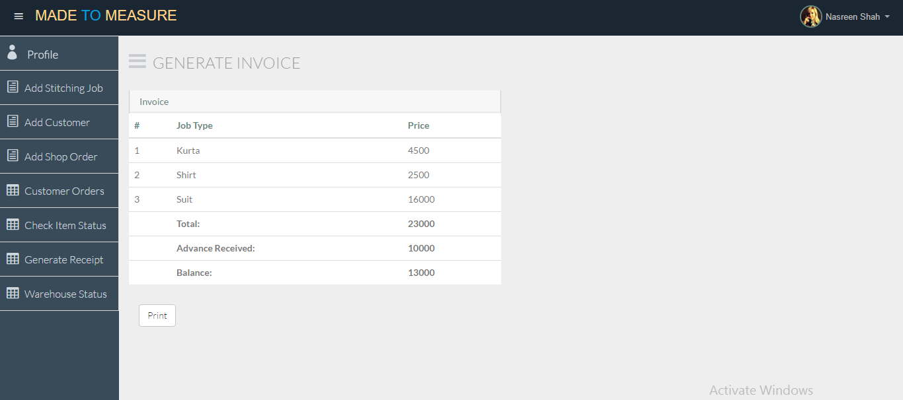Generate Invoice

Generate Receipt

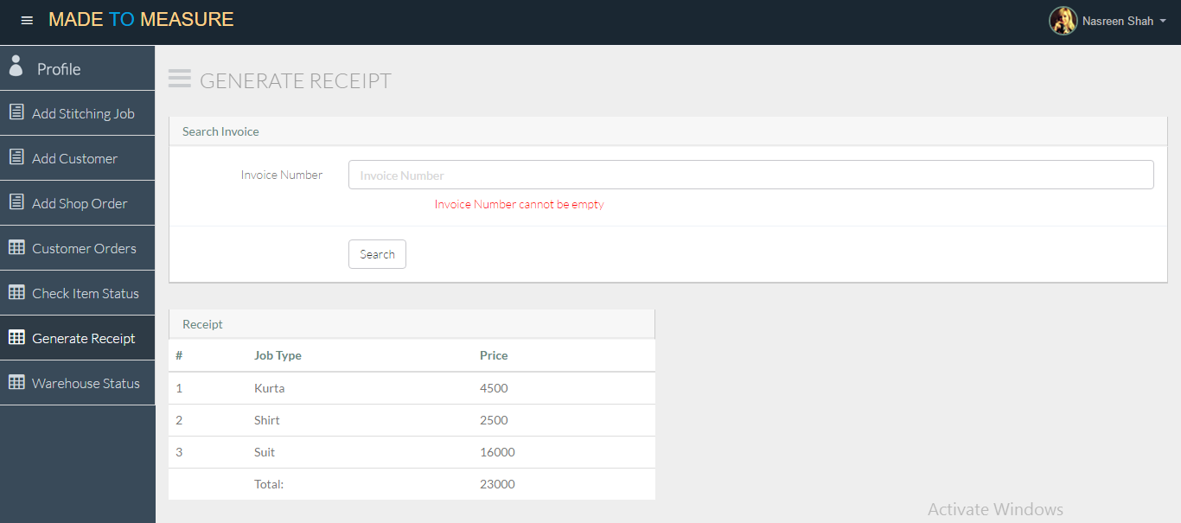

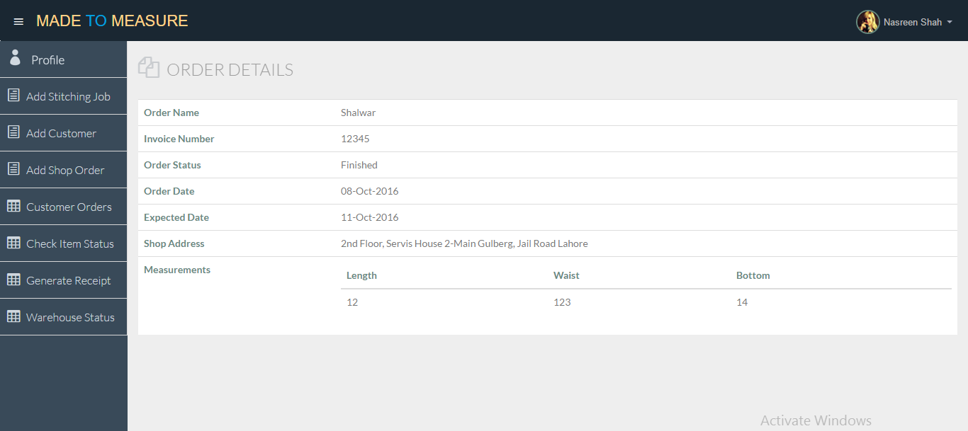Order details

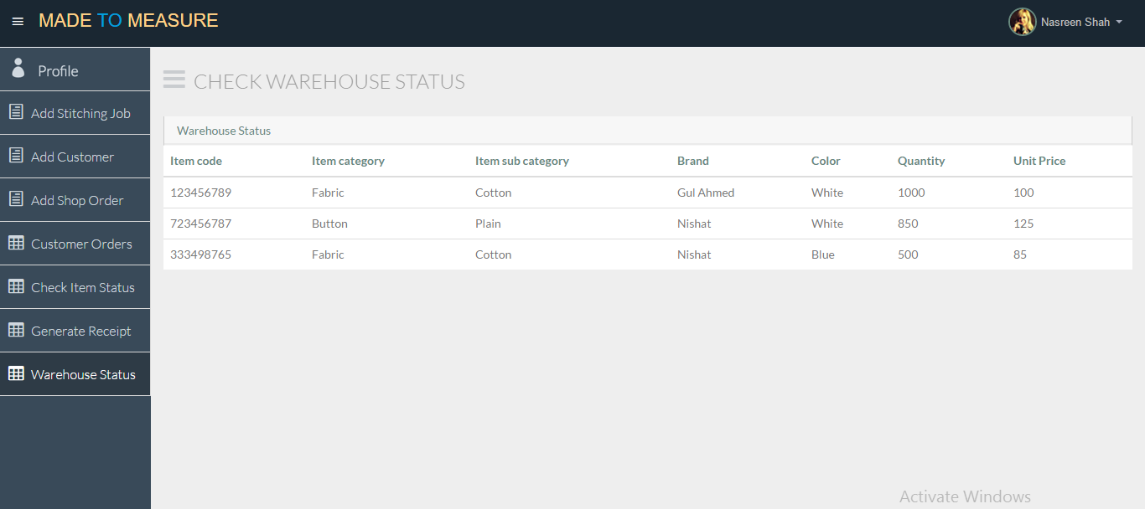Warehouse Stock Status

Admin Profile

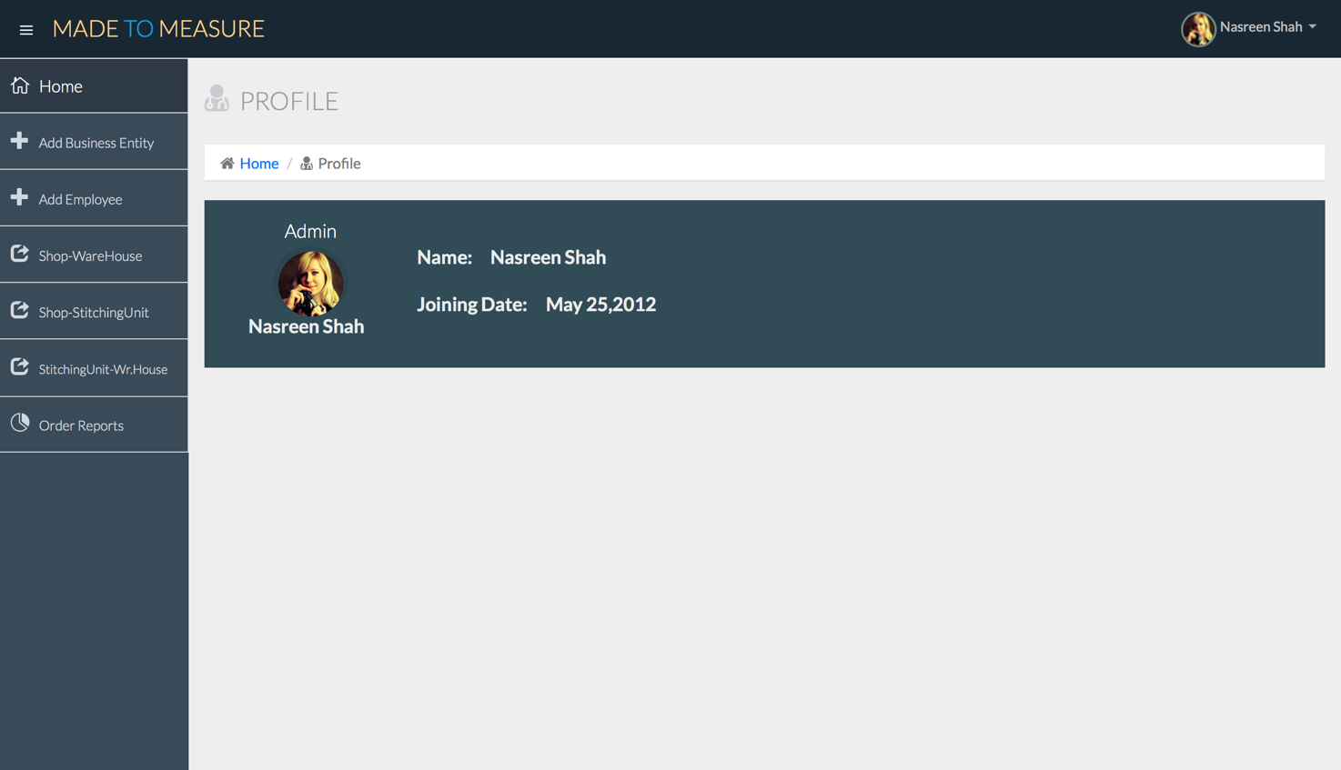

Link Shop and Stitching Unit

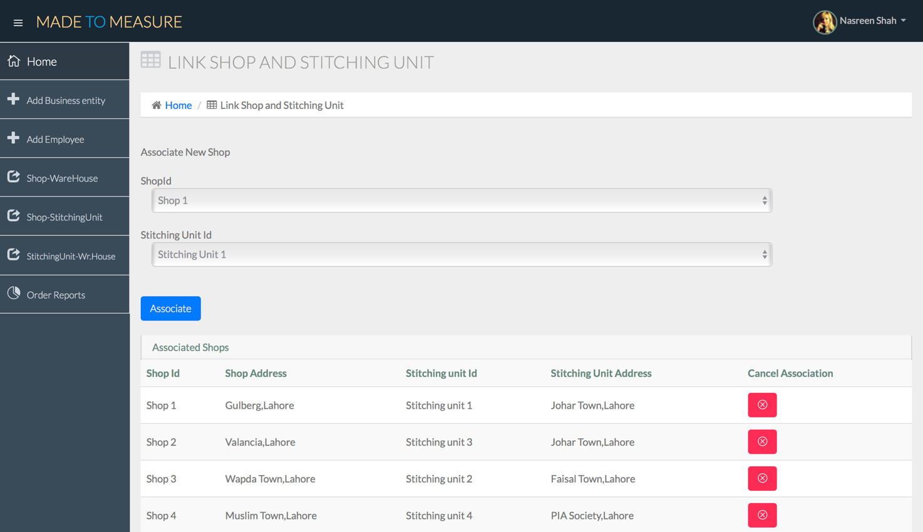

Link shop and warehouse

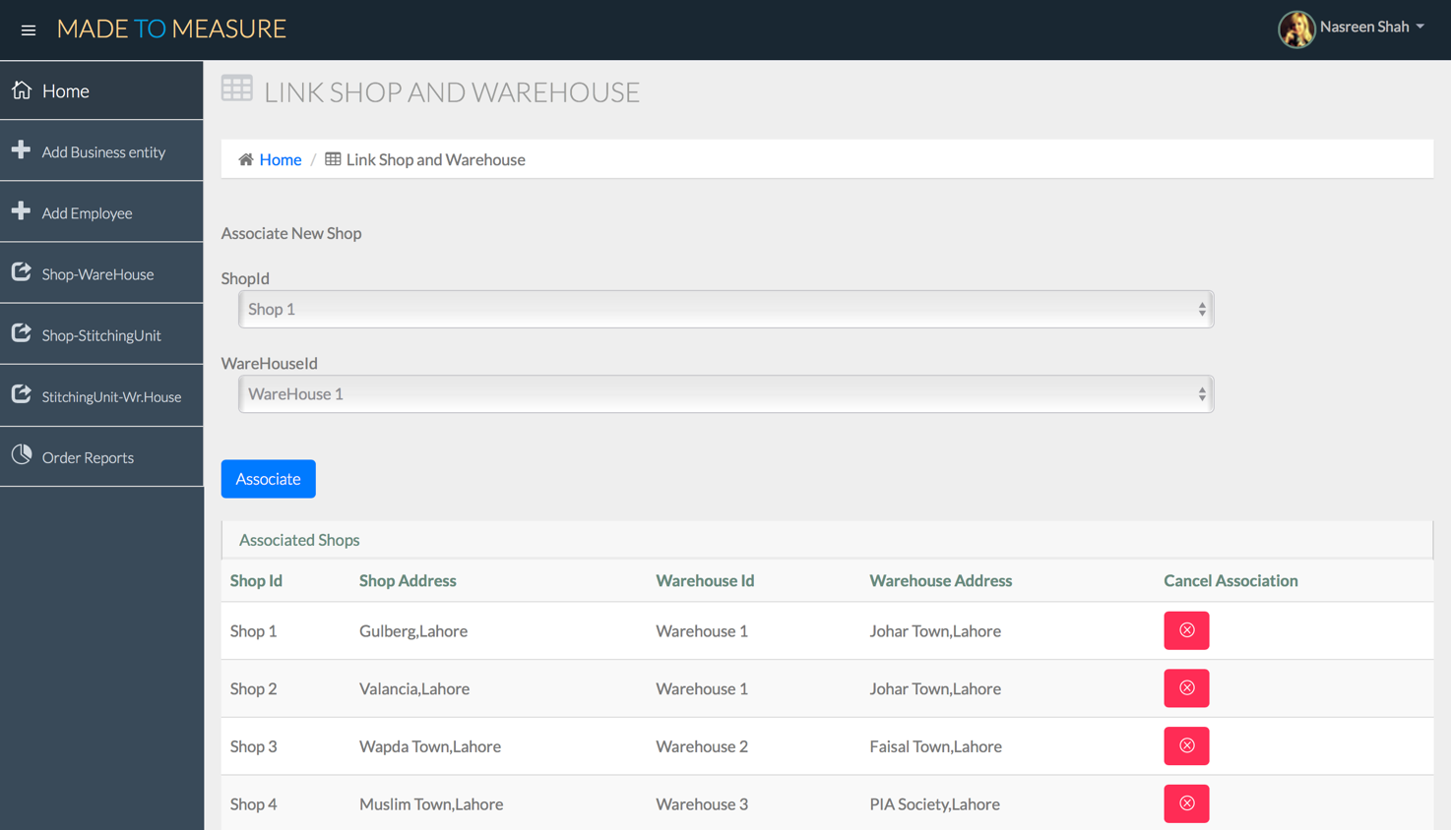

Link warehouse and stitching unit

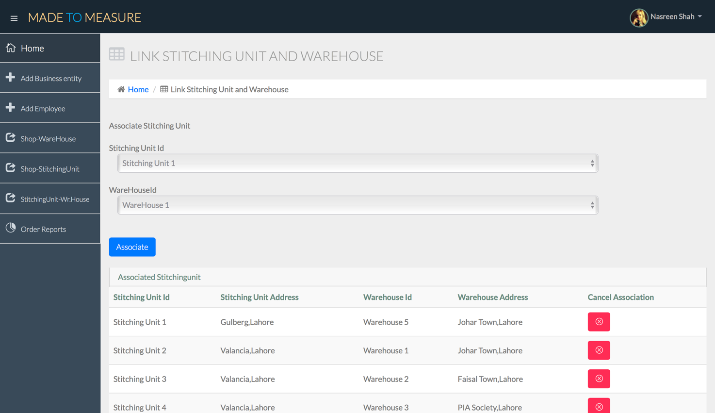

Add Warehouse

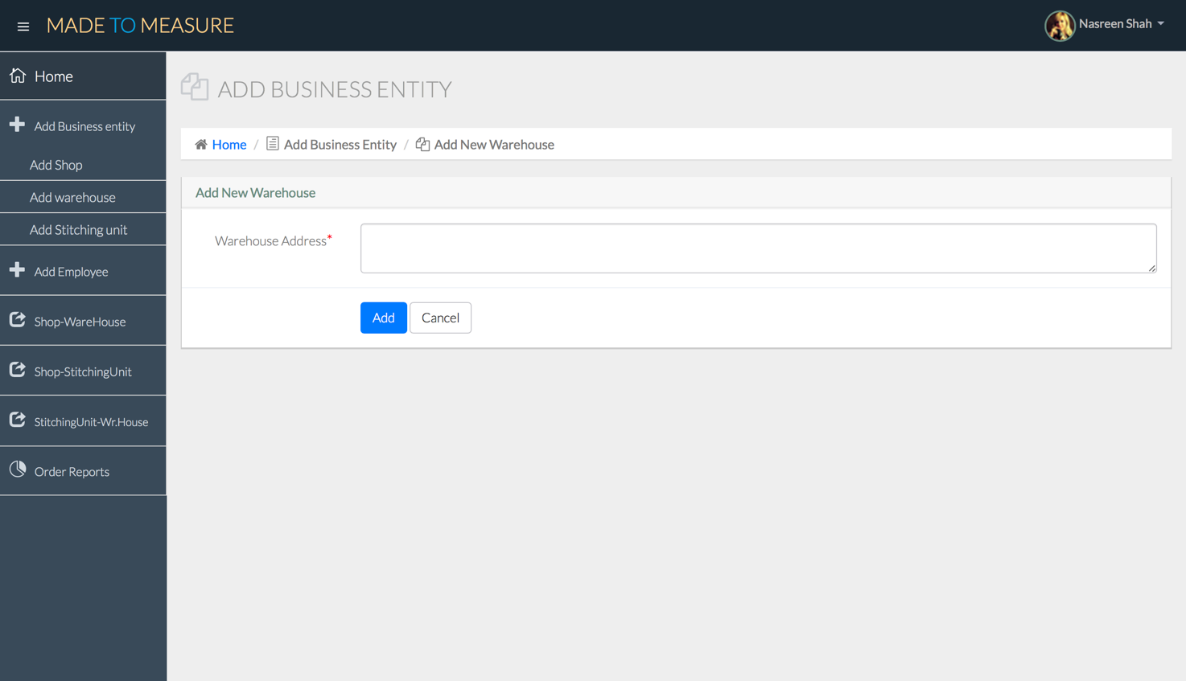

Add Warehouse Validation

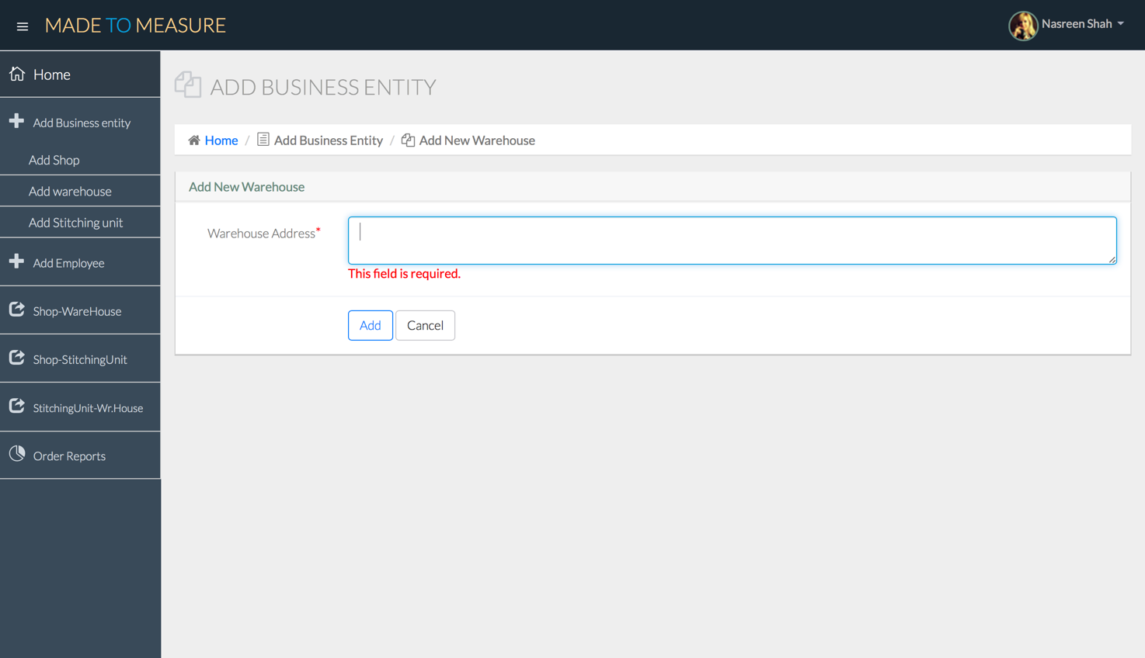

Add Employee

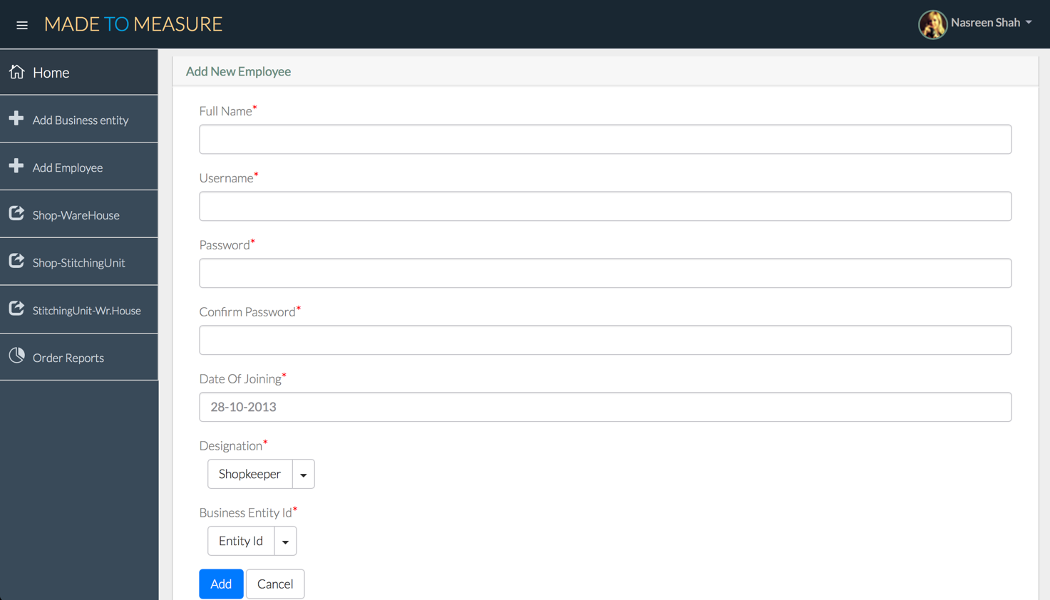  
  
Add Employee Validations

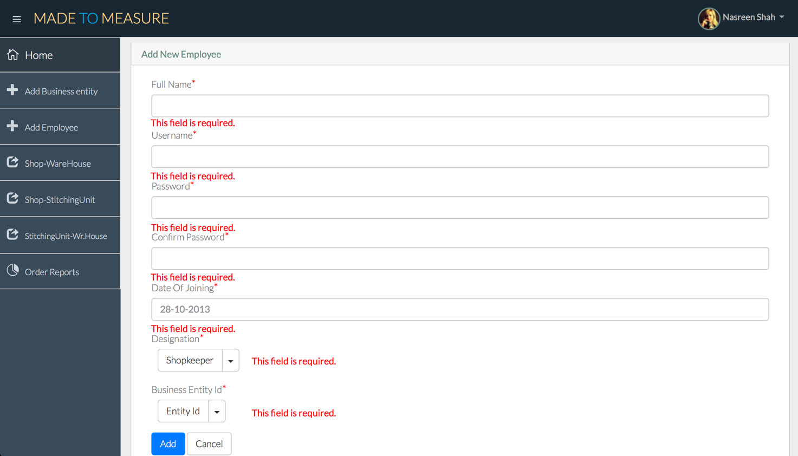

Add Stitching Unit

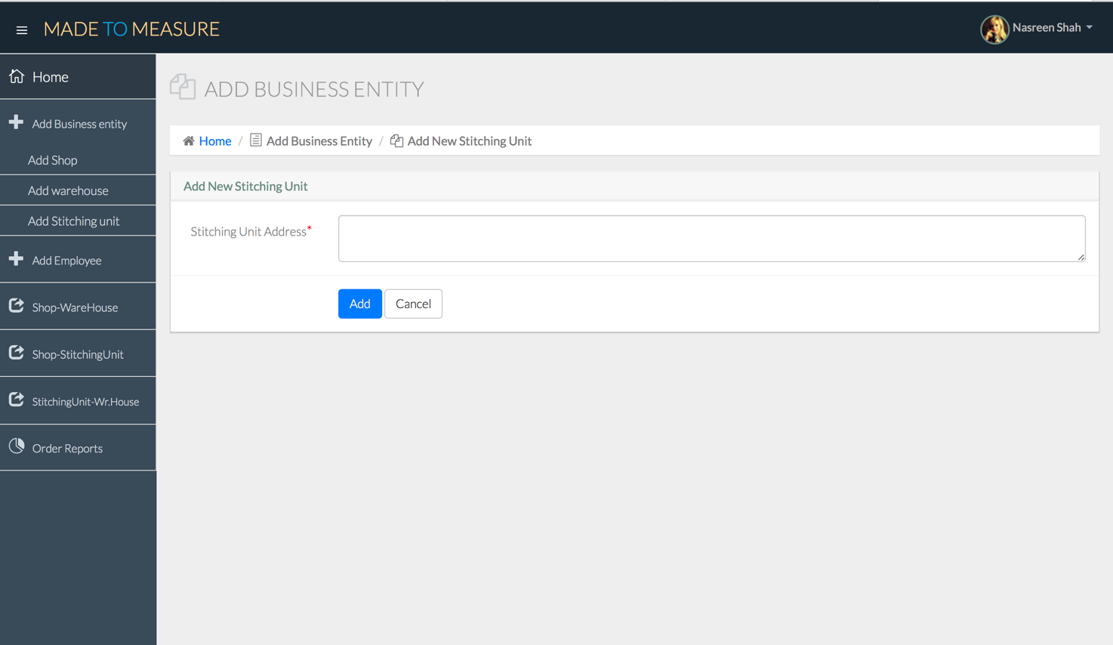  
  
Add Stitching Unit Validation

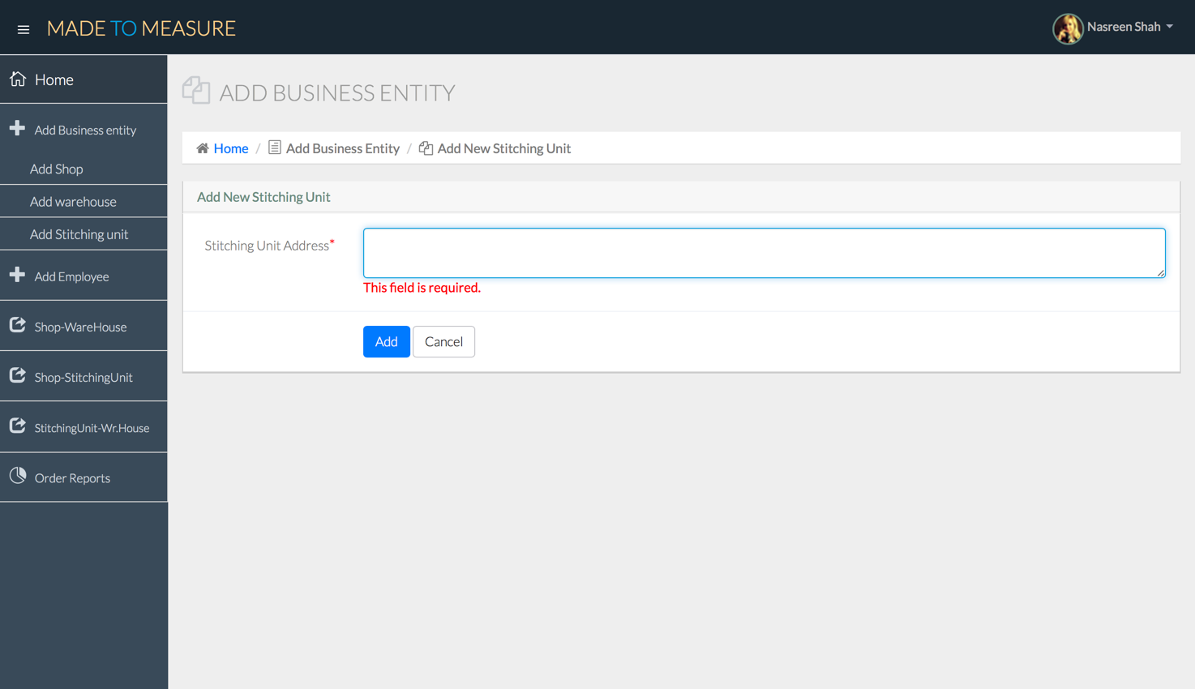

Add shop

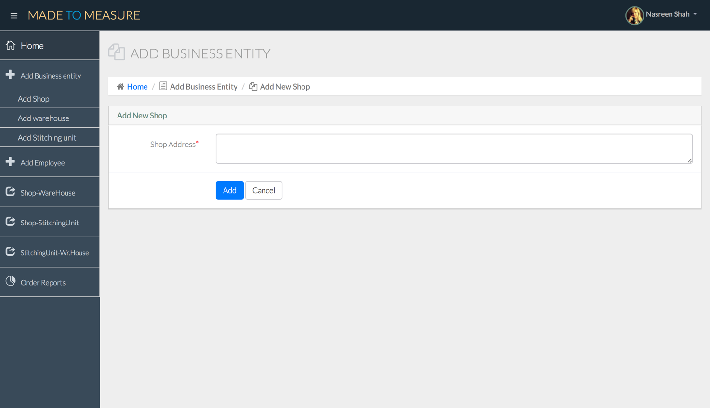

Add shop validations

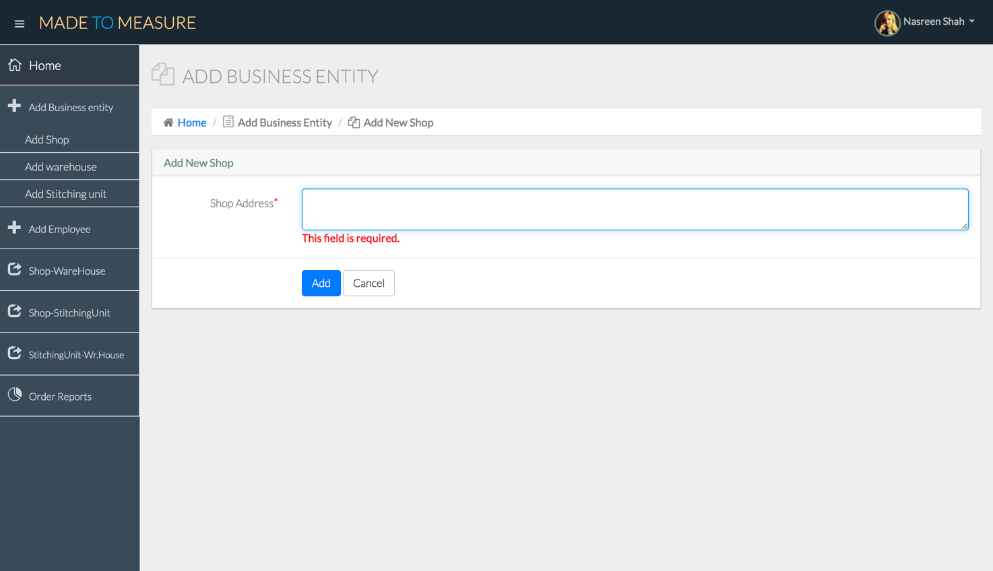

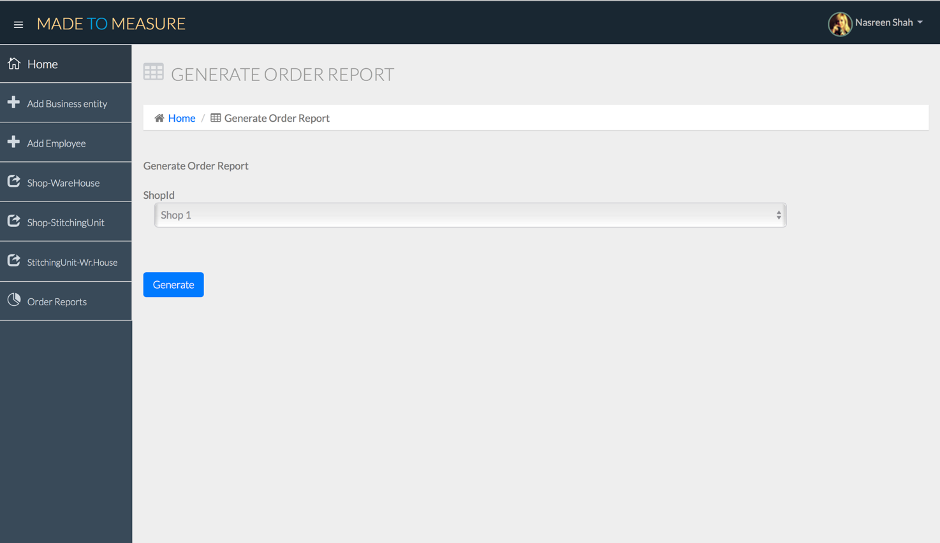Generate Report

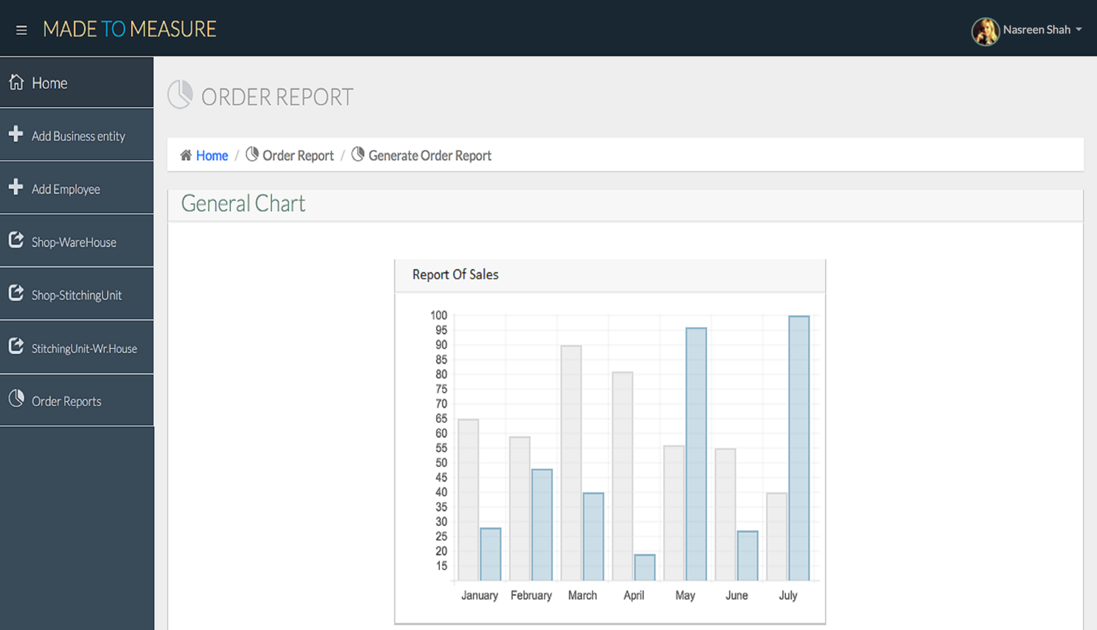Reports

Stitching Unit Manager Profile

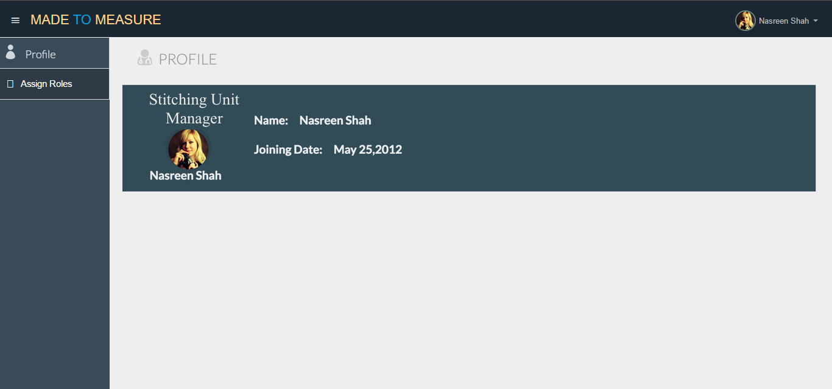

Assign Job roles

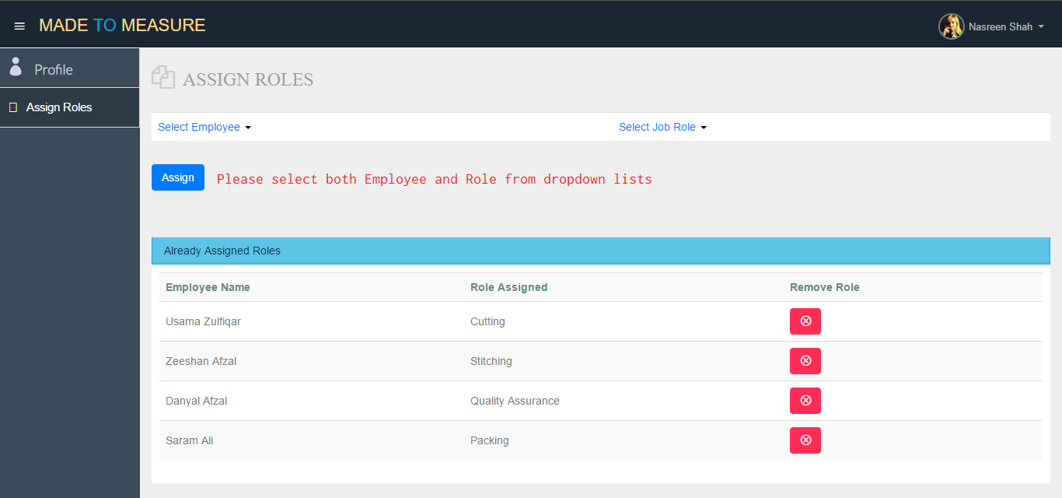

Stitching Unit Dept. Head Profile

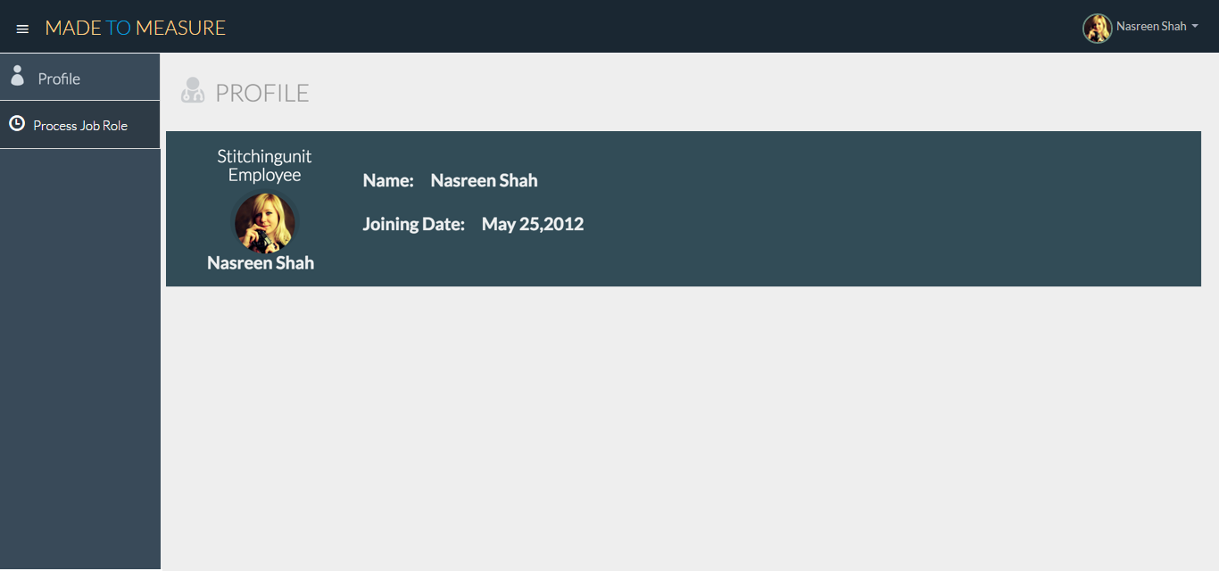

Process Job role

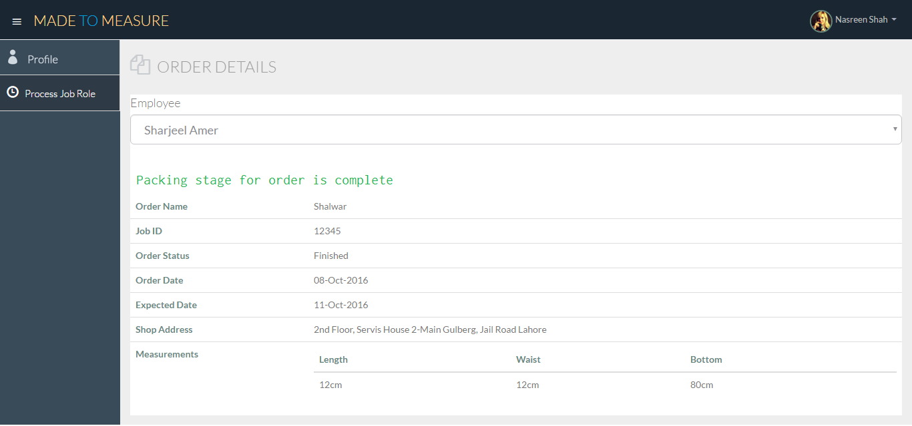

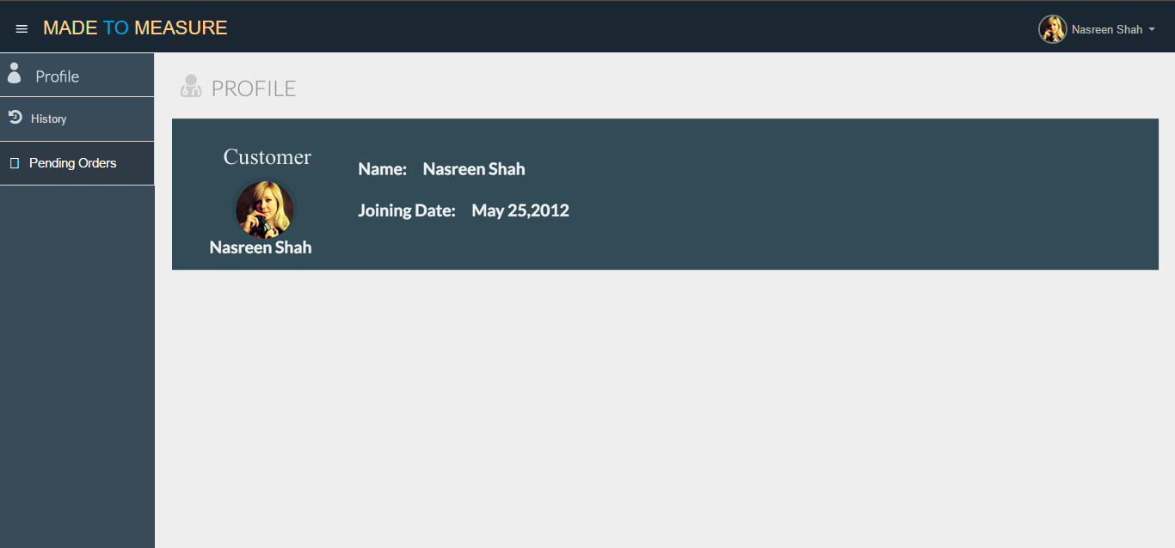Customer Profile

Order details

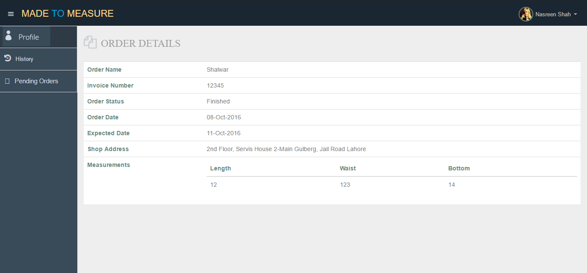

Order history

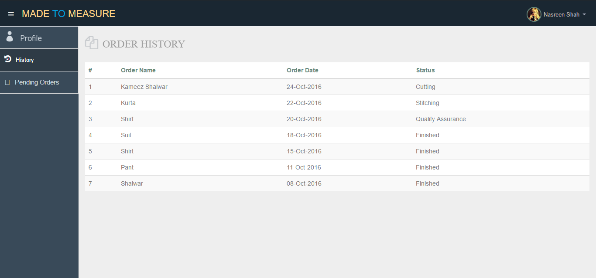

Pending Orders

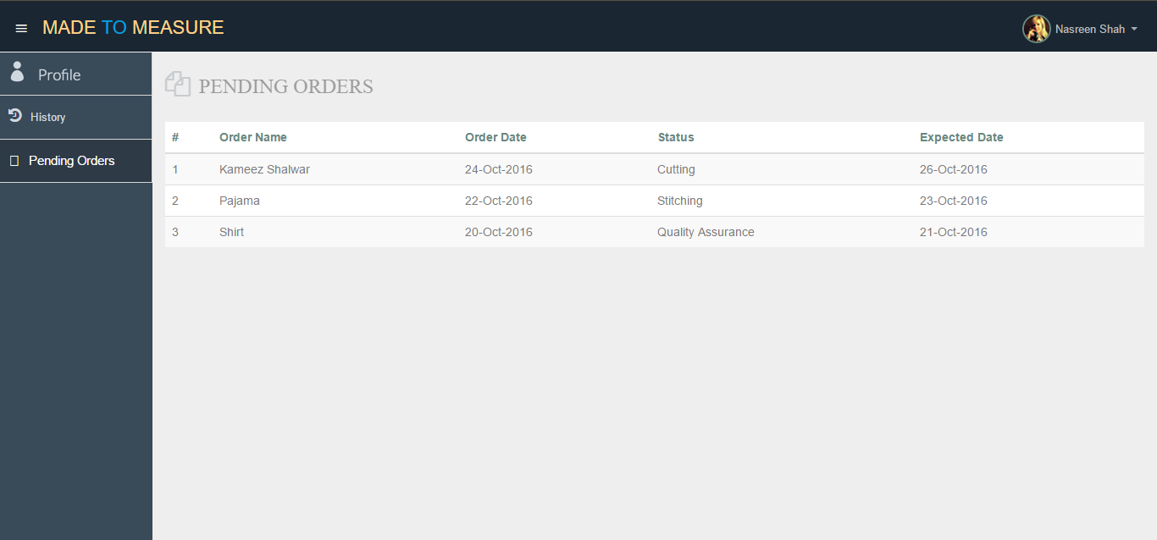

# Appendix E: Test Cases

## Login

|  |  |
| --- | --- |
| **Identifier** | TC-1 |
| **Priority** | High |
| **Related requirements(s)** | UC-1 |
| **Short description** | Primary Scenario of “Log In” |
| **Pre-condition(s)** | User exists in database |
| **Input data** | Phone Number = 03211234567  Password = 1234567 |
| **Detailed steps** | 1. Enter Phone Number 2. Enter Password 3. Click Login Button |
| **Expected result(s)** | “Profile Page” of user is displayed |
| **Post-condition(s)** | No change in system |

## Login

|  |  |
| --- | --- |
| **Identifier** | TC-2 |
| **Priority** | High |
| **Related requirements(s)** | UC-1 |
| **Short description** | Check Scenario of “Log In” when information is incorrect |
| **Pre-condition(s)** | User exists in database |
| **Input data** | Phone Number = 03211234567  Password = 12345675 |
| **Detailed steps** | 1. Enter Phone Number 2. Enter Password 3. Click Login Button |
| **Expected result(s)** | Error Screen “Incorrect Information” displayed |
| **Post-condition(s)** | No change in system |

## Track Order Status

|  |  |
| --- | --- |
| **Identifier** | TC-3 |
| **Priority** | Medium |
| **Related requirements(s)** | UC-1 |
| **Short description** | Check primary scenario of track order status |
| **Pre-condition(s)** | Customer and his orders exists in database |
| **Input data** | Phone Number = 03211234567  Password = 123456 |
| **Detailed steps** | 1. Click “Pending Orders” Option 2. Click Pending Order “Suit” in the list |
| **Expected result(s)** | Details of selected pending order |
| **Post-condition(s)** | No change in system |

## Track Order Status

|  |  |
| --- | --- |
| **Identifier** | TC-4 |
| **Priority** | Medium |
| **Related requirements(s)** | UC-1 |
| **Short description** | Check scenario of “Track Order Status” when no pending orders |
| **Pre-condition(s)** | Customer exists in database and no pending order exist before |
| **Input data** | Phone Number = 03211234567  Password = 123456 |
| **Detailed steps** | Click “Pending Orders” Option |
| **Expected result(s)** | “No Pending Orders” screen |
| **Post-condition(s)** | No change in system |

## View Order History

|  |  |
| --- | --- |
| **Identifier** | TC-5 |
| **Priority** | Medium |
| **Related requirements(s)** | UC-2 |
| **Short description** | Check primary scenario of “View Order History” |
| **Pre-condition(s)** | Customer and his/her Orders exists in database |
| **Input data** | Phone Number = 03211234567  Password = 123456 |
| **Detailed steps** | 1. Click “History” Option 2. Click Order “Suit” in the list |
| **Expected result(s)** | Details of selected order  Order Date, Status, Type, Shop Address |
| **Post-condition(s)** | No change in system |

## View Profile

|  |  |
| --- | --- |
| **Identifier** | TC-6 |
| **Priority** | Medium |
| **Related requirements(s)** | UC-3 |
| **Short description** | Primary Scenario of “View Profile” when user logs in |
| **Pre-condition(s)** | User exists in database |
| **Input data** | Phone Number = 03211234567  Password = 123456 |
| **Detailed steps** | 1. Enter Phone Number 2. Enter Password 3. Click Login Button |
| **Expected result(s)** | “Profile Page” of Customer is displayed  Name: Nasreen Shah  Joining Date: Dec 25,2016 |
| **Post-condition(s)** | No change in system |

## View Profile

|  |  |
| --- | --- |
| **Identifier** | TC-7 |
| **Priority** | Medium |
| **Related requirements(s)** | UC-3 |
| **Short description** | Primary Scenario of “View Profile” |
| **Pre-condition(s)** | User exists in database and is not on profile page |
| **Input data** |  |
| **Detailed steps** | 1. Click “Profile” Option |
| **Expected result(s)** | “Profile Page” of Customer is displayed  Name: Nasreen Shah  Joining Date: Dec 25,2016 |
| **Post-condition(s)** | No change in system |

## Add a New Customer

|  |  |
| --- | --- |
| **Identifier** | TC-8 |
| **Priority** | Medium |
| **Related requirements(s)** | UC-4 |
| **Short description** | Check primary scenario of “Add New Customer” in the system |
| **Pre-condition(s)** | Shopkeeper is logged in |
| **Input data** | Name = Nasreen Shah  Phone Number = 0321-1234567  Password = 123456 |
| **Detailed steps** | 1. Click “Add Customer” Option 2. Enter Phone Number 3. Enter Name 4. Enter Password 5. Click “Add” Button |
| **Expected result(s)** | Confirmation screen that customer is successfully added |
| **Post-condition(s)** | A new customer is added to the system |

## Add a New Customer

|  |  |
| --- | --- |
| **Identifier** | TC-9 |
| **Priority** | Medium |
| **Related requirements(s)** | UC-4 |
| **Short description** | Check scenario of “Add New Customer” when customer already exists in the system |
| **Pre-condition(s)** | Shopkeeper is logged in and customer already exists |
| **Input data** | Name = Nasreen Shah  Phone Number = 03211234567  Password = 123456 |
| **Detailed steps** | 1. Click “Add Customer” Option 2. Enter Phone Number 3. Enter Name 4. Enter Password 5. Click “Add” Button |
| **Expected result(s)** | Error screen that “Customer Already Exists” |
| **Post-condition(s)** | No change in the system |

## Add a Stitching Job

|  |  |
| --- | --- |
| **Identifier** | TC-10 |
| **Priority** | Medium |
| **Related requirements(s)** | UC-5 |
| **Short description** | Check primary scenario of “Add Stitching Job” in the system |
| **Pre-condition(s)** | Shopkeeper is logged in |
| **Input data** | Customer Contact Number = 03211234567  Expected Date = 25-Dec-2016  Job Type = Suit  Item Code = 123456 |
| **Detailed steps** | 1. Click “Add Stitching Job” Option 2. Enter Customer Contact Number 3. Enter Expected Date 4. Enter Job Type 5. Enter Item Code 6. Click “Add” Button 7. Click “Generate Invoice” Button |
| **Expected result(s)** | Confirmation screen “Stitching Job Successfully Added” and invoice of job is printed |
| **Post-condition(s)** | A new stitching job is added in the system |

## Add a Stitching Job

|  |  |
| --- | --- |
| **Identifier** | TC-11 |
| **Priority** | Medium |
| **Related requirements(s)** | UC-5 |
| **Short description** | Check scenario of “Add Stitching Job” in the system when the customer in the system does not exists |
| **Pre-condition(s)** | Shopkeeper is logged in |
| **Input data** | Customer Contact Number = 03211234567  Expected Date = 25-Dec-2016  Job Type = Suit  Item Code = 123456 |
| **Detailed steps** | 1. Click “Add Stitching Job” Option 2. Enter Customer Contact Number 3. Enter Expected Date 4. Enter Job Type 5. Enter Item Code 6. Click “Generate Invoice” Button |
| **Expected result(s)** | Display “Customer does not exists” |
| **Post-condition(s)** | No change in the system |

## Generate Invoice

|  |  |
| --- | --- |
| **Identifier** | TC-12 |
| **Priority** | High |
| **Related requirements(s)** | UC-6 |
| **Short description** | Check primary scenario of “Generate Invoice” |
| **Pre-condition(s)** | Related stitching job exists in the system |
| **Input data** | Advance Payment = 2000 |
| **Detailed steps** | 1. Click “Generate Invoice” Option 2. Enter Advance Payment 3. Click “Print” Button |
| **Expected result(s)** | Display “Invoice is Printing” |
| **Post-condition(s)** | A new invoice entry is added in the system |

## View History Details of particular order of Customer

|  |  |
| --- | --- |
| **Identifier** | TC-13 |
| **Priority** | High |
| **Related requirements(s)** | UC-7 |
| **Short description** | Check primary scenario of “View History Details of Particular Order of Customer” |
| **Pre-condition(s)** | Customer and Related stitching job exists in the system |
| **Input data** | Customer’s Contact Number = 0321-1234567 |
| **Detailed steps** | 1. Click “Customer’s Order” Option 2. Enter Contact Number 3. Select Order “Suit” at order date 25-Dec-2016 |
| **Expected result(s)** | Details of the order with  all measurements  order name = Suit  order status = cutting  Expected Date = 01-Jan-2017  Shop Address = 2nd Floor, House 2-Main Gulberg, Jail Road, Lahore |
| **Post-condition(s)** | No change in system |

## Generate Receipt

|  |  |
| --- | --- |
| **Identifier** | TC-14 |
| **Priority** | High |
| **Related requirements(s)** | UC-8 |
| **Short description** | Check primary scenario of “Generate Invoice” |
| **Pre-condition(s)** | Related invoice exists in the system |
| **Input data** | Invoice Number = 123456 |
| **Detailed steps** | 1. Click “Generate Invoice” Option 2. Enter Invoice Number 3. Click Print Button |
| **Expected result(s)** | Display orders in invoice |
| **Post-condition(s)** | A new receipt entry added in the system |

## Generate Receipt

|  |  |
| --- | --- |
| **Identifier** | TC-15 |
| **Priority** | High |
| **Related requirements(s)** | UC-8 |
| **Short description** | Check primary scenario of “Generate Invoice” when invoice does not exist in the system |
| **Pre-condition(s)** | Shopkeeper is logged in and related invoice doesn’t exist |
| **Input data** | Invoice Number = 123456 |
| **Detailed steps** | 1. Click “Generate Invoice” Option 2. Enter Invoice Number 3. Click Print Button |
| **Expected result(s)** | Display “No Related Invoice Found” |
| **Post-condition(s)** | No change in the system |

## View the stock position of warehouse

|  |  |
| --- | --- |
| **Identifier** | TC-16 |
| **Priority** | High |
| **Related requirements(s)** | UC-9 |
| **Short description** | Check primary scenario of “View Stock Position of Warehouse” |
| **Pre-condition(s)** | Shopkeeper is logged in and Warehouse is already associated with the shop |
| **Input data** |  |
| **Detailed steps** | 1. Click “Warehouse Status” Option |
| **Expected result(s)** | Display all items under  Item code, Item Category, Item Sub-Category, Brand, Color, Quantity, Unit Price |
| **Post-condition(s)** | No change in the system |

## View the stock position of warehouse

|  |  |
| --- | --- |
| **Identifier** | TC-17 |
| **Priority** | High |
| **Related requirements(s)** | UC-9 |
| **Short description** | Check primary scenario of “View Stock Position of Warehouse” |
| **Pre-condition(s)** | Shopkeeper is logged in and Warehouse is not associated with the shop |
| **Input data** |  |
| **Detailed steps** | 1. Click “Warehouse Status” Option |
| **Expected result(s)** | Display “No Warehouse is Associated with this Shop” |
| **Post-condition(s)** | No change in the system |

## View the stock position of Item in warehouse

|  |  |
| --- | --- |
| **Identifier** | TC-18 |
| **Priority** | High |
| **Related requirements(s)** | UC-10 |
| **Short description** | Check primary scenario of “View Stock Position of Item in Warehouse” |
| **Pre-condition(s)** | Shopkeeper is logged in and Warehouse is already associated with the shop and specific item exists in the system |
| **Input data** | Item Code = 123456 |
| **Detailed steps** | 1. Click “Check Item Status” Option 2. Enter item code |
| **Expected result(s)** | Display item under  Item Category, Item Sub-Category, Brand, Color, Quantity, Unit Price |
| **Post-condition(s)** | No change in the system |

## View the stock position of Item in warehouse

|  |  |
| --- | --- |
| **Identifier** | TC-19 |
| **Priority** | High |
| **Related requirements(s)** | UC-10 |
| **Short description** | Check primary scenario of “View Stock Position of Item in Warehouse” |
| **Pre-condition(s)** | Shopkeeper is logged in and Warehouse is already associated with the shop and specific item does not exists in the system |
| **Input data** | Item Code = 1234567 |
| **Detailed steps** | 1. Click “Check Item Status” Option 2. Enter item code |
| **Expected result(s)** | Display “No item corresponds to this item code” |
| **Post-condition(s)** | No change in the system |

## Order stock from the associated warehouse

|  |  |
| --- | --- |
| **Identifier** | TC-20 |
| **Priority** | High |
| **Related requirements(s)** | UC-11 |
| **Short description** | Check primary scenario of “Order Stock from Associated Warehouse” and Item exists in the system |
| **Pre-condition(s)** | Shopkeeper is logged in and Warehouse is already associated |
| **Input data** | Item Code = 123456  Item Quantity = 100 |
| **Detailed steps** | 1. Click “Add Shop Order” Option 2. Enter Item Code 3. Enter Item Quantity 4. Click “Add” Button |
| **Expected result(s)** | Display confirmation screen “Order is successfully Placed” |
| **Post-condition(s)** | A new shop order entry added in the system |

## Order stock from the associated warehouse

|  |  |
| --- | --- |
| **Identifier** | TC-21 |
| **Priority** | High |
| **Related requirements(s)** | UC-11 |
| **Short description** | Check primary scenario of “Order Stock from Associated Warehouse” and Item does not exist in the system |
| **Pre-condition(s)** | Shopkeeper is logged in and Warehouse is already associated |
| **Input data** | Item Code = 1234567  Item Quantity = 100 |
| **Detailed steps** | 1. Click “Add Shop Order” Option 2. Enter Item Code 3. Enter Item Quantity 4. Click “Add” Button |
| **Expected result(s)** | Display “Item with Respect to Item Code Not Found” |
| **Post-condition(s)** | No change in the system |

## Generate Job Card

|  |  |
| --- | --- |
| **Identifier** | TC-22 |
| **Priority** | High |
| **Related requirements(s)** | UC-12 |
| **Short description** | Check primary scenario of “Generate Job Card” |
| **Pre-condition(s)** | Related invoice exists in the system |
| **Input data** | Invoice Number = 123456 |
| **Detailed steps** | 1. Click “Generate Invoice” Option 2. Enter Invoice Number 3. Click Print Button |
| **Expected result(s)** | Display orders in invoice and print out of as much number of job cards as the number of orders in the invoice |
| **Post-condition(s)** | A new receipt entry added in the system if not exists |

## Generate Job Card

|  |  |
| --- | --- |
| **Identifier** | TC-23 |
| **Priority** | High |
| **Related requirements(s)** | UC-12 |
| **Short description** | Check primary scenario of “Generate Job Card” |
| **Pre-condition(s)** | Related invoice does not exist in the system |
| **Input data** | Invoice Number = 123456 |
| **Detailed steps** | 1. Click “Generate Invoice” Option 2. Enter Invoice Number 3. Click Print Button |
| **Expected result(s)** | Display orders in invoice and print out of as much number of job cards as the number of orders in the invoice |
| **Post-condition(s)** | A new receipt entry added in the system if not exists |

## Add fabric stock to the inventory

|  |  |
| --- | --- |
| **Identifier** | TC-24 |
| **Priority** | Medium |
| **Related requirements(s)** | UC-13 |
| **Short description** | Check primary scenario of “Add Fabric Stock to Inventory” and item entry is already in the system |
| **Pre-condition(s)** | Warehouse Manager is logged |
| **Input data** | Category = Fabric  Sub-Category = Lawn  Brand = Gul Ahmed  Vendor Name = Gul Ahmed  Color = White  Cost Price = 10000  Sale Price (% per meter) = 15  Unit of Measure = Meters  Quantity = 100 |
| **Detailed steps** | 1. Click “Add Item Stock” Option 2. Enter Category 3. Enter Sub-Category 4. Enter Brand 5. Enter Vendor Name 6. Enter Color 7. Enter Cost Price 8. Enter Sale Price 9. Enter Unit of Measure 10. Enter Quantity 11. Click “Add” Button |
| **Expected result(s)** | Display “Stock Successfully Added” and display bar code of item |
| **Post-condition(s)** | Fabric Stock is updated |

## Add fabric stock to the inventory

|  |  |
| --- | --- |
| **Identifier** | TC-25 |
| **Priority** | Medium |
| **Related requirements(s)** | UC-13 |
| **Short description** | Check primary scenario of “Add Fabric Stock to Inventory” and item entry does not exist in the system |
| **Pre-condition(s)** | Warehouse Manager is logged |
| **Input data** | Category = Fabric  Sub-Category = Lawn  Brand = Gul Ahmed  Vendor Name = Gul Ahmed  Color = White  Cost Price = 10000  Sale Price (% per meter) = 15  Unit of Measure = Meters  Quantity = 100 |
| **Detailed steps** | 1. Click “Add Item Stock” Option 2. Enter Category 3. Enter Sub-Category 4. Enter Brand 5. Enter Vendor Name 6. Enter Color 7. Enter Cost Price 8. Enter Sale Price 9. Enter Unit of Measure 10. Enter Quantity 11. Click “Add” Button |
| **Expected result(s)** | Display “Stock Successfully Added” and display bar code of item |
| **Post-condition(s)** | Fabric stock is updated and new Bar Code is generated in the system corresponding to the fabric |

## Add fabric stock to the inventory

|  |  |
| --- | --- |
| **Identifier** | TC-26 |
| **Priority** | Medium |
| **Related requirements(s)** | UC-13 |
| **Short description** | Check primary scenario of “Add Fabric Stock to Inventory” and incomplete information of item is entered |
| **Pre-condition(s)** | Warehouse Manager is logged |
| **Input data** | Category = Fabric  Sub-Category = Lawn  Brand = ‘’  Vendor Name = Gul Ahmed  Color = White  Cost Price = ‘’  Sale Price (% per meter) = 15  Unit of Measure = Meters  Quantity = 100 |
| **Detailed steps** | 1. Click “Add Item Stock” Option 2. Enter Category 3. Enter Sub-Category 4. Enter Vendor Name 5. Enter Color 6. Enter Sale Price 7. Enter Unit of Measure 8. Enter Quantity 9. Click “Add” Button |
| **Expected result(s)** | Display “Enter Complete Information of item” |
| **Post-condition(s)** | No change in the system |

## Add accessory stock to the inventory

|  |  |
| --- | --- |
| **Identifier** | TC-27 |
| **Priority** | Medium |
| **Related requirements(s)** | UC-14 |
| **Short description** | Check primary scenario of “Add Accessory Stock to Inventory” and item entry is already in the system |
| **Pre-condition(s)** | Warehouse Manager is logged |
| **Input data** | Category = Accessory  Sub-Category = Button  Brand = Mr. Button  Vendor Name = Mr. Button  Color = White  Cost Price = 100  Sale Price (% per packet) = 15  Unit of Measure = Packet  Quantity = 100 |
| **Detailed steps** | 1. Click “Add Item Stock” Option 2. Enter Category 3. Enter Sub-Category 4. Enter Brand 5. Enter Vendor Name 6. Enter Color 7. Enter Cost Price 8. Enter Sale Price 9. Enter Unit of Measure 10. Enter Quantity 11. Click “Add” Button |
| **Expected result(s)** | Display “Stock Successfully Added” and display bar code of item |
| **Post-condition(s)** | Accessory Stock is updated |

## Add accessory stock to the inventory

|  |  |
| --- | --- |
| **Identifier** | TC-28 |
| **Priority** | Medium |
| **Related requirements(s)** | UC-14 |
| **Short description** | Check primary scenario of “Add Accessory Stock to Inventory” and item entry does not exist in the system |
| **Pre-condition(s)** | Warehouse Manager is logged |
| **Input data** | Category = Accessory  Sub-Category = Button  Brand = Mr. Button  Vendor Name = Mr. Button  Color = White  Cost Price = 100  Sale Price (% per packet) = 15  Unit of Measure = Packet  Quantity = 100 |
| **Detailed steps** | 1. Click “Add Item Stock” Option 2. Enter Category 3. Enter Sub-Category 4. Enter Brand 5. Enter Vendor Name 6. Enter Color 7. Enter Cost Price 8. Enter Sale Price 9. Enter Unit of Measure 10. Enter Quantity 11. Click “Add” Button |
| **Expected result(s)** | Display “Stock Successfully Added” and display bar code of item |
| **Post-condition(s)** | Accessory Stock is updated add new Bar code entry with respect to the stock in the system |

## Add accessory stock to the inventory

|  |  |
| --- | --- |
| **Identifier** | TC-29 |
| **Priority** | Medium |
| **Related requirements(s)** | UC-14 |
| **Short description** | Check primary scenario of “Add Accessory Stock to Inventory” and incomplete information is provided |
| **Pre-condition(s)** | Warehouse Manager is logged |
| **Input data** | Category = Accessory  Sub-Category = Button  Brand =””  Vendor Name = Mr. Button  Color = White  Cost Price =””  Sale Price (% per packet) = 15  Unit of Measure = Packet  Quantity = 100 |
| **Detailed steps** | 1. Click “Add Item Stock” Option 2. Enter Category 3. Enter Sub-Category 4. Enter Vendor Name 5. Enter Color 6. Enter Sale Price 7. Enter Unit of Measure 8. Enter Quantity 9. Click “Add” Button |
| **Expected result(s)** | Display “Please Fill all the Fields Provided” |
| **Post-condition(s)** | No change in the system |

## Process Order with fabric issued from shop

|  |  |
| --- | --- |
| **Identifier** | TC-30 |
| **Priority** | Medium |
| **Related requirements(s)** | UC-15 |
| **Short description** | Check primary scenario of “Process Order with Fabric Issued from Shop” |
| **Pre-condition(s)** | Warehouse Manager is logged and shop orders with fabric for that warehouse already exists in the system |
| **Input data** | Item Code Button = 345  Item Code Embroidery = 456 |
| **Detailed steps** | 1. Click “Stitching Job Orders” 2. Click order number 1 in Orders with fabric 3. Scan Accessory Buttons Black, Dash 4. Scan Accessory Embroidery Brown, Alam 5. Click “Ordered Processed” |
| **Expected result(s)** | Display “Order Processed Successfully” and display Job number |
| **Post-condition(s)** | Accessory Stock for that specific buttons and embroidery is updated generate job orders for further processing |

## Process Order with fabric issued from shop

|  |  |
| --- | --- |
| **Identifier** | TC-31 |
| **Priority** | Medium |
| **Related requirements(s)** | UC-15 |
| **Short description** | Check primary scenario of “Process Order with Fabric Issued from Shop” and manually entering item code |
| **Pre-condition(s)** | Warehouse Manager is logged and shop orders with fabric for that warehouse already exists in the system |
| **Input data** | Item Button Code = 345  Item Embroidery Code = 456 |
| **Detailed steps** | 1. Click “Stitching Job Orders” 2. Click order number 1 3. Enter Accessory Buttons Code 4. Enter Accessory Embroidery Code 5. Click “Ordered Processed” |
| **Expected result(s)** | Display “Order Processed Successfully” and display Job number |
| **Post-condition(s)** | Accessory Stock for that specific buttons and embroidery is updated generate job orders for further processing |

## Process Order with fabric issued from shop

|  |  |
| --- | --- |
| **Identifier** | TC-32 |
| **Priority** | Medium |
| **Related requirements(s)** | UC-15 |
| **Short description** | Check scenario of “Process Order with Fabric Issued from Shop” when every item in the order is not scanned |
| **Pre-condition(s)** | Warehouse Manager is logged and shop orders with fabric for that warehouse already exists in the system |
| **Input data** | Item Code Button = 345 |
| **Detailed steps** | 1. Click “Stitching Job Orders” 2. Click order number 1 in fabric issued 3. Scan Accessory Buttons Black, Dash 4. Not Scanned Accessory Embroidery Brown,Alam 5. Click “Ordered Processed” |
| **Expected result(s)** | Display “Please First Scan all the items in the order” |
| **Post-condition(s)** | No change in the system |

## Process order with fabric not issued from shop

|  |  |
| --- | --- |
| **Identifier** | TC-33 |
| **Priority** | Medium |
| **Related requirements(s)** | UC-16 |
| **Short description** | Check primary scenario of “Process Order with Fabric Not Issued from Shop” |
| **Pre-condition(s)** | Warehouse Manager is logged and shop orders with fabric not issued for that warehouse already exists in the system |
| **Input data** | Item Code Fabric = 123  Item Code Button = 234  Item Code Embroidery = 456 |
| **Detailed steps** | 1. Click “Stitching Job Orders” 2. Click order number 1 in stitching orders without fabric 3. Scan Fabric Silk, White, Nishat 4. Scan Accessory Buttons, Black, Dash 5. Scan Accessory Embroidery, Brown, Alam 6. Click “Ordered Processed” |
| **Expected result(s)** | Display “Order Processed Successfully” and display Job number |
| **Post-condition(s)** | Fabric stock for that cloth is updated.  Accessory stock for that specific buttons and embroidery is updated. Generate job orders for further processing |

## Process order with fabric not issued from shop

|  |  |
| --- | --- |
| **Identifier** | TC-34 |
| **Priority** | Medium |
| **Related requirements(s)** | UC-16 |
| **Short description** | Check primary scenario of “Process Order with Fabric Not Issued from Shop” Giving wrong item code not in the order |
| **Pre-condition(s)** | Warehouse Manager is logged and shop orders with fabric not issued for that warehouse already exists in the system |
| **Input data** | Item Code Fabric = 123  Item Code Button = 234  Item Code Embroidery = 4567 |
| **Detailed steps** | 1. Click “Stitching Job Orders” 2. Click order number 1 in stitching orders without fabric 3. Scan Fabric Silk, White, Nishat 4. Scan Accessory Buttons, Black, Dash 5. Scan Accessory Embroidery, Black(instead of Brown), Alam |
| **Expected result(s)** | Display “Scanned Item is not part of the order” |
| **Post-condition(s)** | No change in the system |

## Process order with fabric not issued from shop

|  |  |
| --- | --- |
| **Identifier** | TC-35 |
| **Priority** | Medium |
| **Related requirements(s)** | UC-16 |
| **Short description** | Check primary scenario of “Process Order with Fabric Not Issued from Shop” Not enough stock to fulfill order |
| **Pre-condition(s)** | Warehouse Manager is logged and shop orders with fabric not issued for that warehouse already exists in the system |
| **Input data** | Item Code Fabric = 123  Item Code Button = 234  Item Code Embroidery = 456 |
| **Detailed steps** | 1. Click “Stitching Job Orders” 2. Click order number 1 in stitching orders without fabric 3. Scan Fabric Silk, White, Nishat 4. Scan Accessory Buttons, Black, Dash 5. Scan Accessory Embroidery, Brown, Alam |
| **Expected result(s)** | Display “Scanned Item is on low stock Order not processed” |
| **Post-condition(s)** | No change in the system |

## Process Shop Order

|  |  |
| --- | --- |
| **Identifier** | TC-36 |
| **Priority** | Medium |
| **Related requirements(s)** | UC-17 |
| **Short description** | Check primary scenario of “Process Shop Order” when stock is enough to process order |
| **Pre-condition(s)** | Warehouse Manager is logged in and shop orders exists in the system |
| **Input data** |  |
| **Detailed steps** | 1. Click “Shop Orders” 2. Mark check order in the list with category “Fabric”, Sub-category “Silk”, Brand “Nishat”, Quantity “100” 3. Click “Ordered Processed” |
| **Expected result(s)** | Display “Order Processed Successfully” |
| **Post-condition(s)** | The stock of fabric “silk” by “Nishat” will be decreased by 100 units |

## Process Shop Order

|  |  |
| --- | --- |
| **Identifier** | TC-37 |
| **Priority** | Medium |
| **Related requirements(s)** | UC-17 |
| **Short description** | Check primary scenario of “Process Shop Order” when stock is not enough to process order |
| **Pre-condition(s)** | Warehouse Manager is logged in and shop orders exists in the system |
| **Input data** |  |
| **Detailed steps** | 1. Click “Shop Orders” 2. Mark check order in the list with category “Fabric”, Sub-category “Silk”, Brand “Nishat”, Quantity “100” 3. Click “Ordered Processed” |
| **Expected result(s)** | Display “Order Stock is Not Enough to Process Order” |
| **Post-condition(s)** | No change in the system database |

## Process Shop Order

|  |  |
| --- | --- |
| **Identifier** | TC-38 |
| **Priority** | Medium |
| **Related requirements(s)** | UC-17 |
| **Short description** | Check primary scenario of “Process Shop Order” when no order exists for the warehouse |
| **Pre-condition(s)** | Warehouse Manager is logged in |
| **Input data** |  |
| **Detailed steps** | 1. Click “Shop Orders” |
| **Expected result(s)** | Display “No Orders Present” |
| **Post-condition(s)** | No change in the system database |

## Add to Vendor List

|  |  |
| --- | --- |
| **Identifier** | TC-39 |
| **Priority** | Medium |
| **Related requirements(s)** | UC-18 |
| **Short description** | Check primary scenario of “Add to Vendor List” when complete information is provided |
| **Pre-condition(s)** | Warehouse Manager is logged in |
| **Input data** | Category Name = Fabric  Sub-Category = Silk  Brand = Nishat  Vendor Name = Nishat  Color = Red  Quantity = 1000  Unit = Meters |
| **Detailed steps** | 1. Click “Vendor List” 2. Enter Category 3. Enter Sub-Category 4. Enter Brand 5. Enter Vendor Name 6. Enter Color 7. Enter Quantity 8. Enter Unit of Measure 9. Click “Add” |
| **Expected result(s)** | Display “Item Successfully Added to Vendor List” |
| **Post-condition(s)** | An entry for vendor list added in the system |

## Add to Vendor List

|  |  |
| --- | --- |
| **Identifier** | TC-40 |
| **Priority** | Medium |
| **Related requirements(s)** | UC-18 |
| **Short description** | Check primary scenario of “Add to Vendor List” when information is incomplete |
| **Pre-condition(s)** | Warehouse Manager is logged in |
| **Input data** | Category Name = Fabric  Sub-Category = Silk  Brand =””  Vendor Name = Nishat  Color = Red  Quantity =””  Unit = Meters |
| **Detailed steps** | 1. Click “Vendor List” 2. Enter Category 3. Enter Sub-Category 4. Enter Vendor Name 5. Enter Color 6. Enter Unit of Measure 7. Click “Add” |
| **Expected result(s)** | Display “Please Fill All the Required Fields” |
| **Post-condition(s)** | No change in the system |

## Assign Roles to Stitching Unit Employees

|  |  |
| --- | --- |
| **Identifier** | TC-41 |
| **Priority** | Medium |
| **Related requirements(s)** | UC-19 |
| **Short description** | Check primary scenario of “Assign Roles to Stitching Unit Employees” when employee with no role assigned exist in database |
| **Pre-condition(s)** | Stitching Unit Manager is logged in |
| **Input data** | Employee = Ahmed  Job Role = Quality Assurance |
| **Detailed steps** | 1. Click “Assign Roles” 2. Click Select Employee 3. Select Employee 4. Click Job Role 5. Select Job Role 6. Click “Assign” |
| **Expected result(s)** | Display updated roles assigned list |
| **Post-condition(s)** | Job Role for the employee changed to Quality Assurance in database |

## Un-Assign Roles to Stitching Unit Employees

|  |  |
| --- | --- |
| **Identifier** | TC-42 |
| **Priority** | Medium |
| **Related requirements(s)** | UC-19 |
| **Short description** | Check primary scenario of “Un-Assign Roles to Stitching Unit Employees” when employee with role assigned exist in database |
| **Pre-condition(s)** | Stitching Unit Manager is logged in |
| **Input data** |  |
| **Detailed steps** | 1. Click “Assign Roles” 2. Select Employee in the list “Already Assigned Roles” 3. Click “Remove Role Button” |
| **Expected result(s)** | Display updated roles assigned list |
| **Post-condition(s)** | Job Role for the employee changed to Un-Assigned in database |

## Assign Roles to Stitching Unit Employees

|  |  |
| --- | --- |
| **Identifier** | TC-43 |
| **Priority** | Medium |
| **Related requirements(s)** | UC-19 |
| **Short description** | Check primary scenario of “Assign Roles List” when no employee exists in database with assigned roles |
| **Pre-condition(s)** | Stitching Unit Manager is logged in |
| **Input data** |  |
| **Detailed steps** | 1. Click “Assign Roles” |
| **Expected result(s)** | Display “No Role is Assigned to Any Employee” in the assigned roles list |
| **Post-condition(s)** | No change in the system |

## Process job role

|  |  |
| --- | --- |
| **Identifier** | TC-44 |
| **Priority** | Medium |
| **Related requirements(s)** | UC-20 |
| **Short description** | Check primary scenario of “Process Job Role” when “Packing” department head is scanning |
| **Pre-condition(s)** | Stitching Unit Department Head is logged in |
| **Input data** | Employee = Ahmed  Job Card Number = 123456 |
| **Detailed steps** | 1. Click “Process Job Role” 2. Click Select Employee 3. Select Employee 4. Scan “Job Card” |
| **Expected result(s)** | Display “Packing Stage for Order is Complete” with order details and an SMS is sent to Customer |
| **Post-condition(s)** | Order Status is updated in database |

## Add new Shop

|  |  |
| --- | --- |
| **Identifier** | TC-45 |
| **Priority** | Medium |
| **Related requirements(s)** | UC-21 |
| **Short description** | Primary scenario to “add a new shop” in the system |
| **Pre-condition(s)** | Admin is logged in |
| **Input data** | Address = Shop # 10, Karim Market, Lahore |
| **Detailed steps** | 1. Click “Add Business Entity” 2. Click “Add Shop” 3. Enter Address 4. Click “Add” Button |
| **Expected result(s)** | Display “A shop is successfully added in the system” |
| **Post-condition(s)** | A new shop record is added in the system |

## Add new Shop

|  |  |
| --- | --- |
| **Identifier** | TC-46 |
| **Priority** | Medium |
| **Related requirements(s)** | UC-21 |
| **Short description** | Primary scenario to “add a new shop” in the system when “no address is provided” |
| **Pre-condition(s)** | Admin is logged in |
| **Input data** | Address = “” |
| **Detailed steps** | 1. Click “Add Business Entity” 2. Click “Add Shop” 3. Enter Address 4. Click “Add” Button |
| **Expected result(s)** | Display “The Field is Required” |
| **Post-condition(s)** | No change in the system |

## Add new Warehouse

|  |  |
| --- | --- |
| **Identifier** | TC-47 |
| **Priority** | Medium |
| **Related requirements(s)** | UC-22 |
| **Short description** | Primary scenario to “add a new warehouse” in the system |
| **Pre-condition(s)** | Admin is logged in |
| **Input data** | Address = Shop # 10, Karim Market, Lahore |
| **Detailed steps** | 1. Click “Add Business Entity” 2. Click “Add Warehouse” 3. Enter Address 4. Click “Add” Button |
| **Expected result(s)** | Display “A warehouse is successfully added in the system” |
| **Post-condition(s)** | A new warehouse record is added in the system |

## Add new Warehouse

|  |  |
| --- | --- |
| **Identifier** | TC-48 |
| **Priority** | Medium |
| **Related requirements(s)** | UC-22 |
| **Short description** | Primary scenario to “add a new warehouse” in the system when “address field is left empty” |
| **Pre-condition(s)** | Admin is logged in |
| **Input data** | Address = “” |
| **Detailed steps** | 1. Click “Add Business Entity” 2. Click “Add Warehouse” 3. Enter Address 4. Click “Add” Button |
| **Expected result(s)** | Display “Please Fill all the required fields” |
| **Post-condition(s)** | No change in the system |

## Add new Stitching Unit

|  |  |
| --- | --- |
| **Identifier** | TC-49 |
| **Priority** | Medium |
| **Related requirements(s)** | UC-23 |
| **Short description** | Primary scenario to “add a new stitching unit” in the system |
| **Pre-condition(s)** | Admin is logged in |
| **Input data** | Address = Shop # 10, Karim Market, Lahore |
| **Detailed steps** | 1. Click “Add Business Entity” 2. Click “Add Stitching Unit” 3. Enter Address 4. Click “Add” Button |
| **Expected result(s)** | Display “A stitching unit is successfully added in the system” |
| **Post-condition(s)** | A new stitching unit record is added in the system |

## Add new Stitching Unit

|  |  |
| --- | --- |
| **Identifier** | TC-50 |
| **Priority** | Medium |
| **Related requirements(s)** | UC-23 |
| **Short description** | Primary scenario to “add a new stitching unit” in the system when “address field is left empty” |
| **Pre-condition(s)** | Admin is logged in |
| **Input data** | Address = “” |
| **Detailed steps** | 1. Click “Add Business Entity” 2. Click “Add Stitching Unit” 3. Enter Address 4. Click “Add” Button |
| **Expected result(s)** | Display “Please fill all the required fields” |
| **Post-condition(s)** | No change in the system |

## Associate Shop with Warehouse

|  |  |
| --- | --- |
| **Identifier** | TC-51 |
| **Priority** | Medium |
| **Related requirements(s)** | UC-24 |
| **Short description** | Primary scenario to “Associate a Shop and Warehouse” when both entities records exist in database |
| **Pre-condition(s)** | Admin is logged in |
| **Input data** | Shop ID = 123  Warehouse ID = 456 |
| **Detailed steps** | 1. Click “Shop-Warehouse” 2. Select Shop ID from drop down 3. Select Warehouse ID from drop down 4. Click “Associate” Button |
| **Expected result(s)** | A new entry should appear in Associated Shops-Warehouse list |
| **Post-condition(s)** | Shop is linked with Warehouse in database |

## Associate Shop with Warehouse

|  |  |
| --- | --- |
| **Identifier** | TC-52 |
| **Priority** | Medium |
| **Related requirements(s)** | UC-24 |
| **Short description** | Primary scenario to “Associate a Shop and Warehouse” when both entities records exist in database but admin does not select warehouse |
| **Pre-condition(s)** | Admin is logged in |
| **Input data** | Shop ID = 123  Warehouse ID = “” |
| **Detailed steps** | 1. Click “Shop-Warehouse” 2. Select Shop ID from drop down 3. Click “Associate” Button |
| **Expected result(s)** | Display “Please select both entities to be associated” |
| **Post-condition(s)** | No change in the system |

## Associate Shop with Warehouse

|  |  |
| --- | --- |
| **Identifier** | TC-53 |
| **Priority** | Medium |
| **Related requirements(s)** | UC-24 |
| **Short description** | Primary scenario to “Associate a Shop and Warehouse” when both entities records exist in database but admin does not select shop |
| **Pre-condition(s)** | Admin is logged in |
| **Input data** | Shop ID = “”  Warehouse ID = 456 |
| **Detailed steps** | 1. Click “Shop-Warehouse” 2. Select Warehouse ID from drop down 3. Click “Associate” Button |
| **Expected result(s)** | Display “Please select both entities to be associated” |
| **Post-condition(s)** | No change in the system |

## Cancel association between a Shop and Warehouse

|  |  |
| --- | --- |
| **Identifier** | TC-54 |
| **Priority** | Medium |
| **Related requirements(s)** | UC-24 |
| **Short description** | Primary scenario to “cancel association between shop and warehouse” |
| **Pre-condition(s)** | Admin is logged in |
| **Input data** | Shop ID = 123  Warehouse ID = 456 |
| **Detailed steps** | 1. Click “Shop-Warehouse” 2. Select entry from Associated Shop-Warehouse list with Shop ID and Warehouse given 3. Click “Cancel Association” Button in the entry |
| **Expected result(s)** | Associated Shop-Warehouse should be updated |
| **Post-condition(s)** | Shop is un-linked with Warehouse in database |

## Associate shop with Stitching Unit

|  |  |
| --- | --- |
| **Identifier** | TC-55 |
| **Priority** | Medium |
| **Related requirements(s)** | UC-25 |
| **Short description** | Primary scenario to “Associate a Shop and Stitching Unit” when both entities records exist in database |
| **Pre-condition(s)** | Admin is logged in |
| **Input data** | Shop ID = 123  Stitching Unit ID = 456 |
| **Detailed steps** | 1. Click “Shop-Stitching Unit” 2. Select Shop ID from drop down 3. Select Stitching Unit ID from drop down 4. Click “Associate” Button |
| **Expected result(s)** | A new entry should appear in Associated Shops-Stitching Unit list |
| **Post-condition(s)** | Shop is linked with stitching unit in database |

## Associate shop with Stitching Unit

|  |  |
| --- | --- |
| **Identifier** | TC-56 |
| **Priority** | Medium |
| **Related requirements(s)** | UC-25 |
| **Short description** | Primary scenario to “Associate a Shop and Stitching Unit” when both entities records exist in database but admin does not select stitching unit |
| **Pre-condition(s)** | Admin is logged in |
| **Input data** | Shop ID = 123  Stitching Unit ID = “” |
| **Detailed steps** | 1. Click “Shop-Stitching Unit” 2. Select Shop ID from drop down 3. Click “Associate” Button |
| **Expected result(s)** | Display “Please select both entities to be associated” |
| **Post-condition(s)** | No change in the system |

## Associate shop with Stitching Unit

|  |  |
| --- | --- |
| **Identifier** | TC-57 |
| **Priority** | Medium |
| **Related requirements(s)** | UC-25 |
| **Short description** | Primary scenario to “Associate a Shop and Stitching Unit” when both entities records exist in database but admin does not select shop |
| **Pre-condition(s)** | Admin is logged in |
| **Input data** | Shop ID = “”  Stitching Unit ID = 456 |
| **Detailed steps** | 1. Click “Shop-Stitching Unit” 2. Select Stitching Unit ID from drop down 3. Click “Associate” Button |
| **Expected result(s)** | Display “Please select both entities to be associated” |
| **Post-condition(s)** | No change in the system |

## Cancel Association between shop with Stitching Unit

|  |  |
| --- | --- |
| **Identifier** | TC-58 |
| **Priority** | Medium |
| **Related requirements(s)** | UC-25 |
| **Short description** | Primary scenario to “cancel association between shop and stitching unit” |
| **Pre-condition(s)** | Admin is logged in |
| **Input data** | Shop ID = 123  Stitching Unit ID = 456 |
| **Detailed steps** | 1. Click “Shop-Stitching Unit” 2. Select entry from Associated Shop-Stitching Unit list with Shop ID and Stitching Unit ID given 3. Click “Cancel Association” Button in the entry |
| **Expected result(s)** | Associated Shop-Stitching Unit should be updated |
| **Post-condition(s)** | Shop is un-linked with Stitching Unit in database |

## Associate Stitching unit with Warehouse

|  |  |
| --- | --- |
| **Identifier** | TC-59 |
| **Priority** | Medium |
| **Related requirements(s)** | UC-26 |
| **Short description** | Primary scenario to “Associate a Stitching Unit and a Warehouse” when both entities records exist in database |
| **Pre-condition(s)** | Admin is logged in |
| **Input data** | Warehouse ID = 123  Stitching Unit ID = 456 |
| **Detailed steps** | 1. Click “Stitching Unit-Warehouse” 2. Select Warehouse ID from drop down 3. Select Stitching Unit ID from drop down 4. Click “Associate” Button |
| **Expected result(s)** | A new entry should appear in Associated Stitching Unit-Warehouse list |
| **Post-condition(s)** | warehouse is linked with stitching unit in database |

## Associate Stitching unit with Warehouse

|  |  |
| --- | --- |
| **Identifier** | TC-60 |
| **Priority** | Medium |
| **Related requirements(s)** | UC-26 |
| **Short description** | Primary scenario to “Associate a Stitching Unit and a Warehouse” when both entities records exist in database but admin does not select stitching unit |
| **Pre-condition(s)** | Admin is logged in |
| **Input data** | Warehouse ID = 123  Stitching Unit ID = “” |
| **Detailed steps** | 1. Click “Stitching Unit-Warehouse” 2. Select Warehouse ID from drop down 3. Click “Associate” Button |
| **Expected result(s)** | Display “Please select both entities to be associated” |
| **Post-condition(s)** | No change in the system |

## Associate Stitching unit with Warehouse

|  |  |
| --- | --- |
| **Identifier** | TC-61 |
| **Priority** | Medium |
| **Related requirements(s)** | UC-26 |
| **Short description** | Primary scenario to “Associate a Warehouse and Stitching Unit” when both entities records exist in database but admin does not select warehouse |
| **Pre-condition(s)** | Admin is logged in |
| **Input data** | Warehouse ID = “”  Stitching Unit ID = 456 |
| **Detailed steps** | 1. Click “Stitching Unit-Warehouse” 2. Select Stitching Unit ID from drop down 3. Click “Associate” Button |
| **Expected result(s)** | Display “Please select both entities to be associated” |
| **Post-condition(s)** | No change in the system |

## Cancel Association between Stitching unit with Warehouse

|  |  |
| --- | --- |
| **Identifier** | TC-62 |
| **Priority** | Medium |
| **Related requirements(s)** | UC-26 |
| **Short description** | Primary scenario to “cancel association between stitching unit and warehouse” |
| **Pre-condition(s)** | Admin is logged in |
| **Input data** | Warehouse ID = 123  Stitching Unit ID = 456 |
| **Detailed steps** | 1. Click “Stitching Unit-Warehouse” 2. Select entry from Associated Stitching Unit-Warehouse list with Warehouse ID and Stitching Unit ID given in input data 3. Click “Cancel Association” Button in the entry |
| **Expected result(s)** | Associated Stitching Unit-Warehouse should be updated |
| **Post-condition(s)** | Warehouse is un-linked with Stitching Unit in database |

## Generate Report

|  |  |
| --- | --- |
| **Identifier** | TC-63 |
| **Priority** | Medium |
| **Related requirements(s)** | UC-27 |
| **Short description** | Primary scenario to “Generate Report” |
| **Pre-condition(s)** | Admin is logged in |
| **Input data** | Shop Location = Shop # 10, Karim Market, Lahore |
| **Detailed steps** | 1. Click “Order Report” 2. Select Shop Location from drop down 3. Click “Generate” Button |
| **Expected result(s)** | Report is displayed on screen |
| **Post-condition(s)** | No change in system |

## Add Employee

|  |  |
| --- | --- |
| **Identifier** | TC-64 |
| **Priority** | Medium |
| **Related requirements(s)** | UC-28 |
| **Short description** | Primary scenario of adding an employee in the system |
| **Pre-condition(s)** | Admin is logged in |
| **Input data** | Full Name = Hamza Saleem  User Name = Hamza  Password = 1234567  Confirm Password = 1234567  Date of Joining = 25-12-2016  Designation = Shopkeeper  Shop Address = Shop # 10, Karim Market, Lahore |
| **Detailed steps** | 1. Click “Add Employee” 2. Enter Full Name 3. Enter User Name 4. Enter Password 5. Enter Confirm Password 6. Enter Date of Joining 7. Enter Designation 8. Enter Shop Address 9. Click “Add” Button |
| **Expected result(s)** | Display “Employee is Successfully Added in the System” |
| **Post-condition(s)** | A new employee should be added in the system |

## Add Employee

|  |  |
| --- | --- |
| **Identifier** | TC-65 |
| **Priority** | Medium |
| **Related requirements(s)** | UC-28 |
| **Short description** | Primary scenario of adding an employee in the system when “Full Name” field is left empty |
| **Pre-condition(s)** | Admin is logged in |
| **Input data** | Full Name = “”  User Name = Hamza  Password = 1234567  Confirm Password = 1234567  Date of Joining = 25-12-2016  Designation = Shopkeeper  Shop Address = Shop # 10, Karim Market, Lahore |
| **Detailed steps** | 1. Click “Add Employee” 2. Enter Full Name 3. Enter User Name 4. Enter Password 5. Enter Confirm Password 6. Enter Date of Joining 7. Enter Designation 8. Enter Shop Address 9. Click “Add” Button |
| **Expected result(s)** | Display “This field is required” under Full Name filed |
| **Post-condition(s)** | No change in the system |

## Performance Requirement

|  |  |
| --- | --- |
| **Identifier** | TC-66 |
| **Priority** | Medium |
| **Related requirements(s)** | 4.1 |
| **Short description** | Check primary scenario of “Performance Requirement” |
| **Pre-condition(s)** | Stitching Unit Department Head is logged in |
| **Input data** | Employee = Ahmed  Job Card Number = 123456 |
| **Detailed steps** | 1. Click “Process Job Role” 2. Click Select Employee 3. Select Employee 4. Scan “Job Card” |
| **Expected result(s)** | Display “Packing Stage for Order is Complete” with order details and an SMS should be sent within 2 minutes after scan |
| **Post-condition(s)** | Order Status is updated, new production activity is added in database, SMS is sent |

## Security Requirements

|  |  |
| --- | --- |
| **Identifier** | TC-67 |
| **Priority** | Medium |
| **Related requirements(s)** | 4.2 |
| **Short description** | Primary scenario of adding an employee in the system with respect to security requirement (Alphabet Validation in Full Name) |
| **Pre-condition(s)** | Admin is logged in |
| **Input data** | Full Name = Hamza Saleem  User Name = Hamza  Password = 1234567  Confirm Password = 1234567  Date of Joining = 25-12-2016  Designation = Shopkeeper  Shop Address = Shop # 10, Karim Market, Lahore |
| **Detailed steps** | 1. Click “Add Employee” 2. Enter Full Name 3. Enter User Name 4. Enter Password 5. Enter Confirm Password 6. Enter Date of Joining 7. Enter Designation 8. Enter Shop Address 9. Click “Add” Button |
| **Expected result(s)** | Display “Only Alphabets and Spaces are Allowed” under Full Name filed |
| **Post-condition(s)** | No change in the system |

## Security Requirements

|  |  |
| --- | --- |
| **Identifier** | TC-68 |
| **Priority** | Medium |
| **Related requirements(s)** | 4.2 |
| **Short description** | Primary scenario of adding an employee in the system with respect to security requirement (password validation Password Field) |
| **Pre-condition(s)** | Admin is logged in |
| **Input data** | Full Name = Hamza Saleem  User Name = Hamza  Password = 12345  Confirm Password = 12345  Date of Joining = 25-12-2016  Designation = Shopkeeper  Shop Address = Shop # 10, Karim Market, Lahore |
| **Detailed steps** | 1. Click “Add Employee” 2. Enter Full Name 3. Enter User Name 4. Enter Password 5. Enter Confirm Password 6. Enter Date of Joining 7. Enter Designation 8. Enter Shop Address 9. Click “Add” Button |
| **Expected result(s)** | Display “The password require at least 6 characters” under password and Confirm Password filed |
| **Post-condition(s)** | No change in the system |

## Security Requirements

|  |  |
| --- | --- |
| **Identifier** | TC-69 |
| **Priority** | Medium |
| **Related requirements(s)** | 4.2 |
| **Short description** | Check primary scenario of “Add to Vendor List” with respect to security requirement (SQL Injection in Category Name) |
| **Pre-condition(s)** | Warehouse Manager is logged in |
| **Input data** | Category Name = Fabric AND 1=2 UNION SELECT * FROM Employee WHERE usertype='admin'  Sub-Category = Silk  Brand = Nishat  Vendor Name = Nishat  Color = Red  Quantity = 1000  Unit = Meters |
| **Detailed steps** | 1. Click “Vendor List” 2. Enter Category 3. Enter Sub-Category 4. Enter Brand 5. Enter Vendor Name 6. Enter Color 7. Enter Quantity 8. Enter Unit of Measure 9. Click “Add” |
| **Expected result(s)** | Display “Only Alphabets, Digits and Spaces are Allowed” |
| **Post-condition(s)** | No change in the system |

## Security Performance

|  |  |
| --- | --- |
| **Identifier** | TC-70 |
| **Priority** | High |
| **Related requirements(s)** | 4.2 |
| **Short description** | Check primary scenario of “View History Details of Particular Order of Customer” with respect security performance (Digit Validation in Contact Number field) |
| **Pre-condition(s)** | Customer and Related stitching job exists in the system |
| **Input data** | Customer’s Contact Number = 1234567 |
| **Detailed steps** | 1. Click “Customer’s Order” Option 2. Enter Contact Number |
| **Expected result(s)** | Display “Only Digits are allowed” |
| **Post-condition(s)** | No change in system |

## Usability Requirement

|  |  |
| --- | --- |
| **Identifier** | TC-71 |
| **Priority** | Medium |
| **Related requirements(s)** | 4.3 |
| **Short description** | Check primary scenario of “Usability Requirement” with Urdu text |
| **Pre-condition(s)** | System is online |
| **Input data** | User ID = 03023839058  Password = 123456 |
| **Detailed steps** | 1. Enter User ID 2. Enter Password 3. Click “Log In” 4. Observe Urdu text in the tags |
| **Expected result(s)** | Each tag has Urdu text along with English |
| **Post-condition(s)** | No change in the system |

## Usability Requirement

|  |  |
| --- | --- |
| **Identifier** | TC-72 |
| **Priority** | Medium |
| **Related requirements(s)** | 4.3 |
| **Short description** | Check primary scenario of “Usability Requirement” training of users |
| **Pre-condition(s)** | “Shopkeeper” is already trained and is logged in |
| **Input data** | Customer Contact Number = 03211234567  Expected Date = 25-Dec-2016  Job Type = Suit  Item Code = 123456 |
| **Detailed steps** | 1. Click “Add Stitching Job” Option 2. Enter Customer Contact Number 3. Enter Expected Date 4. Enter Job Type 5. Enter Item Code 6. Enter Measurements 7. Click “Add” Button 8. Click “Print” Button 9. Check the errors made by user after an hour |
| **Expected result(s)** | The total number of errors after an hour should not exceed more than 4 |
| **Post-condition(s)** | New entries according to the steps perform should be reflected in the database |

# Appendix F: IV & V Report

**IV & V Resource**

Sherjeel Bin Amer L13-4086 C:\Users\sherj\AppData\Local\Microsoft\Windows\INetCacheContent.Word\285152348314506021216.png

Name Roll # Signature

|  |  |  |  |  |  |
| --- | --- | --- | --- | --- | --- |
| **S#** | **Defect Description** | **Origin Stage** | **Status** | **Fix Time** | |
| **Hours** | **Minutes** |
| 1 | Incorrect format of input field phone number was given in TC-1, TC-2, TC-3, TC-5, TC-6, TC-7 | Implementation and testing | Closed | 1 | 35 |
| 2 | Precondition was very general, had to be specific (applied from TC-3 to, TC-10) | Implementation and testing | Closed | 1 | 30 |
| 3 | Last step missing in detailed steps of TC-9 | Implementation and testing | Closed | 0 | 30 |
| 4 | Inconsistency in expected result of TC-10 (Not matching with the related use case) | Implementation and testing | Closed | 0 | 15 |
| 5 | Incorrect mapping of TC-12 and TC-13 with Use case identifiers | Implementation and testing | Closed | 0 | 10 |
| 6 | Issue in precondition of TC-15 | Implementation and testing | Closed | 0 | 10 |
| 7 | Incomplete Detailed steps given for TC-18, TC-19 | Implementation and testing | Closed | 0 | 25 |
| 8 | Usability requirement missing | Implementation and testing | Closed | 0 | 10 |
| 9 | Comments missing in Customer Controller | Implementation and testing | Closed | 0 | 10 |
| 10 | Inconsistent function names in Shop Controller | Implementation and testing | Closed | 0 | 25 |
| 11 | Inconsistency in variable names in ItemManagement Model of Warehouse Controller | Implementation and testing | Closed | 0 | 12 |
| 12 | Inconsistency in variable names in CategoryManagement Model of Warehouse Controller | Implementation and testing | Closed | 0 | 12 |
| 13 | Wrong Error Message in LoginViewModel for missing Email | Implementation and testing | Closed | 0 | 10 |

**Table 2: List of non-trivial defects**

# 

# Appendix G: Risk Report

**[1]Project Risks**

|  |  |  |  |  |  |
| --- | --- | --- | --- | --- | --- |
| **Risk Description** | **Impact**  **(1 – 10)** | **Probability**  **(0 – 1)** | **[2]Risk**  **Exposure** | **Weeks Active** | **Mitigation Strategy** |
| Possible delay in project due to the fact that barcode libraries available donot support ASP.Core 1.1 | 9 | 0.8 | 7.2 | 2 | Search the web for finding alternate solution. |
| Possible delay in project due to the fact that SMS sending libraries available donot support ASP.Core 1.1 | 9 | 0.8 | 7.2 | 2 | Use the online Twilio API available for SMS sending |
| Possible delay in the project in case the time required to develop the software is underestimated | 8 | 0.6 | 4.8 | 11 | Discuss the requirements of the system with the team members to develop a better understanding of project, develop a project plan, establish deadlines and have a 10 minutes meeting everyday with the team members to know the progress. |
| Possible delay in the project in case a team member is ill at critical times in the project | 7 | 0.4 | 2.8 | 11 | Assign the work in pairs(Pair Programming) so that if one member is ill the other can still continue with the work |
| Possible delay in the project in casethere are a larger number of changes to the requirements than anticipated | 8 | 0.2 | 1.6 | 11 | Discuss the requirements and design of the system with the team members and the client to better anticipate the real need & project goals. |
| Possible delay in the project in case a team member drops the course | 8 | 0.1 | 0.8 | 11 | Discuss the issue with the team members to anticipate the likelihood.Alert customer to potential difficulties and the possibility of delay in case of such likelihood. |

# Appendix H: Activity Timesheet

|  |  |  |
| --- | --- | --- |
| **Activity** | **Time** | |
| **Hours** | **Minutes** |
| Requirements Engineering |  |  |
| Analysis and Design | 1 | 0 |
| Implementation | 120 | 0 |
| Testing | 10 | 0 |
| Deployment | 0 | 0 |
| Project Management | 15 | 20 |
| IV & V | 3 | 30 |

**Project Manager**

Hamza Saleem L13-4106 

Name Roll # Signature

# Appendix I: Updated Project Plan

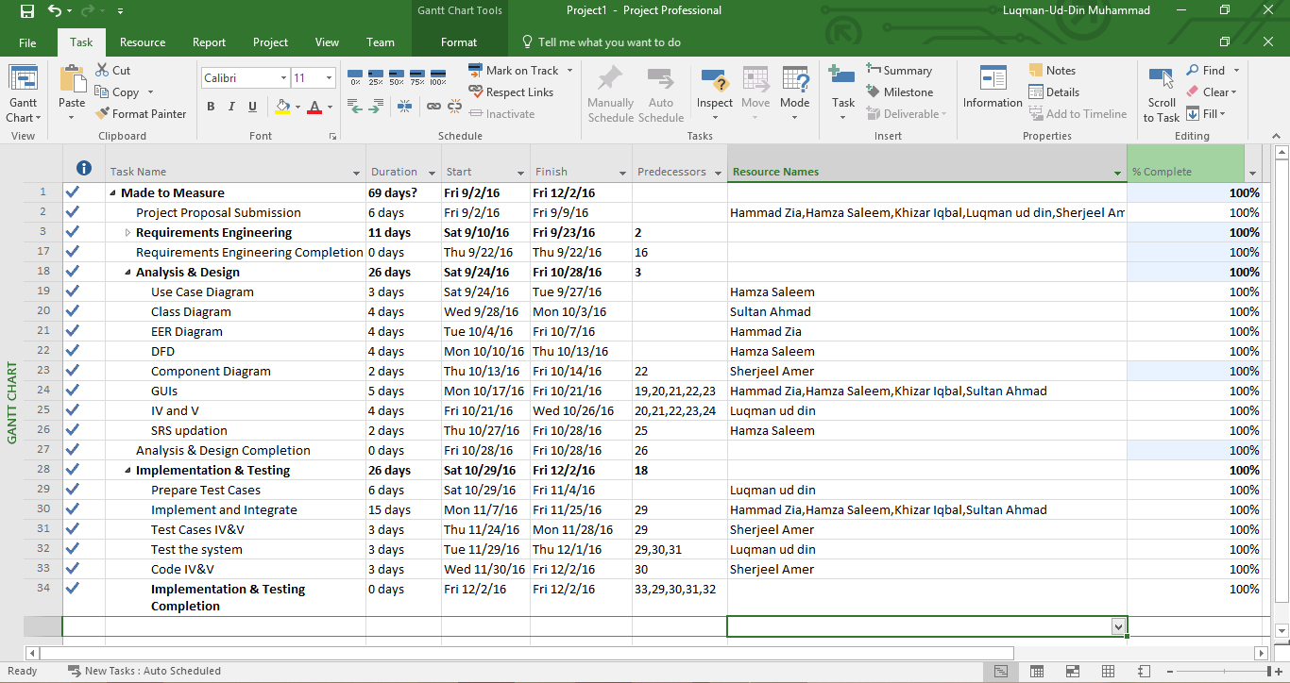

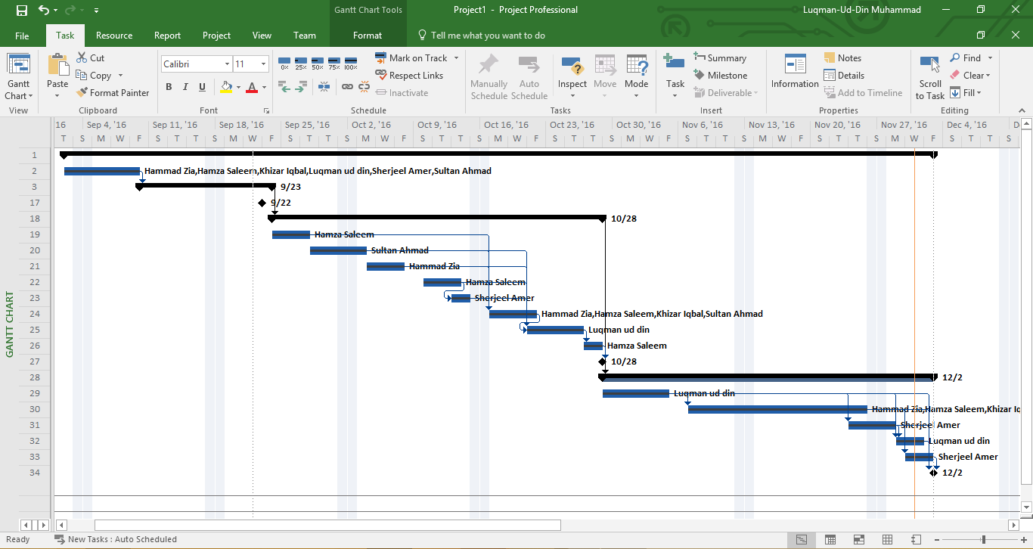

1. Risks should be sorted in descending order of risk exposure.
2. Risk Exposure = Risk Impact x Risk Probability